**ELECTRIC CIRCUITS**

**Exercises**

**Section 25.1 Circuits, Symbols, and Electromotive Force**

**13.** **Interpret** This problem is an exercise in drawing a circuit diagram, given a written description of the circuit in terms of its capacitors, resistors, and battery.

**Develop** A literal reading of the circuit specifications results in connections like those in sketch **(a)**, below.

**Evaluate** See sketch below. Because the connecting wires are assumed to have no resistance (a real wire is represented by a separate resistor), a topologically equivalent circuit diagram is shown in sketch **(b)**.



**Assess** There are three paths to ground (or to the negative battery terminal), two of which go through resistors and the third of which goes through the capacitor.

**14.** **Interpret** This problem involves connecting the various given circuit elements in series to form a closed circuit.

**Develop** In a series circuit, the same current must flow through all elements. The order of the elements is not specified, so we can connect them in any order we like, provided that they are connected in series.

**Evaluate** One possibility is shown below. The order of elements and the polarity of the battery connections are not specified.



**Assess** An important feature about a series circuit is that the current through all the components must be the same. With two batteries, the direction of the current flow is determined by the polarity of the battery with the larger voltage.

**15.** **Interpret** This problem involves drawing a circuit diagram from the description given in the problem statement.

**Develop** The circuit has three parallel branches: one withand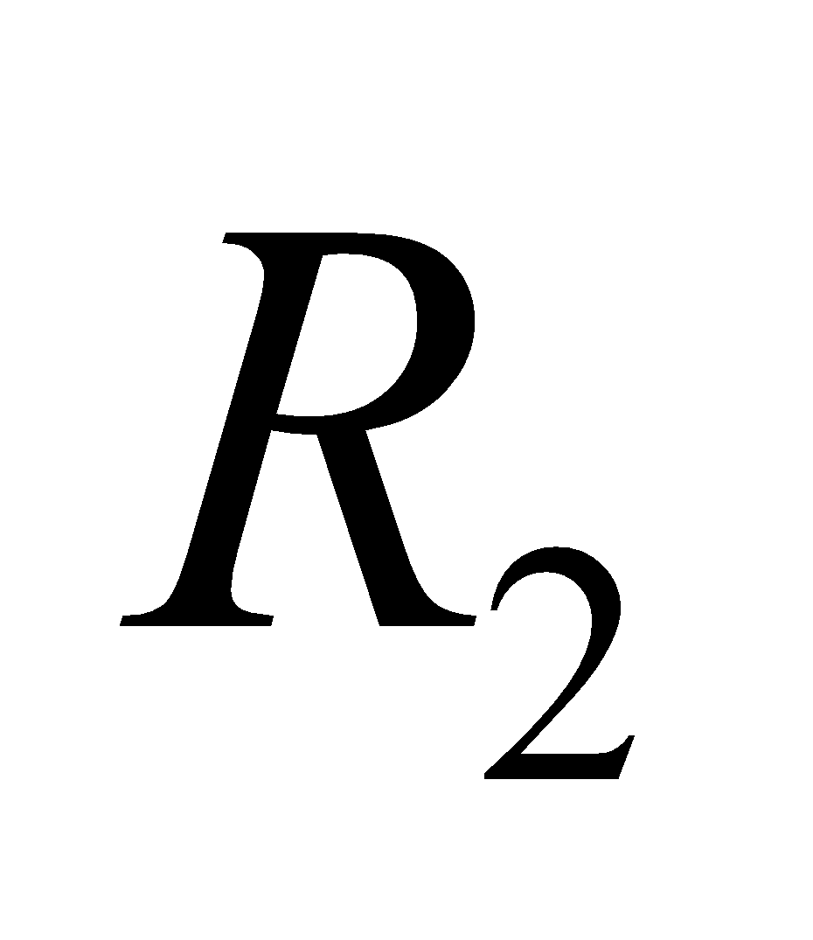in series; one with just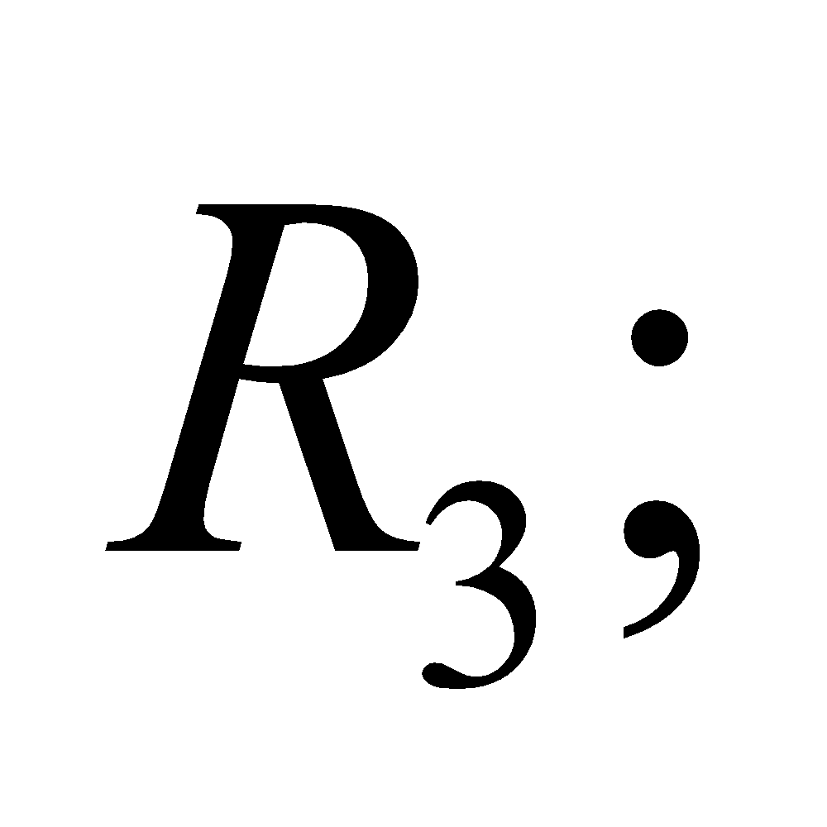and one with the battery.

**Evaluate** See figure below. *R*int is the internal resistance of the battery.



**Assess** This circuit has no capacitors, so we could replace *R*1, *R*2, and *R*3 by an equivalent resistance

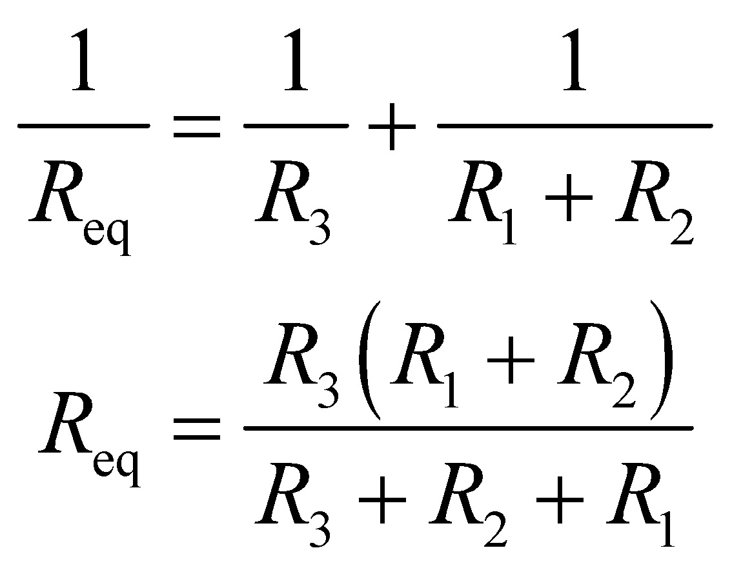

**16. Interpret** This problem explores the connection between the emf of a battery and the energy it delivers. We are to find the emf of a battery given the work it does to move a given amount of charge.

**Develop** Electromotive force, or emf, is defined as work per unit charge,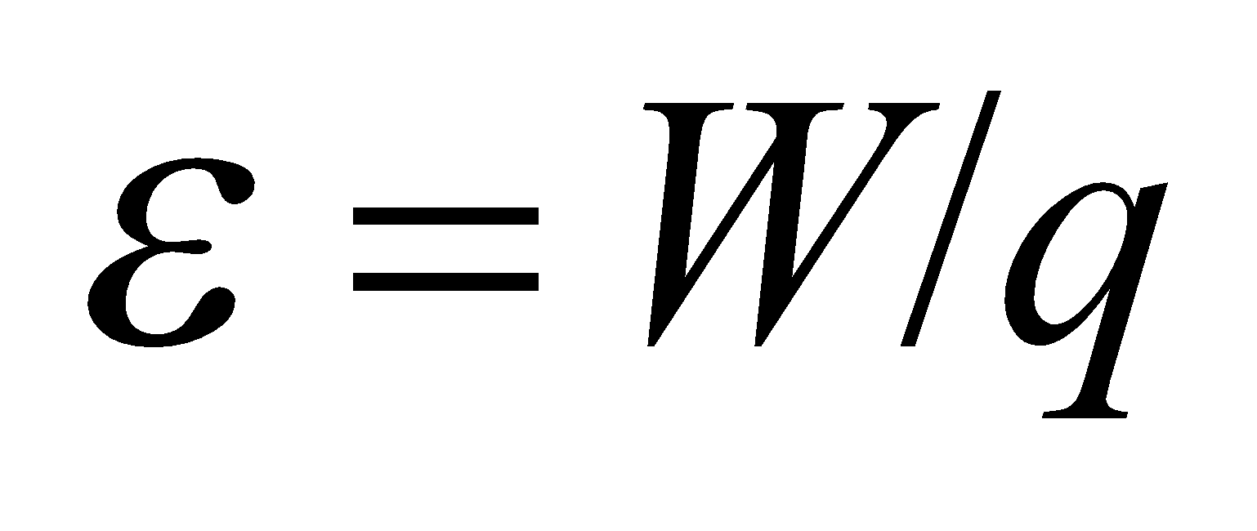 (see discussion accompanying Figure 25.2).

**Evaluate** Substituting the values given in the problem statement, the emf is

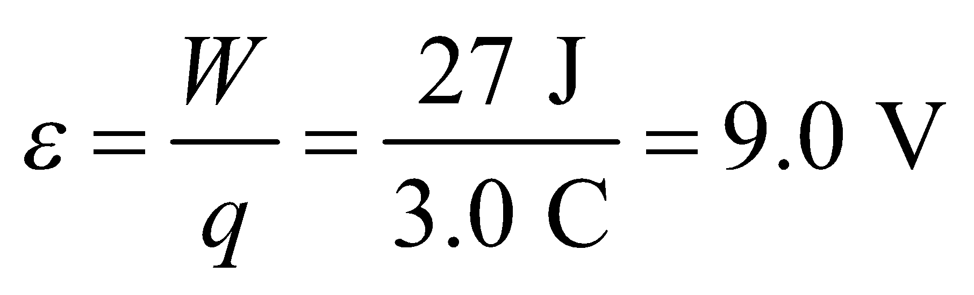

**Assess** For an ideal battery with zero internal resistance, the emf is equal to the terminal voltage (potential difference across the battery terminals).

**17.** **Interpret** This problem involves finding for how long a battery can supply the given current while maintaining its rated voltage. We are given the total energy stored in the battery, so if we can find the power the battery must deliver, we can find the time needed to deplete this energy reservoir.

**Develop** Delivering the given current at the rated voltage results in a power expenditure of

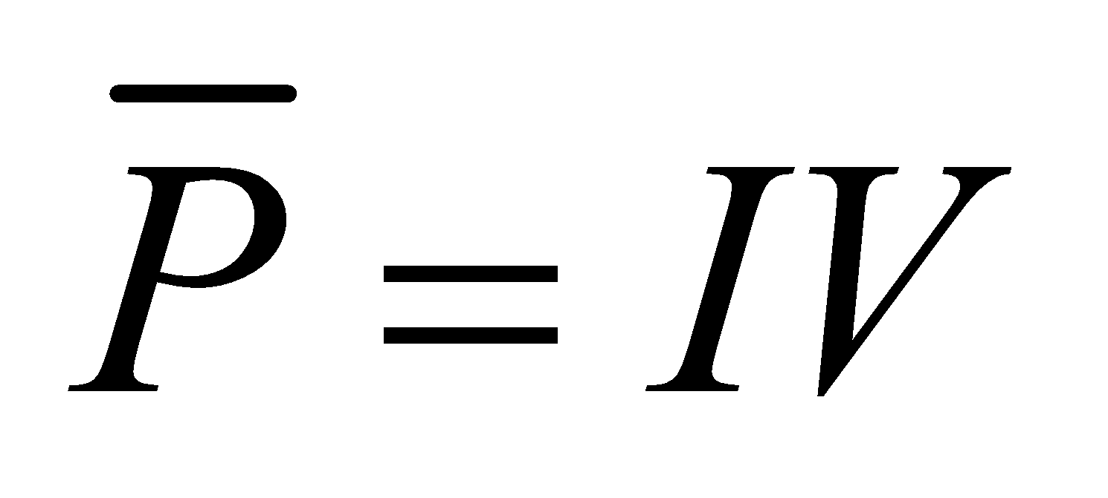

(see Equation 24.7). Because the average power is defined as 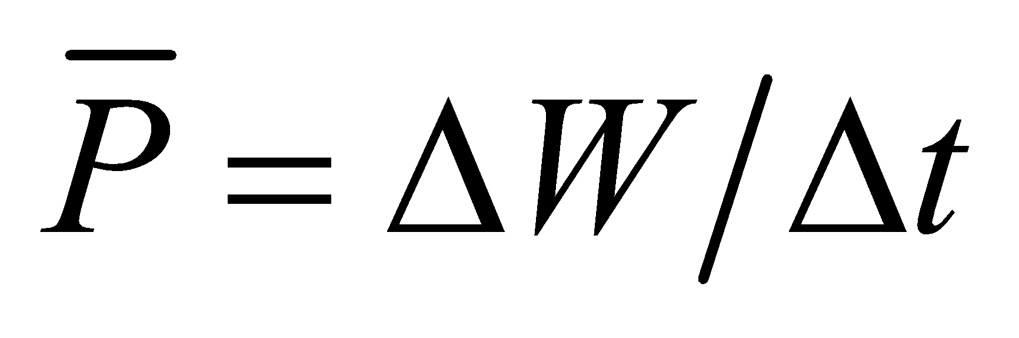, we can find *Δt*, given that the energy we have to spend is *ΔW* = 4.5 kJ.

**Evaluate** Solving for the time interval Δ*t* and inserting the known quantities gives

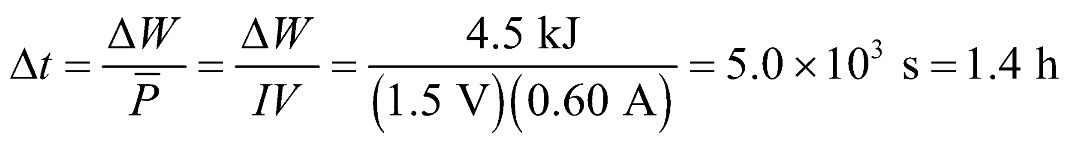

**Assess** This result assumes that the battery voltage does not decrease as it depletes its store of energy, which is not a realistic assumption (although for most batteries, the departure from the ideal situation assumed in this problem is not huge).

**18. Interpret** This problem involves finding the (chemical) energy consumed in the battery for the work done.

**Develop** The power delivered by an emf is P = IV (see Equation 24.7). Therefore, if the voltage and current remain constant, then the energy consumed is *W* = *Pt* = *IVt.*

**Evaluate** Substituting the values given, the energy used in

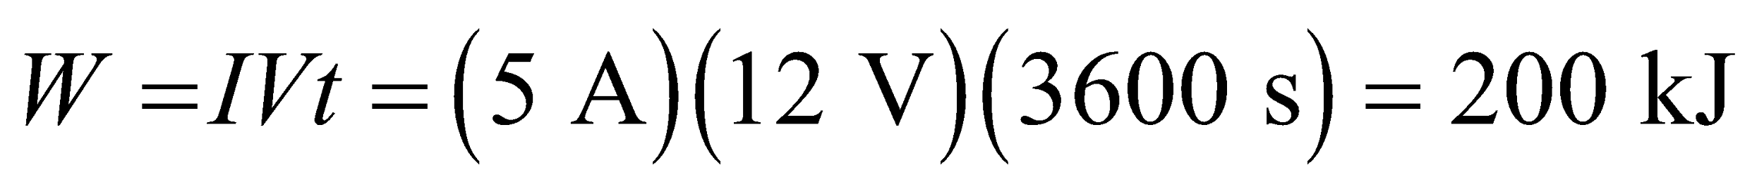

to a single significant figure.

**Assess** The result makes sense; the energy used up is proportional to the current drawn, the emf (i.e., voltage), and the time during which the headlights were left on.

**Section 25.2 Series and Parallel Circuits**

**19.** **Interpret** This problem involves calculating the equivalent resistance of the given resister combination.

**Develop** Apply Equations 25.1 and 25.3b. For the parallel pair of resistors *R*1 and *R*2, Equation 25.3b gives

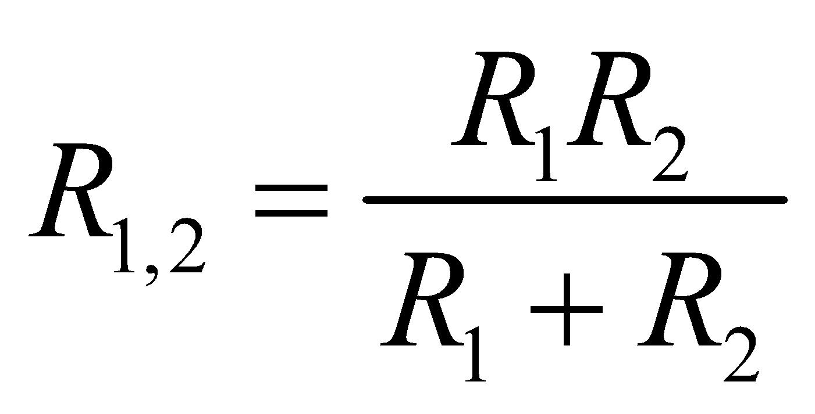

Combining this in series with resistor *R*3 (via Equation 25.1) gives

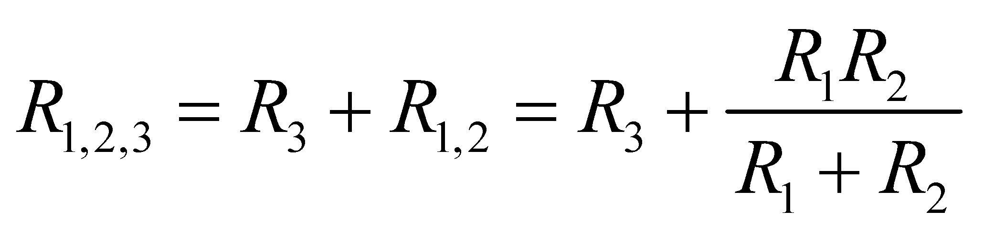

**Evaluate** Inserting the given resistances gives

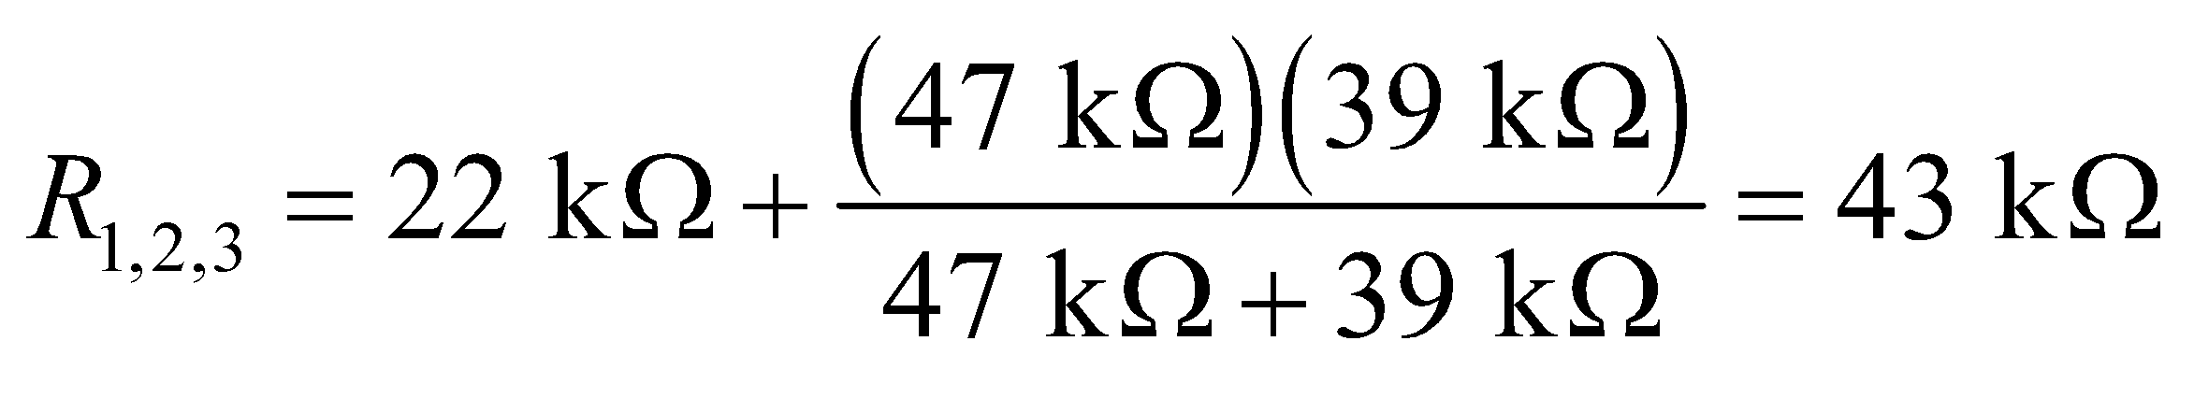

**Assess** The final resistance is greater than the resistance of *R*3 alone, as expected, but it is less than the resistance of *R*1 alone. This is because *R*2 is parallel to *R*1 and allows some current to flow through the circuit without traversing *R*1 (i.e., it adds another “traffic lane”).

**20. Interpret** This problem is about connecting two resistors in parallel and calculating the equivalent resitance.

**Develop** The equivalent resistance of two resistors connected in parallel can be found by Equation 25.3a:

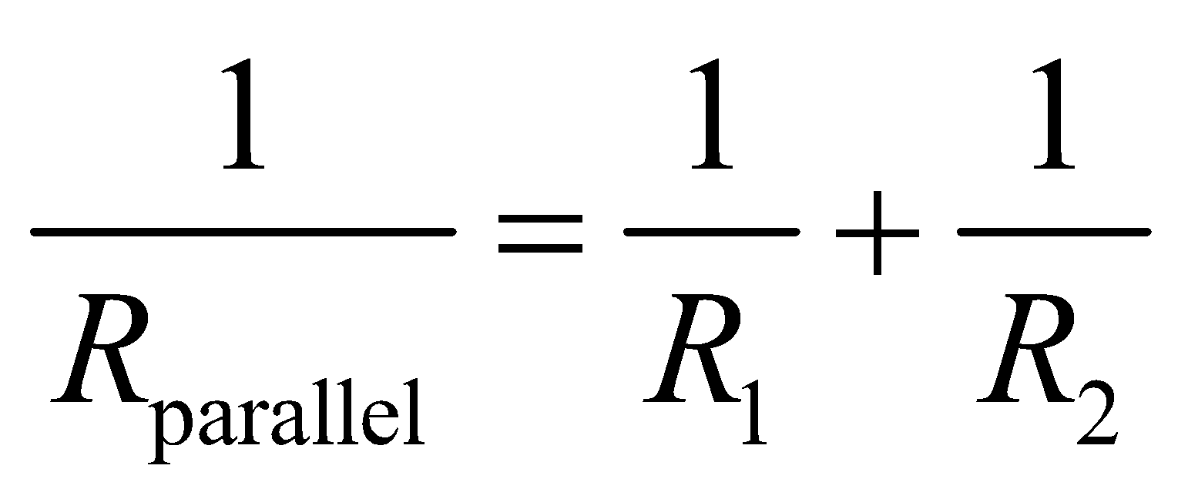

The equation allows us to determine *R*2 when *R*parallel and *R*1 are known.

**Evaluate** The solution for *R*2 in Equation 25.3a is

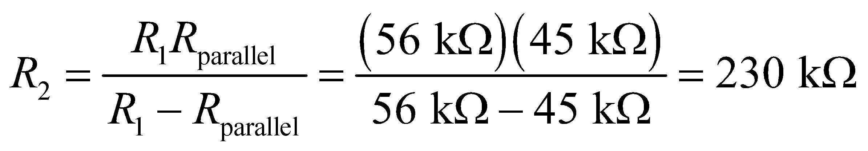

to two significant figures.

**Assess** Our result shows that 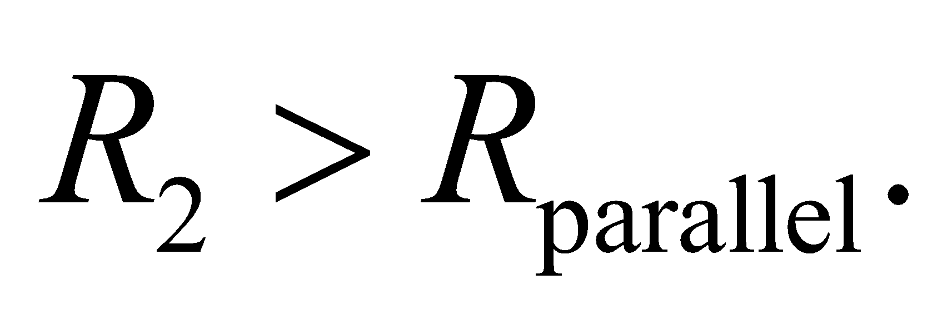 This is consistent with the fact that the equivalent resistance  is smaller than *R*1 and *R*2 because each individual resistor reduces the resistance of the parallel-resistor circuit because they add new “traffic lanes” that allow charge to move through the circuit more easily.

**21.** **Interpret** This problem involves analyzing a real battery circuit. We are given the rated voltage of the battery and its real voltage when it powers the defective starter, and are asked to find its real voltage for a proper starter.

**Develop** This problem is similar to Example 25.2, which shows that the battery is connected in series with the load (i.e., the starter motor, which we treat as a resistor). To find the internal resistance of the battery, we use the macroscopic version of Ohm’s law, *V* = *IR*:

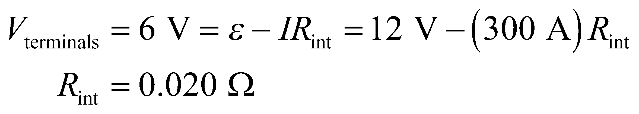

where *V*terminals is the actual voltage across the battery’s terminals. Knowing the internal resistance of the battery, we can repeat this calculation to find *V*terminals when a proper starter is used.

**Evaluate** The voltage across the terminals when a proper starter is used is

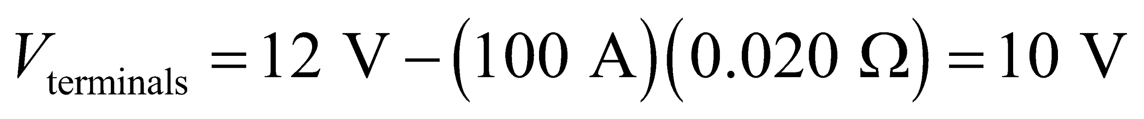

**Assess** Because the battery has an internal resistance, the voltage it can deliver is reduced by the voltage drop across the internal battery.

**22. Interpret** This problem is about the internal resistance of the battery in Problem 25.21.

**Develop** The starter circuit contains all the resistances in series, as in Figure 25.9. (We assume  includes the resistance of the cables, connections, etc., as well as that of the motor.) With the defective starter, the terminal voltage is

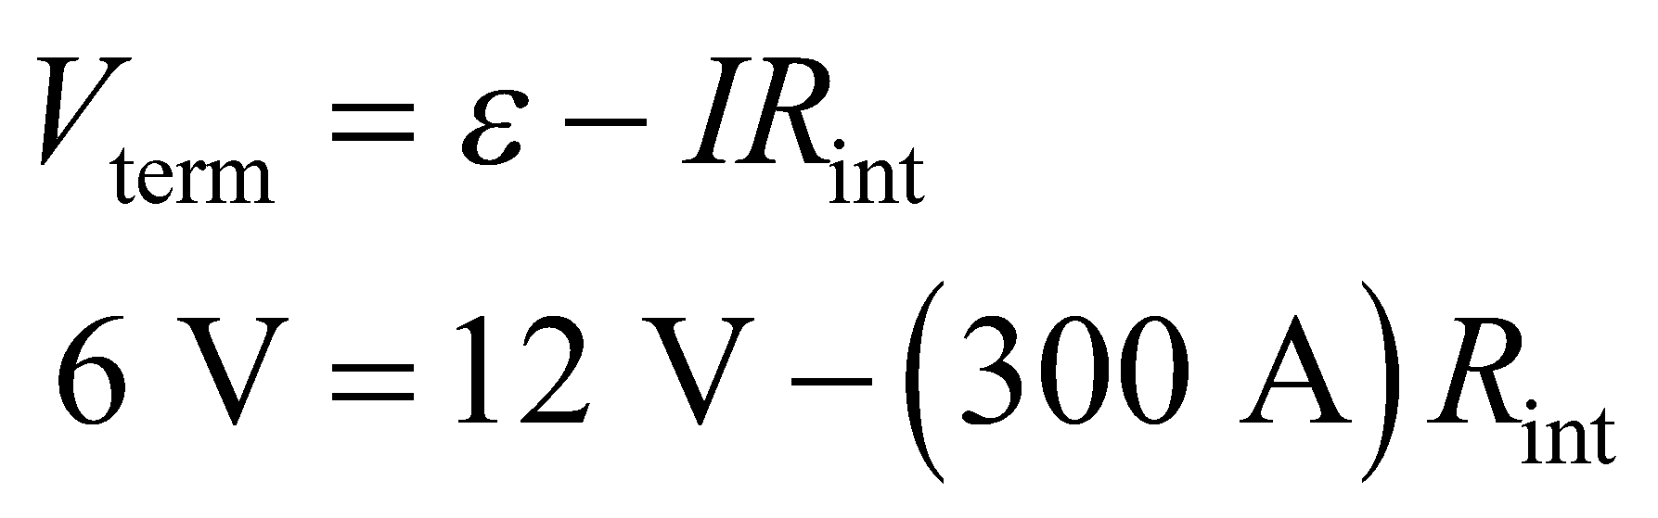

**Evaluate** From the equation above, we find the internal resistance to be

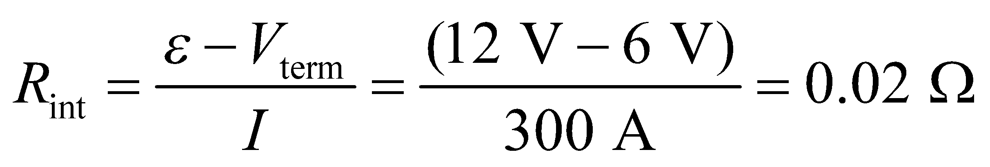

**Assess** The terminal voltage  is substantially less than the battery’s emf 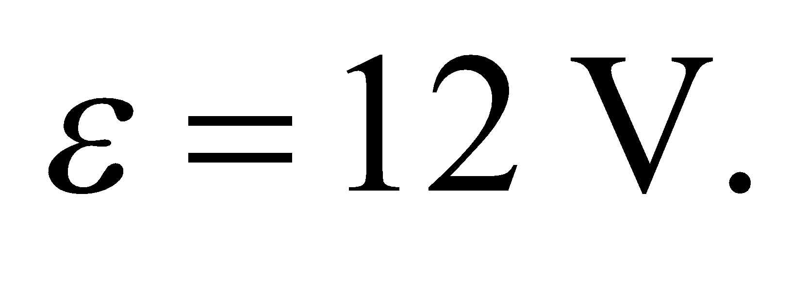 The two are equal only in the ideal case where the internal resistance vanishes.

**23.** **Interpret** We are to find the internal resistance of a battery, given its short-circuit current and its rated voltage.

**Develop** The battery contains an internal resistance (see section “Real Batteries”), which we can find using the macroscopic version of Ohm’s law, *V* = *IR*, where 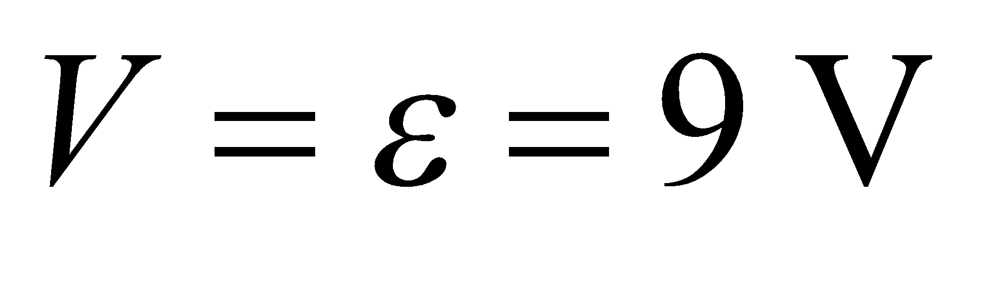.

**Evaluate** Inserting the given quantities into Ohm’ s law gives

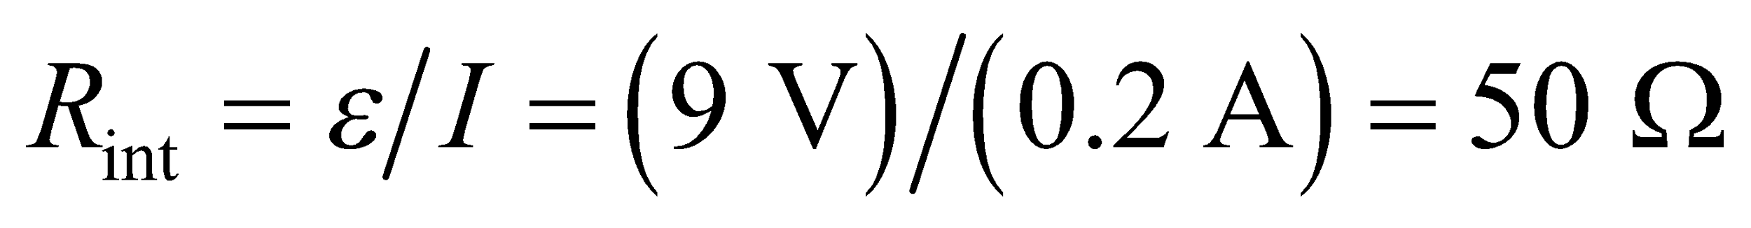

to a single significant figure.

**Assess** This is a rather large value for an internal resistance of a 9-V battery.

**24. Interpret** In this problem we are asked to find all possible values of equivalent resistance that could be obtained with three resistors.

**Develop** Since each resistor can be placed either in parallel or in series, there are eight combinations using all three resistors. To find the equivalent resistance, use Equations 25.1 and 25.3a.

**Evaluate** Let 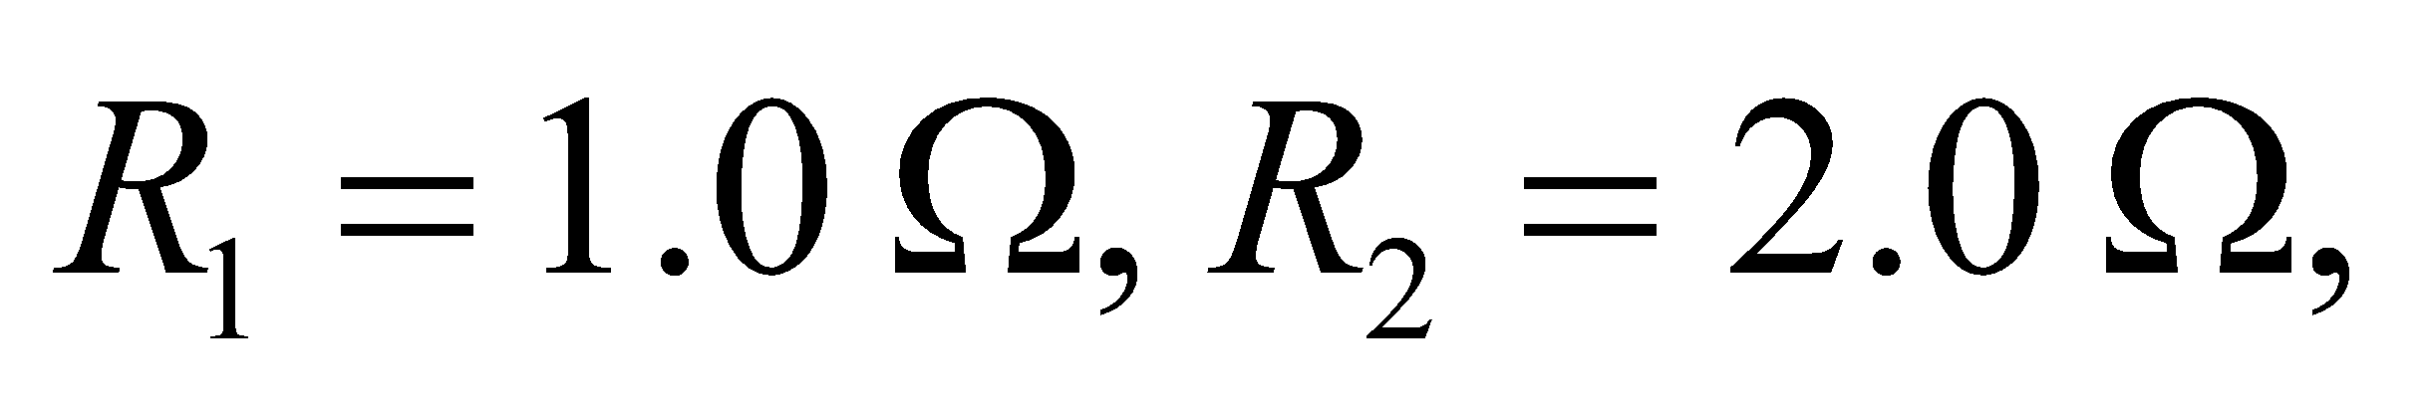 and 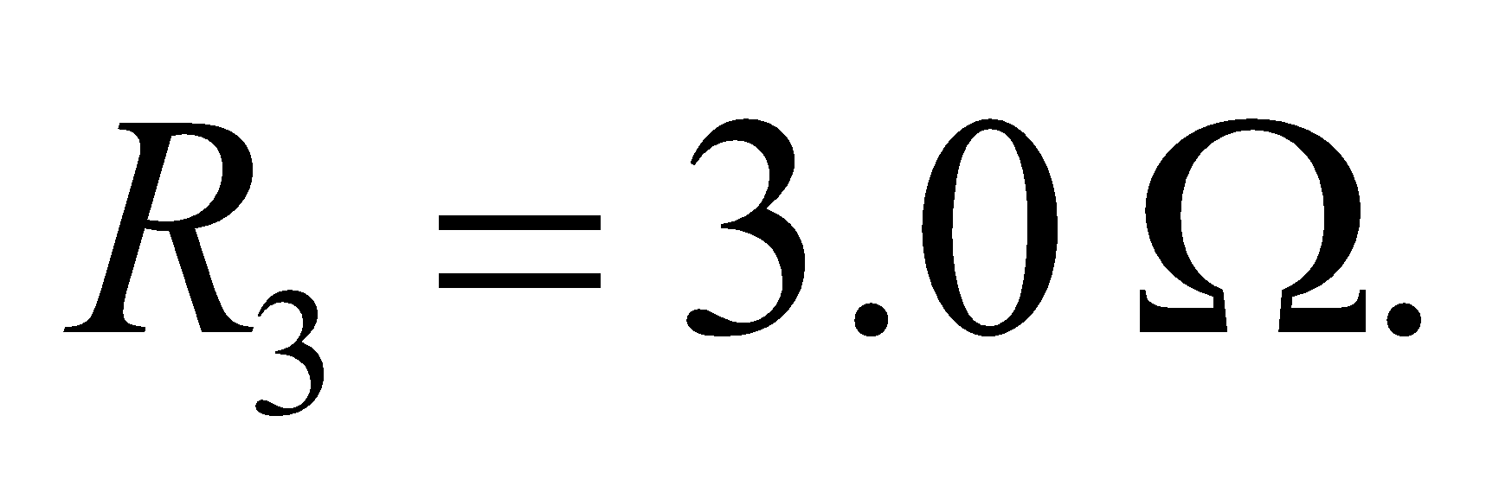 The possible results are **(a)** one resistor in series with two resistors in parallel

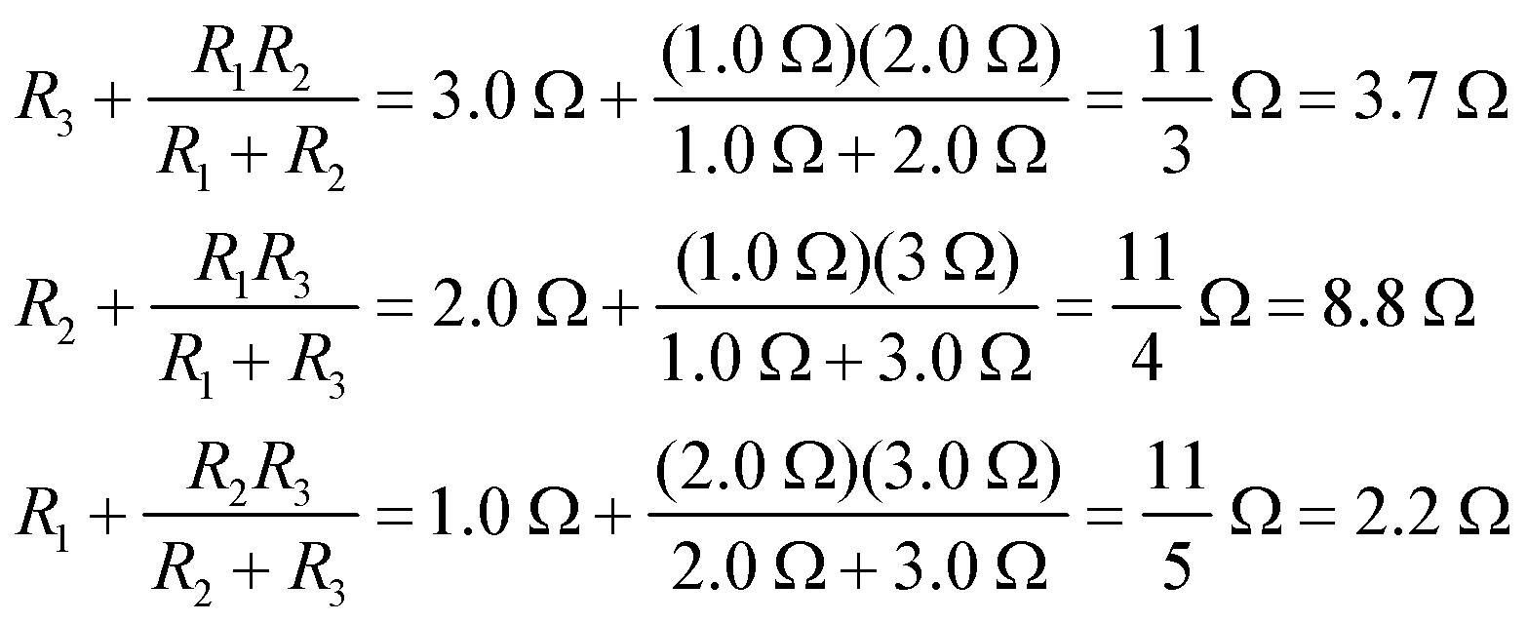

**(b)** one in parallel with two in series:

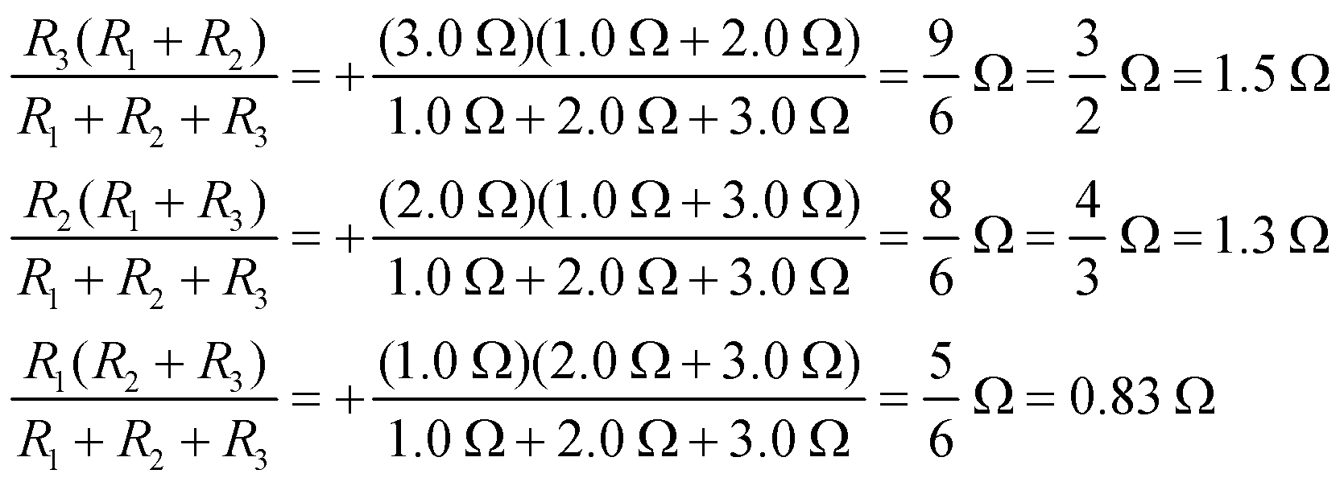

**(c)** three in series: 

**(d)** three in parallel:



**Assess** The equivalent resistance is a maximum when all three are connected in series, as in **(c)**, and a minimum when all are connected in parallel, as in **(d)**.

**Section 25.3 Kirchhoff’s Laws and Multiloop Circuits**

**25. Interpret** This problem requires us to find the currents in all parts of a multi-loop circuit.

**Develop** The general solution of the two loop equations and one node equation given in Example 25.4 can be found using determinants (or *I*1 and *I*2 can be found in terms of *I*3, as in Example 25.4). The equations and the solution are:

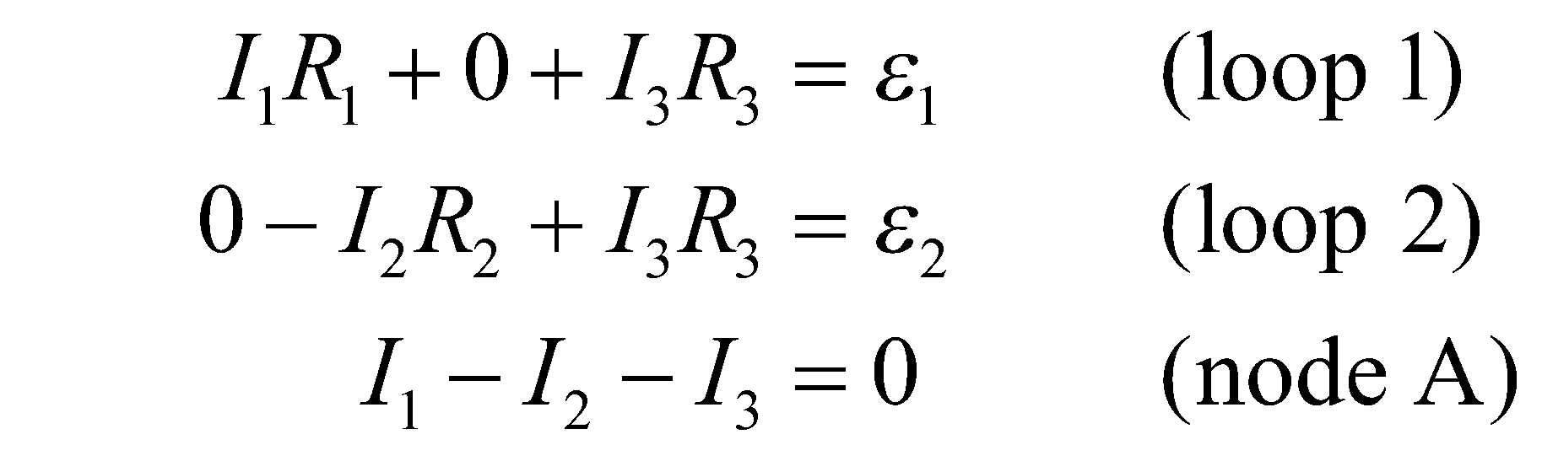

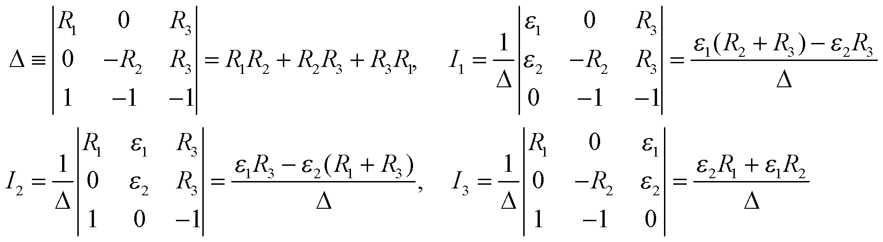

**Evaluate** With the particular values of emfs and resistors in this problem, we have



and the currents are

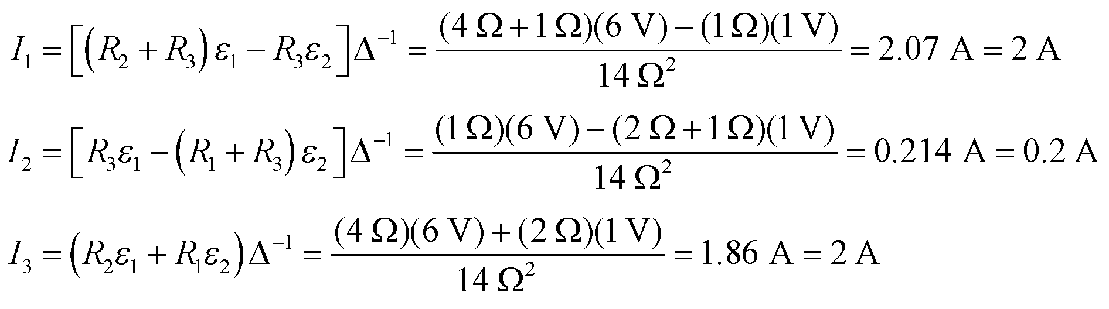

to a single significant figure.

**Assess** The same results could be obtained by retracing the reasoning of Example 25.4, with 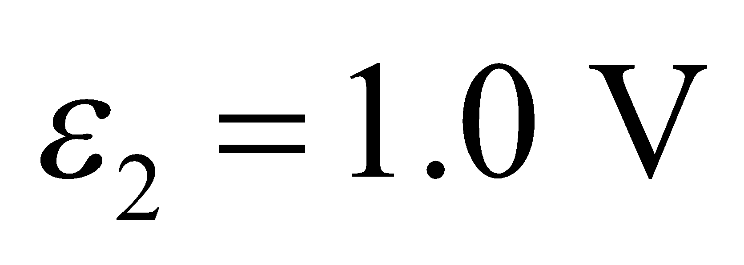 replacing the original value in loop 2. Then, everything is the same until the equation for loop 2: 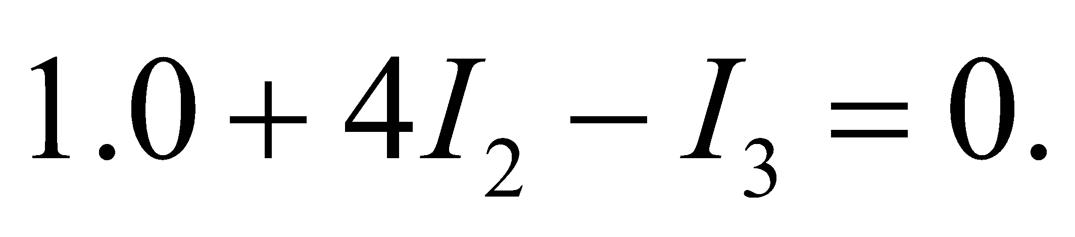

**26.** **Interpret** This problem asks us to find the current through a resistor in a circuit.

**Develop** The right-hand side of this circuit is irrelevant for this problem because the emf source is directly connected to the resistor without any intervening resistances, so the voltage drop across the resistor is simply the emf voltage. Thus, we can apply the macroscopic version of Ohm’s law to find the current.

**Evaluate** The current is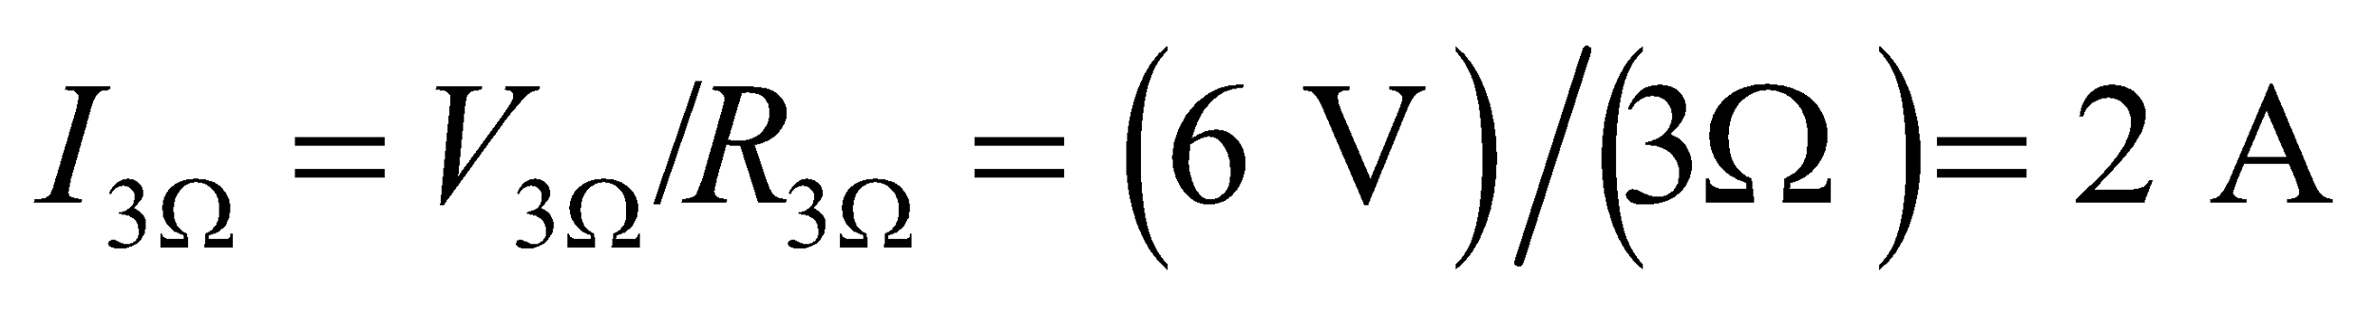.

**Assess** Note that if thebattery had an internal resistance, an argument like that used in Example 25.4 must be applied.

**27. Interpret** We are to find the current through a resistor in a given circuit, for which we can use Kirchhoff’s laws. We will use the loops and nodes drawn in Example 25.4.

**Develop** The circuit is given to us in Figure 25.14, with one change: 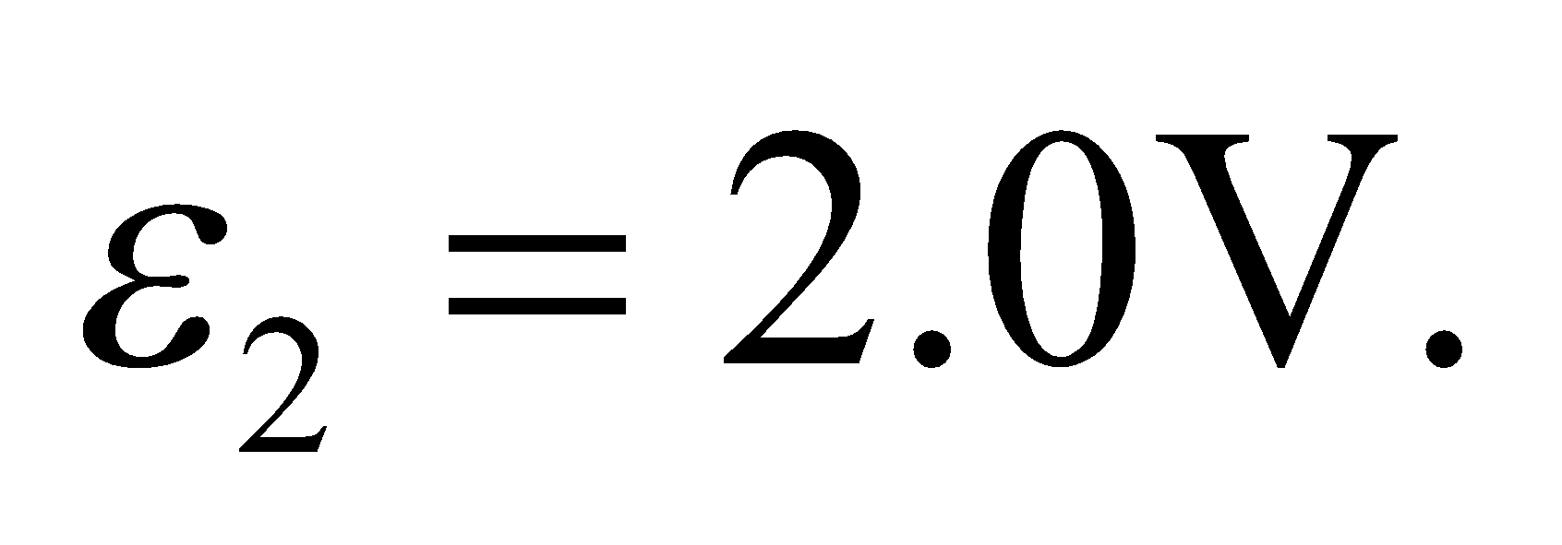 We will use node A and loops 1 and 2. These will give us three equations, which we will use to solve the three unknown currents. At node A, 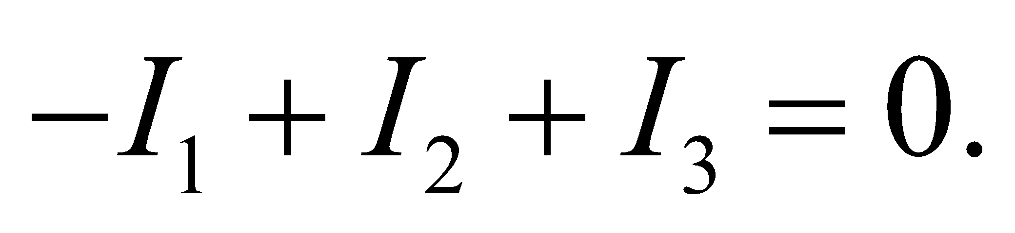 For loop 1, 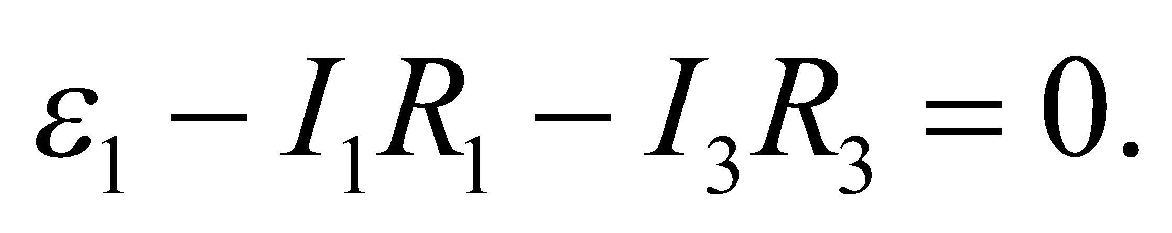 For loop 2, 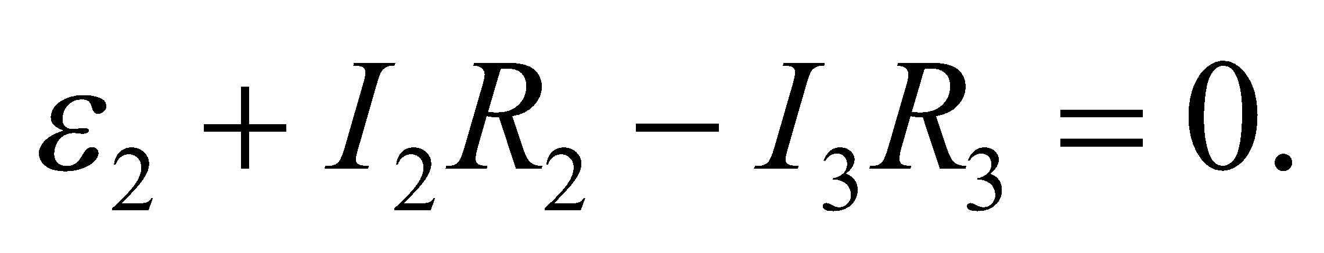

**Evaluate** Because we are interested in the current *I*2, we eliminate the other two currents. The node equation gives us 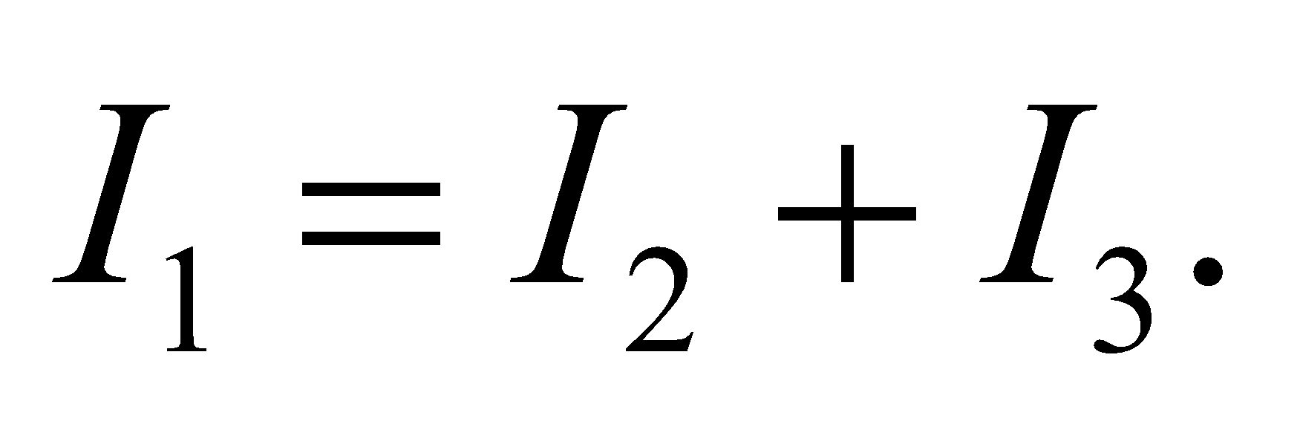 Substitute this into the equation for loop 1 and solve for I3

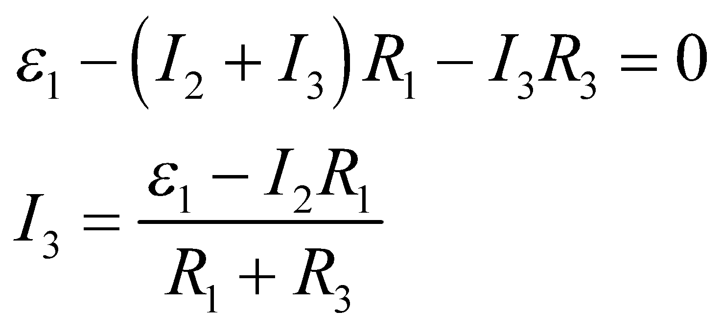

Now substitute this value into the equation for loop 2 and solve for *I*2:

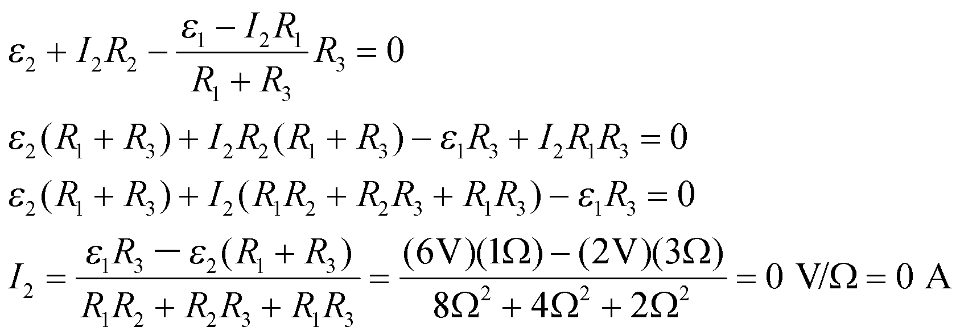

**Assess** The current through resistoris zero! Looking back at the original diagram, we can see that this would mean that battery 2 is supplying no current and the voltage drops through resistors 1 and 3 equal the voltage supplied by battery 1. This is a somewhat unexpected solution, but it is consistent.

**Section 25.4 Electrical Measurements**

**28.** **Interpret** This problem requires us to determine the error in a voltage measurement that results from the internal resistance of the voltmeter.

**Develop** The voltage across the 10-kΩ resistor in Fig. 25.27 is 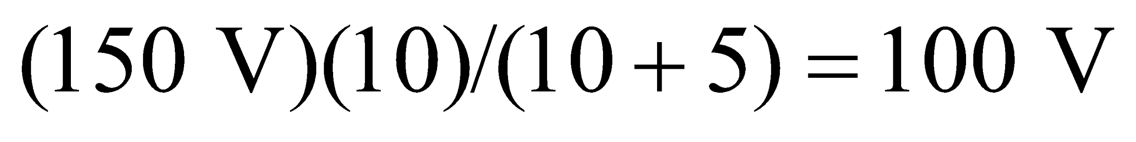 (the circuit is just a voltage divider as described by Equations 25.2a and 25.2b), as would be measured by an ideal voltmeter with infinite resistance. With the real voltmeter connected in parallel across the 10-kW resistor, the effective resistance is changed to so we can find the measurement-error ratio.

**Evaluate** The measured voltage is

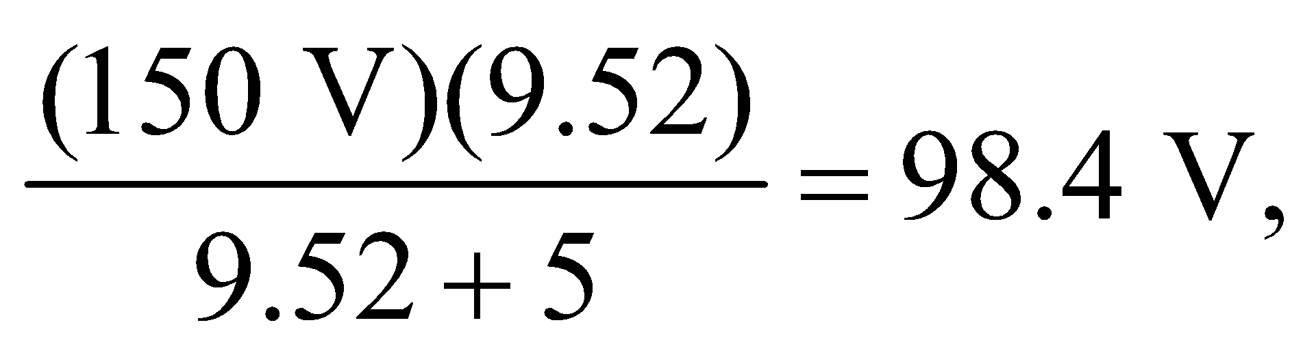

which is some 1.6% lower than the true voltage.

**Assess** The measured voltage is slightly lower than the real voltage because the voltmeter allows some of the current to bleed through it, thus reducing the current that has to traverse the 10-kΩ resistor.

**29. Interpret** This problem involves finding the measurement error caused by the nonzero resistance of the ammeter used to measure the current.

**Develop** The current in the circuit of Fig. 25.27 is

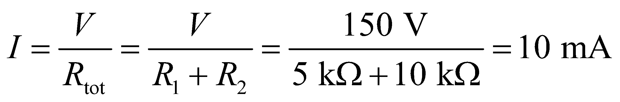

With the ammeter inserted (in series with the resistors), the resistance *R*tot is increased by 

**Evaluate** The resulting current after including *R*A is

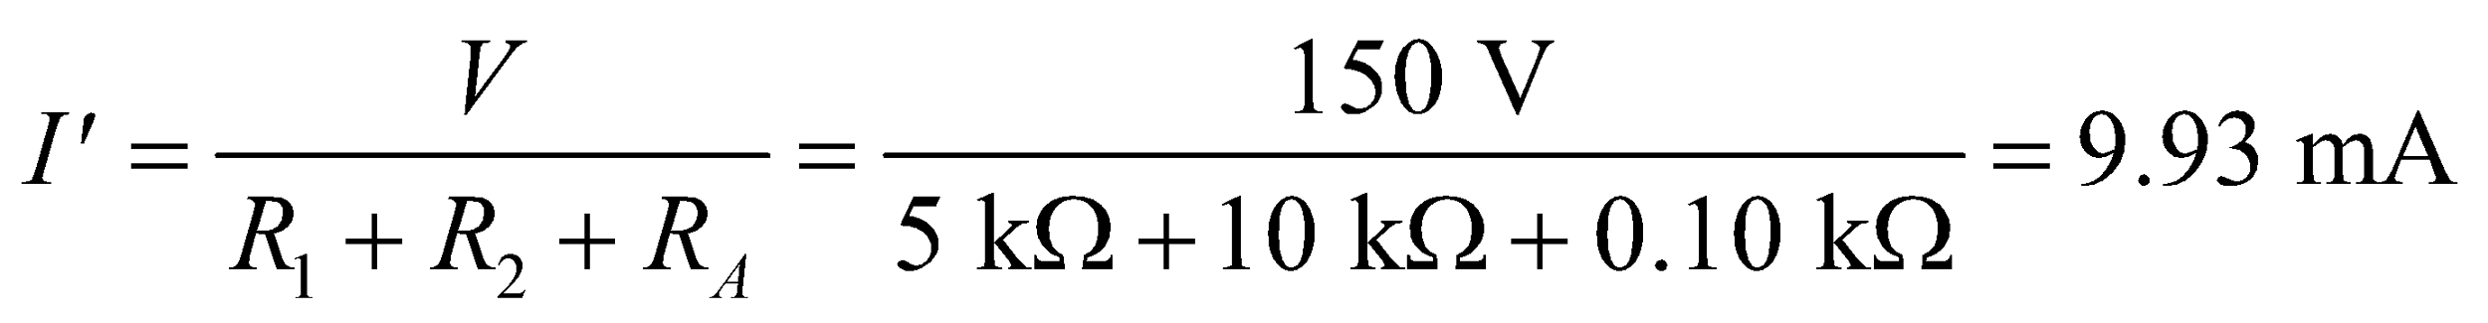

which is about 0.66% lower than *I*.

**Assess** The current reading by the ammeter is lower due to its internal resistance.

**30.** **Interpret** We are to find the power dissipated in a circuit where the given voltage is discharged through the resistance that is the series resistance of the internal resistances of the battery and the ammeter.

**Develop** The series resistance through which the voltage is discharged is



The current flowing through this circuit is 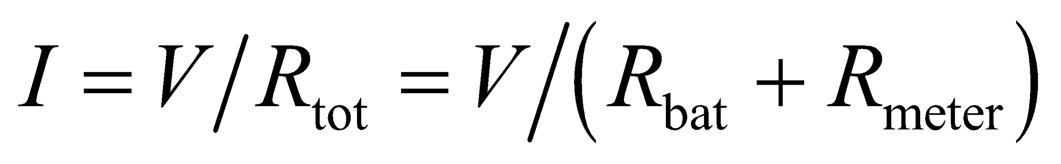 and the power dissipated in the meter is (Equation 24.8a) *P* = *I*2*R* meter.

**Evaluate** Inserting the given values, power dissipated is

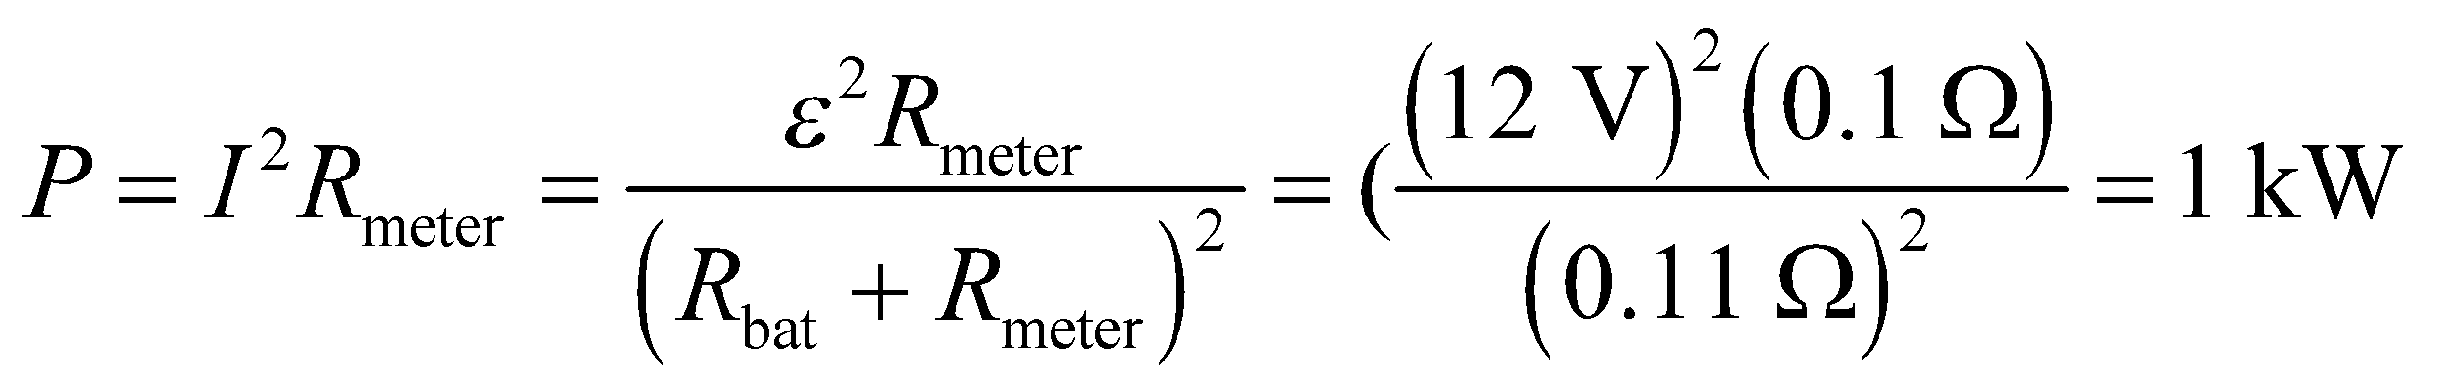

**Assess** This power is comparable to that consumed by a small toaster oven. The ammeter would quickly be destroyed.

**Section 25.5 Capacitors in Circuits**

**31. Interpret** In this problem we are asked to show that the quantity *RC*, the product of resistance and capacitance, has units of time.

**Develop** The SI units for *R* and *C* are Ω and F, respectively. The units can be rewritten as

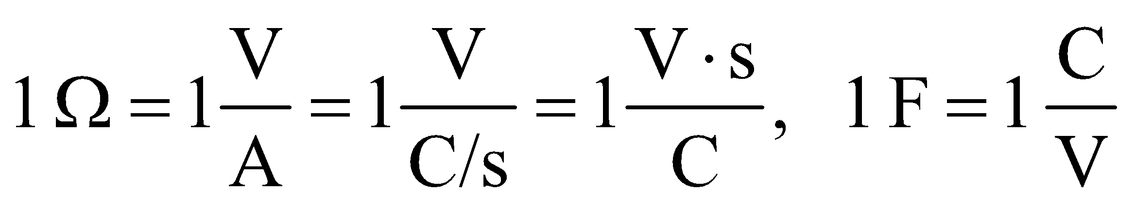

**Evaluate** From the expressions above, the SI units for the time constant, *RC*, are

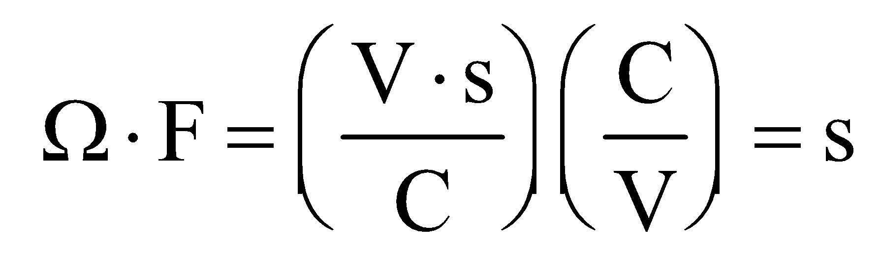

as stated.

**Assess** The quantity *RC* is the characteristic time for changes to occur in an *RC* circuit.

**32.** **Interpret** This problem requires us to find the time units for the *RC* time constant when the resistance *R* is given in various units.

**Develop** From the results of the previous problem, we know that an Ω·F = s, so any prefactors applied to Ω or F are simply applied to s.

Evaluate (a) , (b)  (c) .

**Assess** The prefactors μ, M, k, etc. are simply multiples of ten, so they can be treated mathematically as for scalar factor.

**33. Interpret** This problem involves the time dependence of the capacitor voltage in a charging *RC* circuit. We are to find the charging ratio of a capacitor after 5 *RC* time constants.

**Develop** The capacitor voltage as a function of time is given by Equation 25.6:

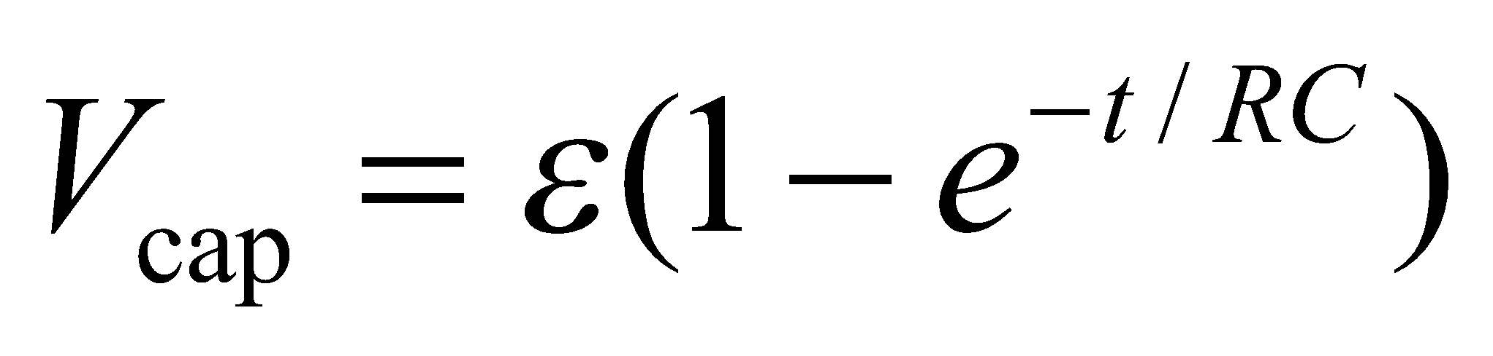

**Evaluate** When  the equation above gives a voltage of

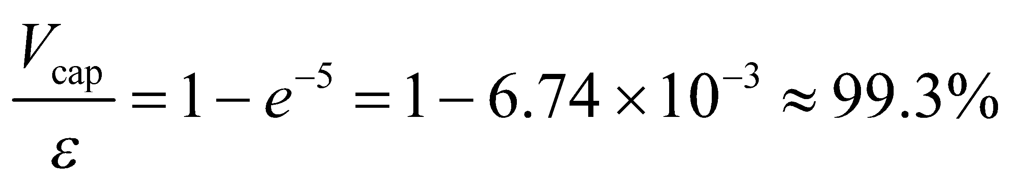

of the applied voltage.

**Assess** As time goes on and after many more time constants, we find essentially no current flowing to the capacitor, and the capacitor could be considered as being fully charged for all practical purposes.

**34.** **Interpret** This problem involves an RC circuit. We are to find the time required for the capacitor to charge given the voltage, resistance, and capacitance of the circuit.

**Develop**  The capacitor voltage as a function of time is given by Equation 25.6:



**Evaluate** Solving the expression above for time and inserting the given quantities gives

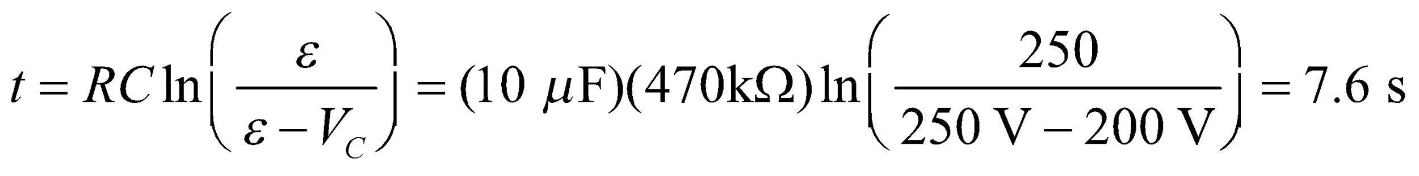

**Assess** Because the circuit capacitance takes time to discharge this explains why, to start afresh, we need to turn devices such as computers off for several seconds before turning them back on.

**35. Interpret** We are to find the voltage across the capacitor in Figure 25.24a when it is fully charged, which implies that the current through the capacitor is zero.

**Develop** Use the results of Example 25.7b and Ohm’s law to find the voltage required. If the capacitor is fully charged, then no current flows through it and the circuit is equivalent to the circuit shown in 25.24c. So we find the current through resistor *R*2 in Figure 25.24c and then determine the voltage across resistor *R*2, which will be the same as the voltage across the capacitor.

**Evaluate** The current through resistor *R*2 is given in Example 25.7 as 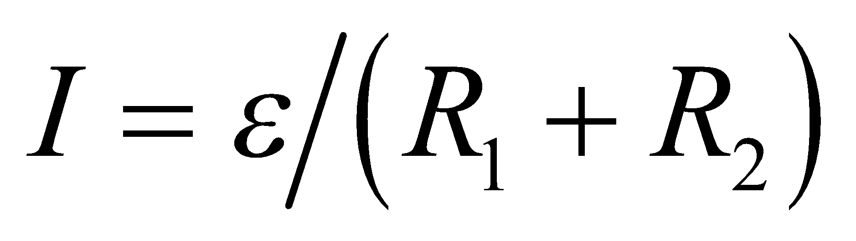. The voltage is given by Ohm’s law as

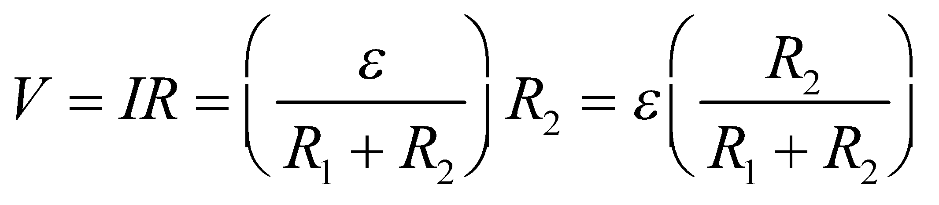

**Assess** In the limit of long charging times, this circuit behaves like a voltage divider.

**Problems**

**36.** **Interpret** This problem involves a multiloop circuit for which we are to find the resistance between the different points given.

**Develop** The resistance between *A* and *B* is equivalent to two resistors of value *R* in series with the parallel combination of resistors of values *R* and 2*R*. Thus, the equivalent resistance may be found by combining Equations 25.1 and 25.3b. *R*AC is equivalent to just one resistor of value *R* in series with the parallel combination of *R* and 2*R* (since the resistor at point *B* carries no current, i.e., its branch is an open circuit).

**Evaluate** **(a)** . **(b)** 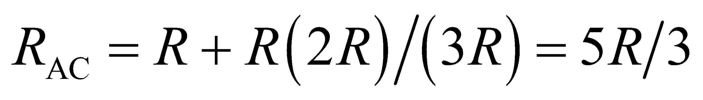.

**Assess**  because the stem B carries no current.

**37. Interpret** This problem asks for the current in a resistor which is part of a more complex multiloop circuit. We will find the voltage drop over this resistor, which is part of a parallel combination of resistors, to find the current passing through it.

**Develop** The circuit in Fig. 25.28, with a battery connected across points *A* and *B*, is similar to the circuit analyzed in Example 25.3. In this case, we have one 1.0-Ω resistor in parallel with two 1.0-Ω resistors in series. Thus, combining Equations 25.1 and 25.3b, we find

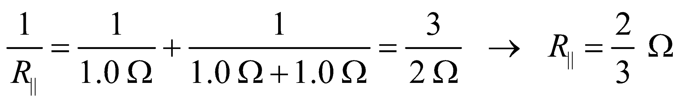

and the total resistance is *R*|| in series with two 1.0-Ω resistors: 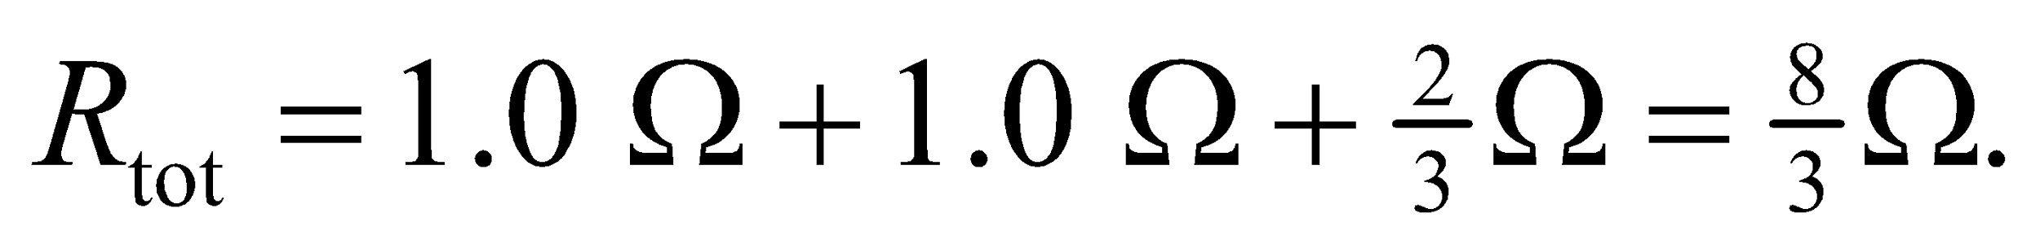 The total current through the battery is

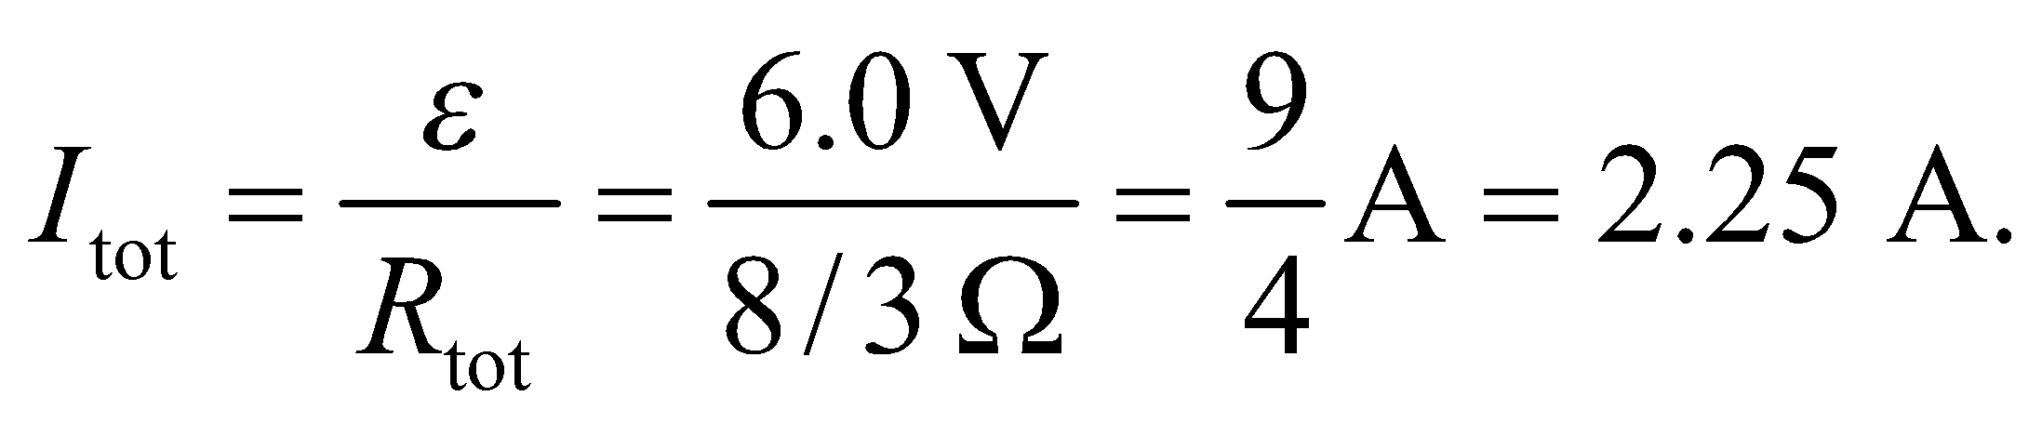

**Evaluate** Using the macroscopic version of Ohm’s law, the voltage across the parallel combination is

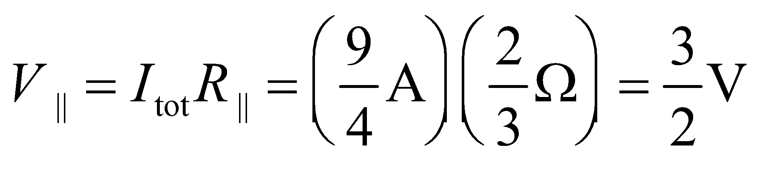

which is the voltage across the vertical 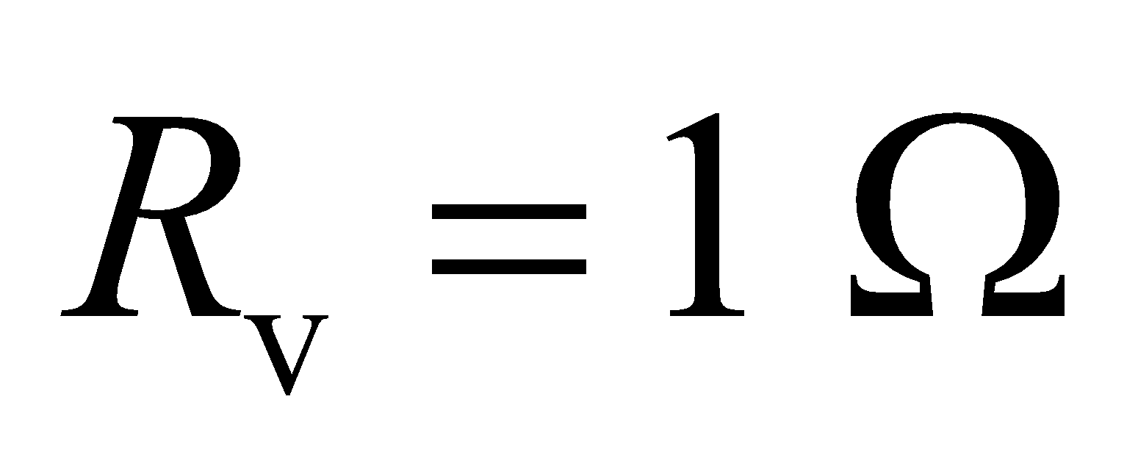 resistor. Thus, the current through this resistor is then

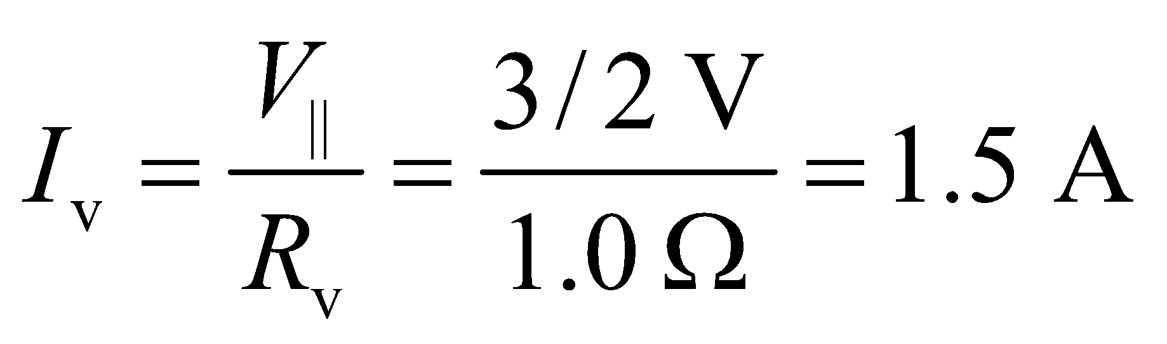

**Assess**We have a total of 2.25 A of current flowing around the circuit. At the vertex of the triangular loop, it is split into 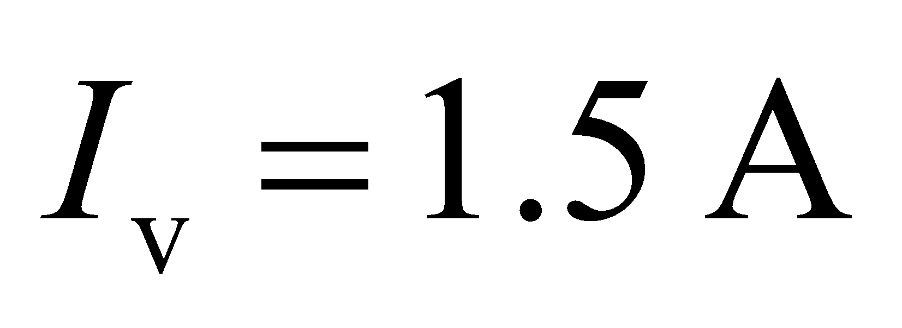 and 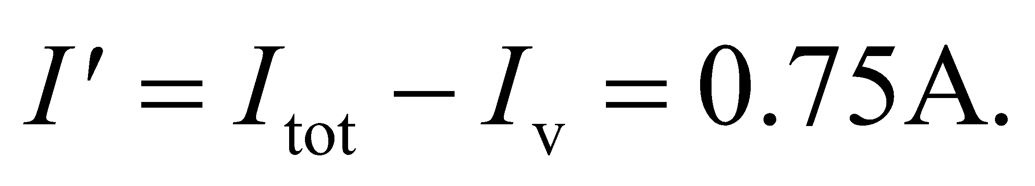 The voltage drop across the vertical resistor 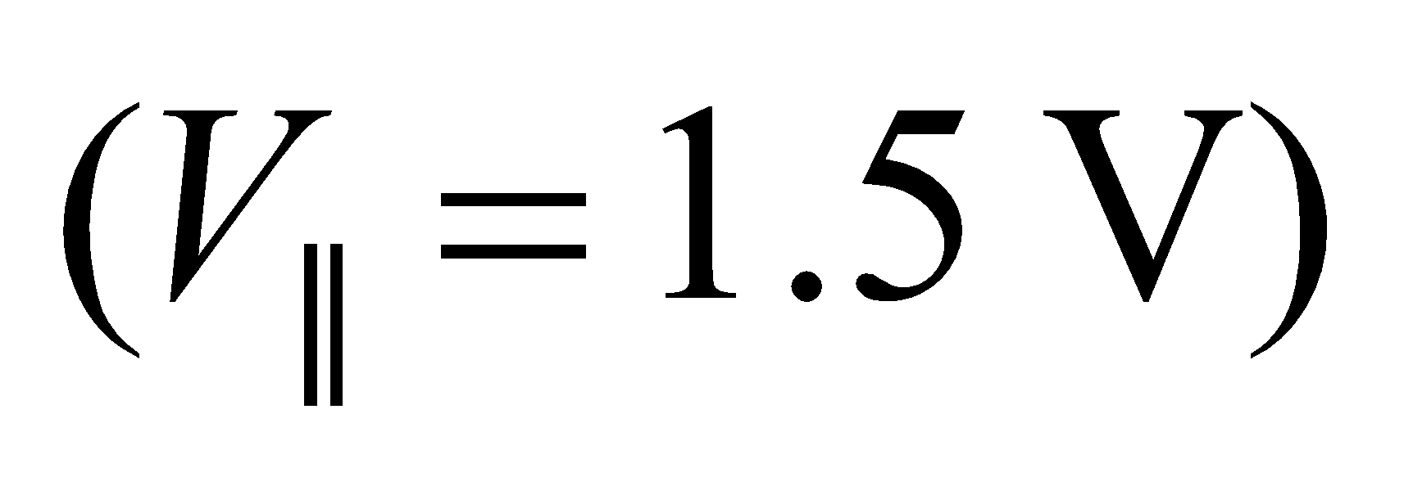 is the same as that going through point *C* and the two 1.0-Ω resistors: 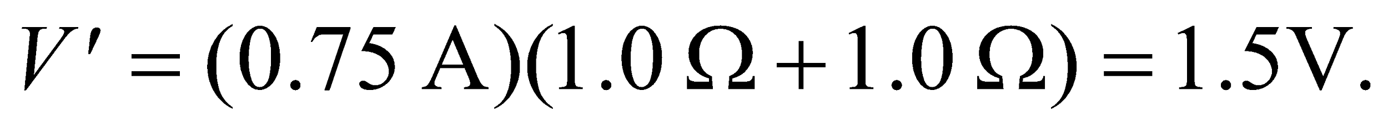 Thus, the result is consistent.

**38.** **Interpret** We are to find (to three significant figures) the voltage across the terminals of a battery for three different internal resistances, and with a 1-Ω resistor connected between the terminals.

**Develop** The circuit diagram is like Fig. 25.9, and the voltage across the load (from Kirchhoff’s voltage law) is 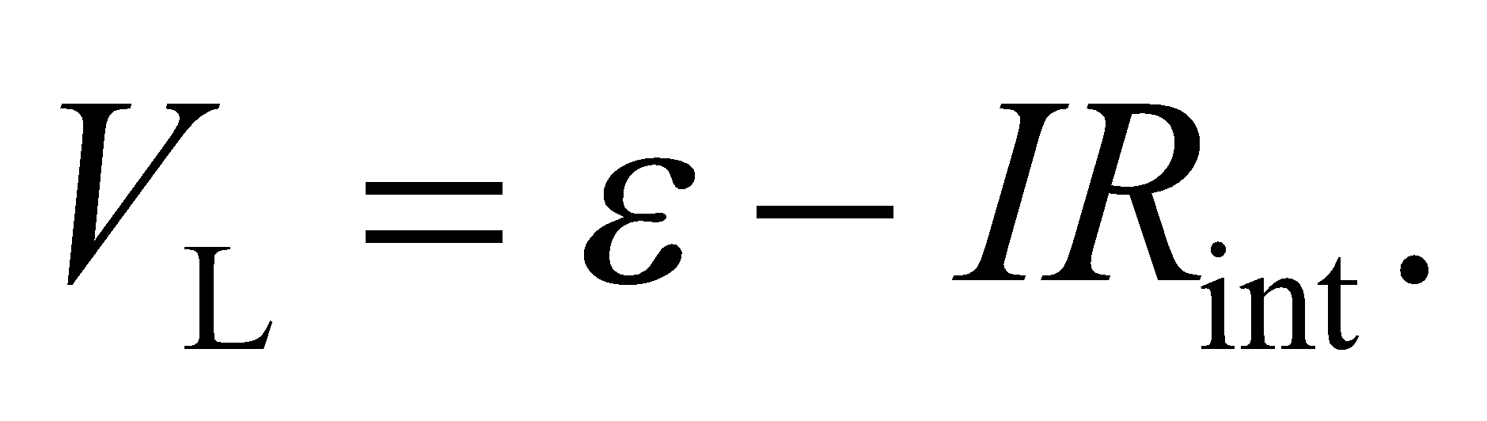 Since 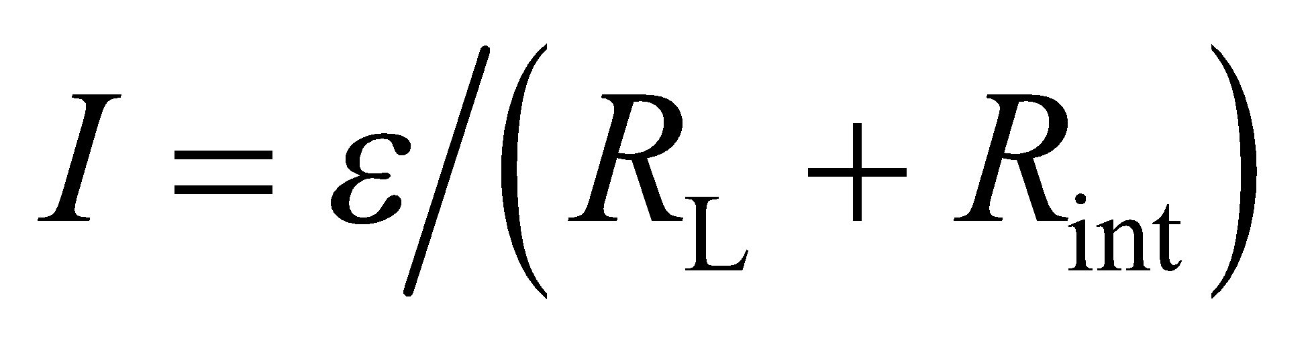, we have 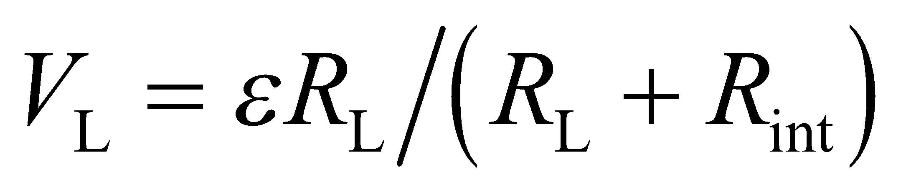 (as for a voltage divider).

**Evaluate** With the given numerical values,



for *R*int = 0.01 Ω, 0.1 Ω, and 1 Ω, respectively.

**Assess** Normally, because the data is given to a single significant figure, we should only retain a single significant figure in the result.

**39. Interpret** The circuit has two batteries connected in series. We will apply Kirchhoff’s law to find the current that flows through the discharged battery.

**Develop** Terminals of like polarity are connected with jumpers of negligible resistance, giving a circuit as shown below. Kirchhoff’s voltage law gives

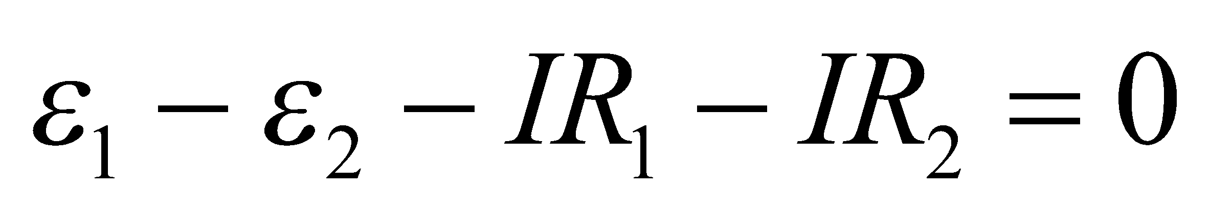



**Evaluate** Solving the equation above for *I*, we obtain

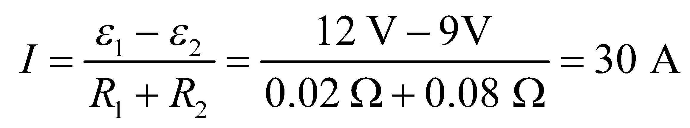

**Assess** When you try to jump start a car, you connect positive to positive and negative to negative terminals. The current is quite significant, which is why you want to have the charged car running to prevent the battery from being drained.

**40.** **Interpret** You want to come up with a combination of 50- Ω resistors that has a total resistance of 50 Ω. Each of the resistors is limited to ½ W of power.

**Develop** If the total resistance of the combination is 50 Ω, then the total current coming out of the battery and the total power dissipated in the circuit will be

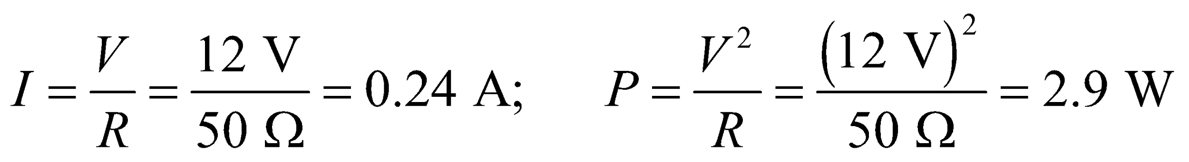

Since this power will be divided up between the individual resistors in the combination, you will need at least 6 of the 50-Ω resistors to ensure that none of them dissipates more than 0.5 W.

**Evaluate** You could put 6 resistors in series, so that the voltage across each would be reduced by a factor of 6, but then the total resistance would be 300 Ω. You could put 6 resistors in parallel, so that the current through each would be reduced by a factor of 6, but then the total resistance would be 50/6 Ω. The only way to keep the resistance at 50 Ω is to put equal numbers of resistors in parallel and in series. Essentially you need to make an 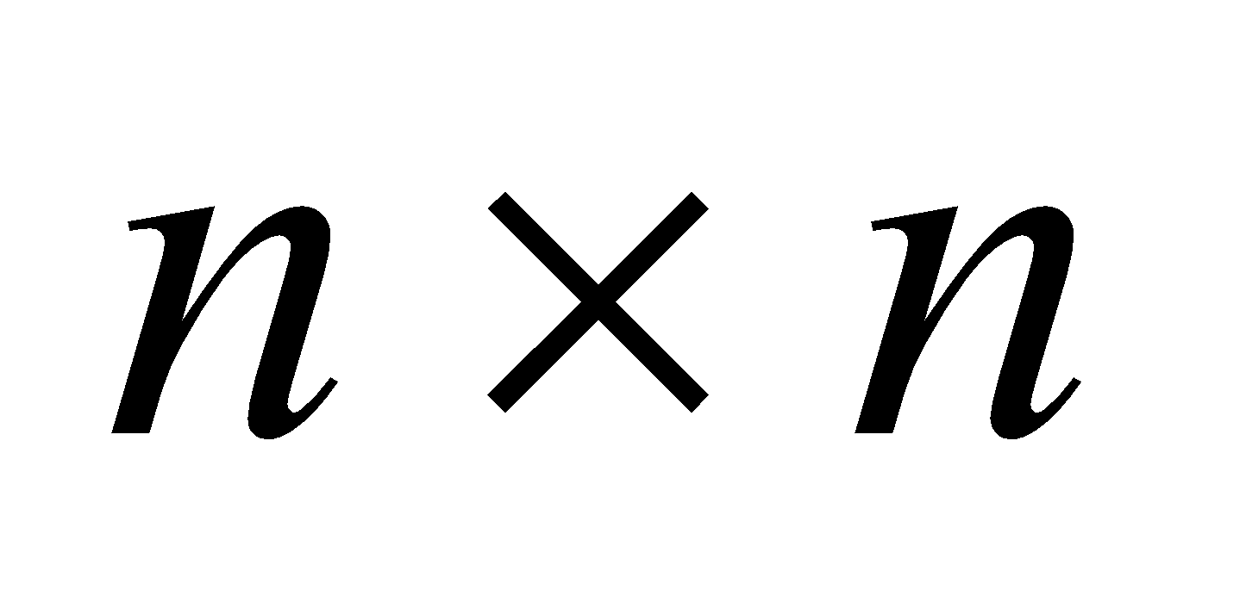 grid of resistors. It could be 6×6, but that's more than is necessary. The smallest *n*with 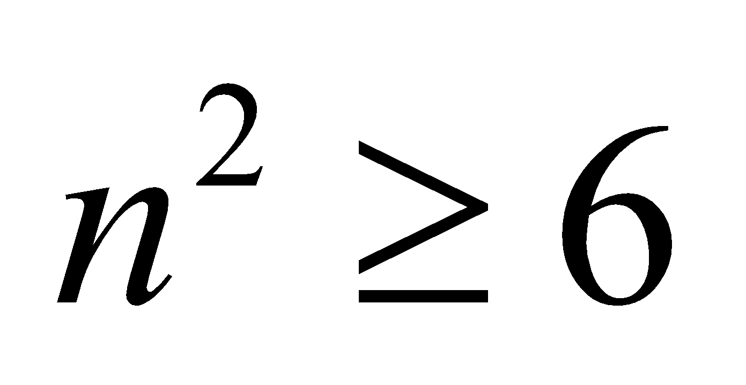 is 3. In summary, you'll need 9 resistors connected as 3 parallel branches of 3 in a series.

**Assess** The current through each of the 3 parallel branches will be 1/3 of the total current coming out of the battery: 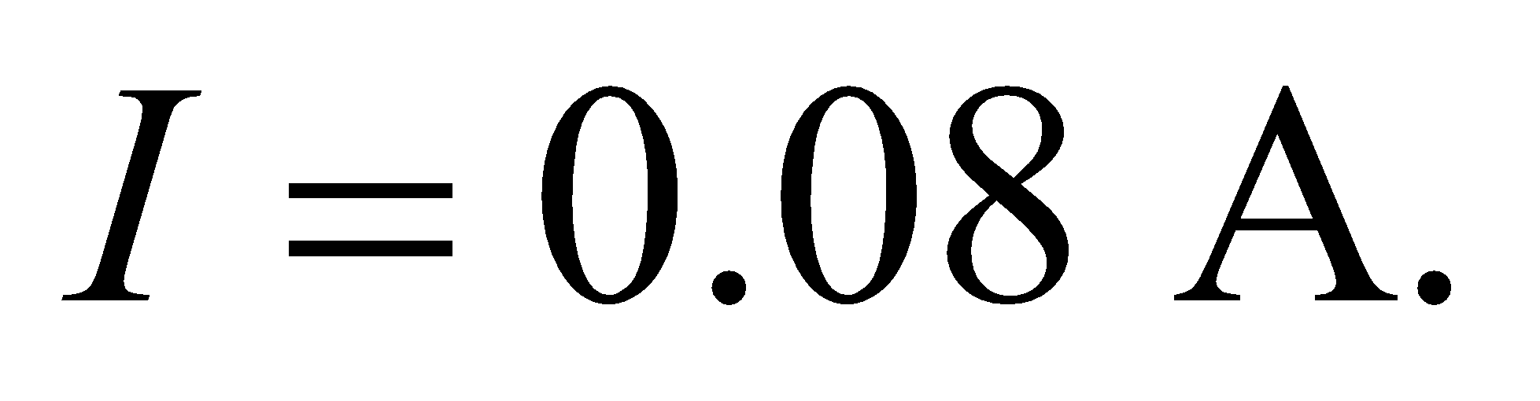 The voltage across each of the 3 resistors in series will be 1/3 of the battery's voltage: 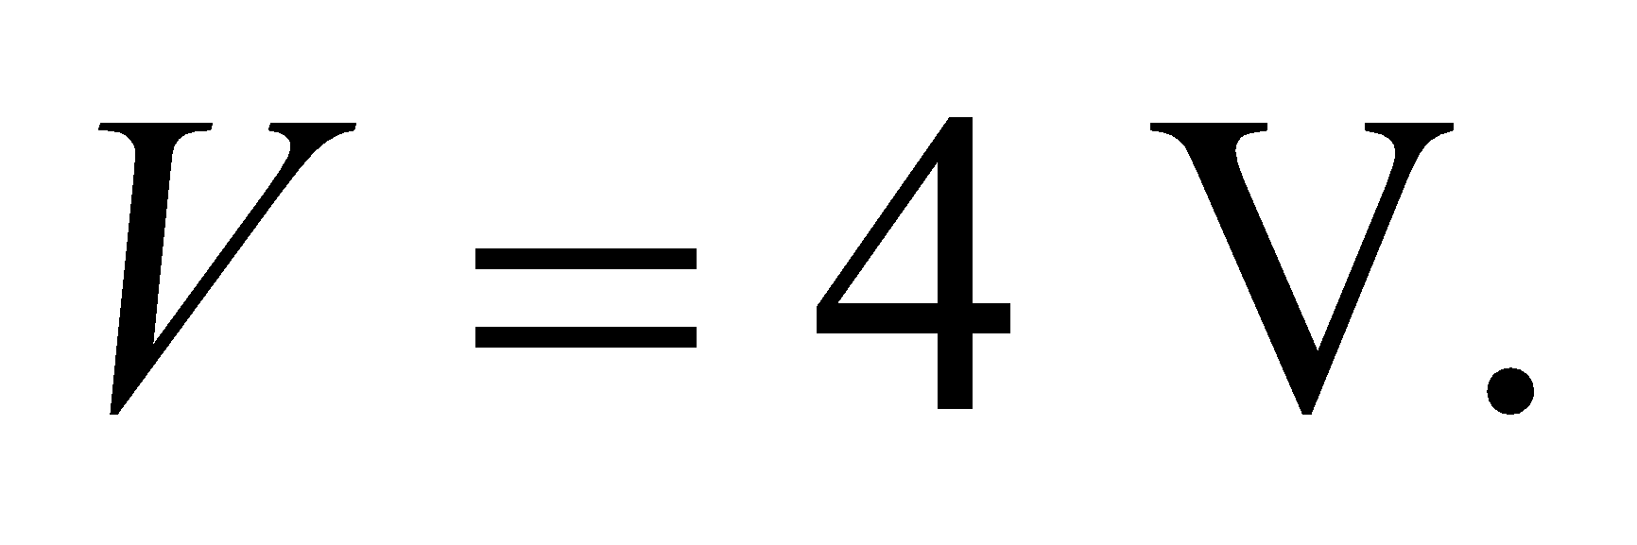 So the power dissipated by each of the 9 resistors will be 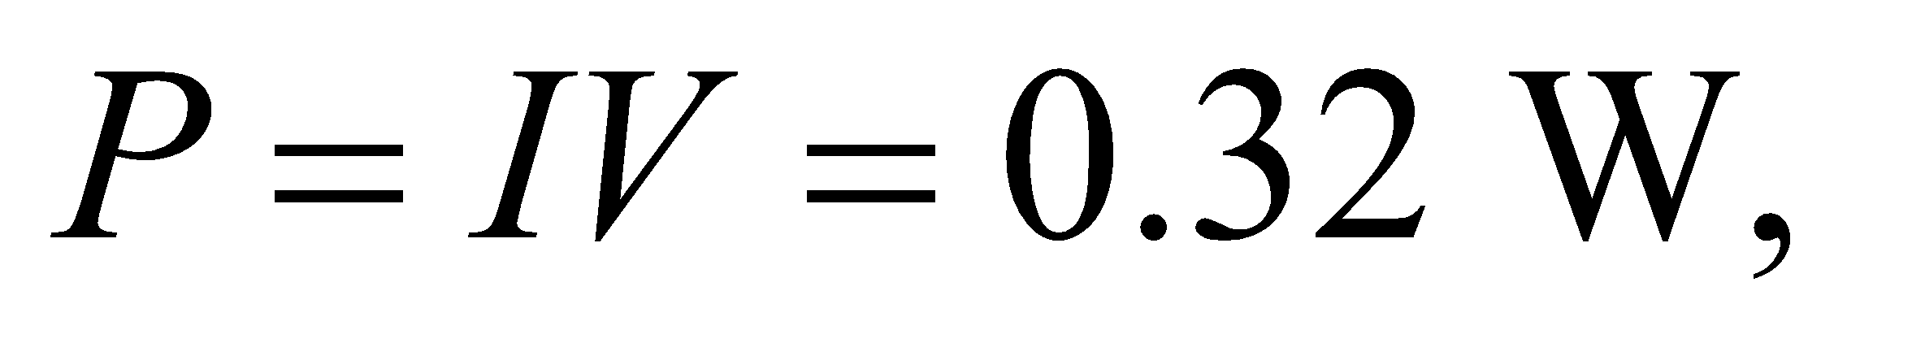which is 1/9 of the total power, as we would expect.

**41. Interpret** This problem involves finding the rate of energy dissipation in the internal resistor of a battery if the terminals are shorted (i.e., connected together with a zero-resistance connection).

**Develop** For a short-circuited battery, the macroscopic version of Ohm’s law (see Table 24.2) gives 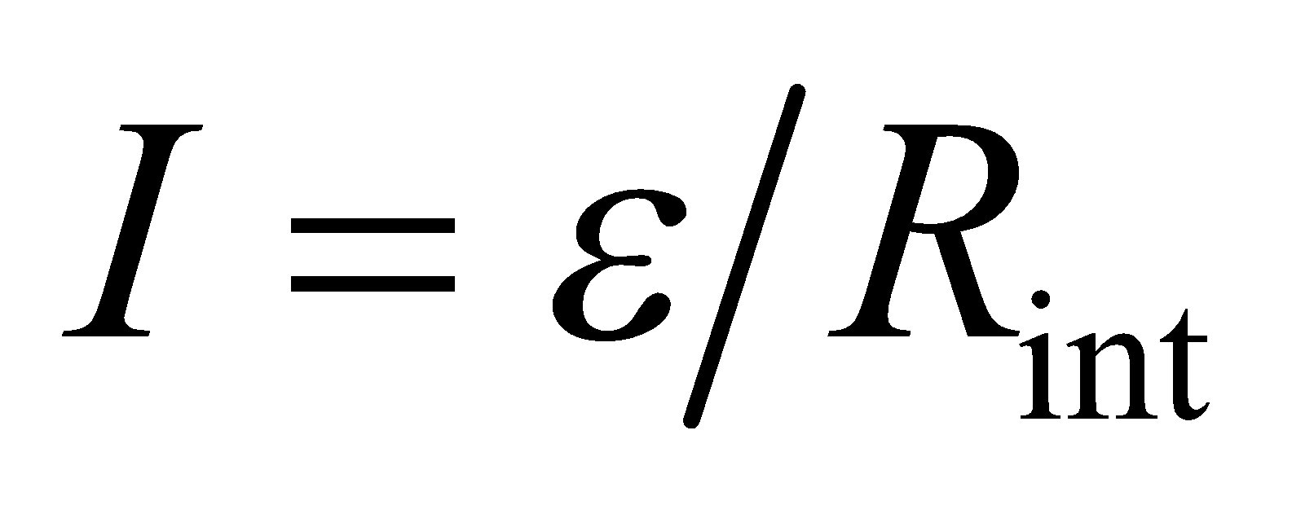, so the dissipated power is (from Equation 24.8a)

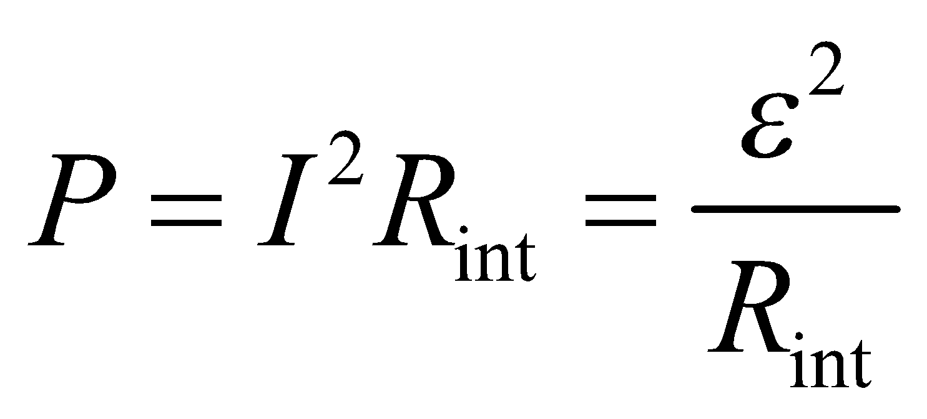

**Evaluate** Inserting the quantities given in the problem, the rate of energy dissipation is

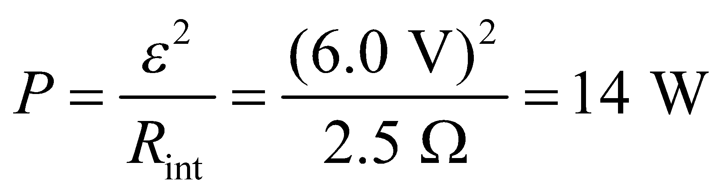

**Assess** With  held fixed at 6.0 V, we see that the power dissipated is inversely proportional to the internal resistance 

**42.** **Interpret** For this problem, we are to find the current that flows through a number of 100-W light bulbs connected in parallel to find the maximum number of light bulbs we can connect with exceeding the 20-A limit set by the circuit breaker.

**Develop** The circuit breaker is activated if 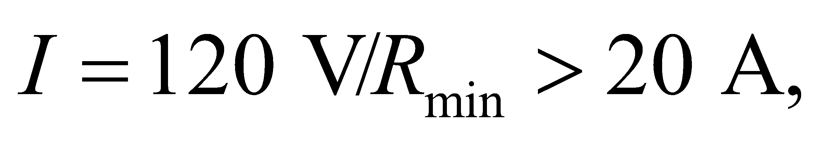 or if . From Equation 24.8b, the resistance of each light bulb is 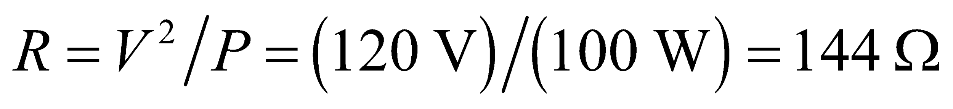, and *n* bulbs in parallel have resistance 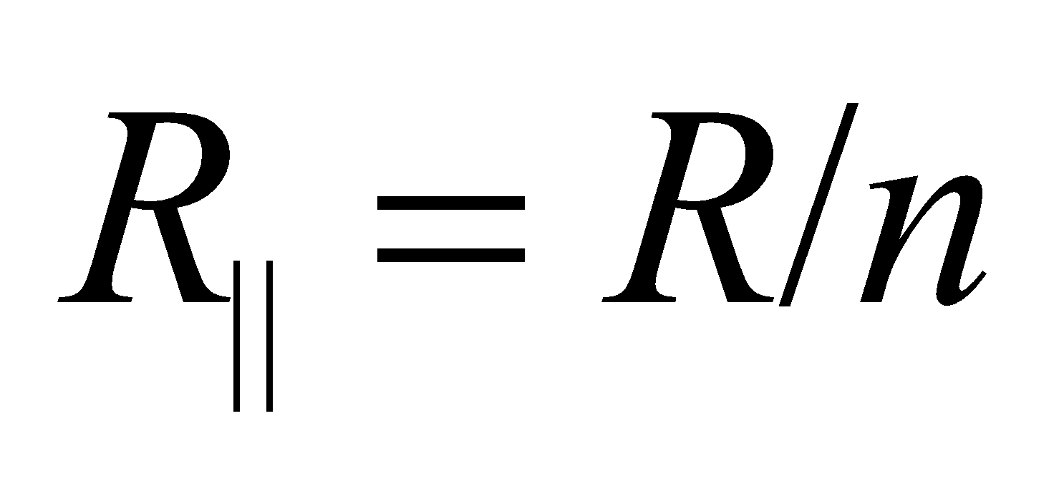, so we can solve for *n*.

**Evaluate** The condition 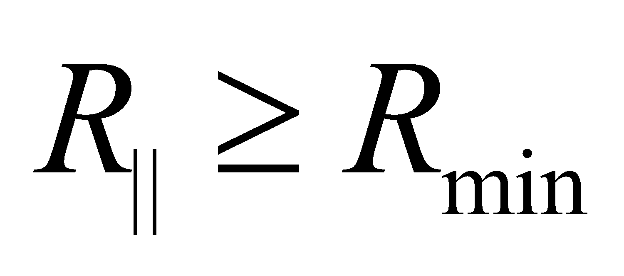 implies 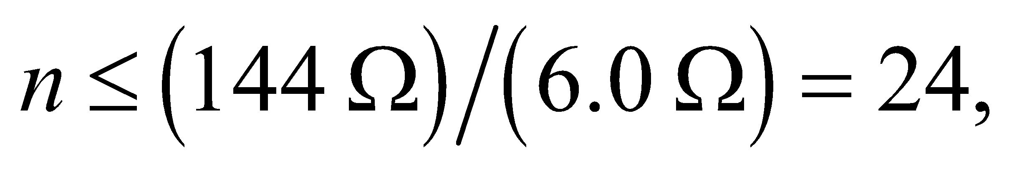 so more than 24 bulbs would blow the circuit.

**Assess** It is not common to attach so many bulbs on a single circuit, so this result seems reasonable.

**43.** **Interpret** To check the safety of a battery, you must determine if a lethal dose of current could potentially flow through a person who is damp or sweaty.

**Develop** The battery is not ideal. It has an internal resistance that will reduce the terminal voltage when current is flowing out of the battery. This internal resistance will be in series with the human body's resistance.

**Evaluate** The total resistance will be the sum of the internal resistance and the human body's resistance. Therefore, the current that could potentially flow through a person with wet skin touching the battery terminals is

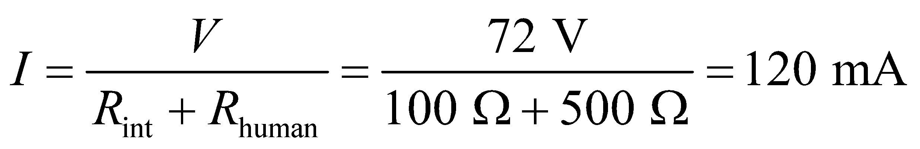

Yes, this current could be fatal.

**Assess** You'll likely need to introduce a safety feature, such as a fuse, that can prevent such a high current from flowing out of the battery.

**44.** **Interpret** This problem involves finding the voltage across a resistor in a pair of series resistors given the voltage across it, the resistance of the other resistor, and the voltage across both resistors.

**Develop** The series combination of *R*1 and *R*2 have a total resistance of *R*tot = *R*1 + *R*2, so the current passing through the circuit (from Ohm’s law) is *I* = *V*/*R*tot and the voltage drop across *R*2 (again using Ohm’s law) is *V*2 = *IR*2 =*VR*2/*R*tot = *VR*2/(*R*1 + *R*2).

**Evaluate** (**a**) Solving for *R*2 and inserting the given values gives

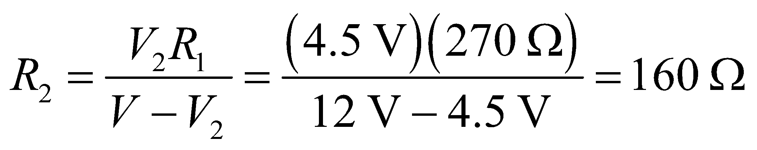

(b) Using Equation 24.8b, the power dissipated in *R*2 is

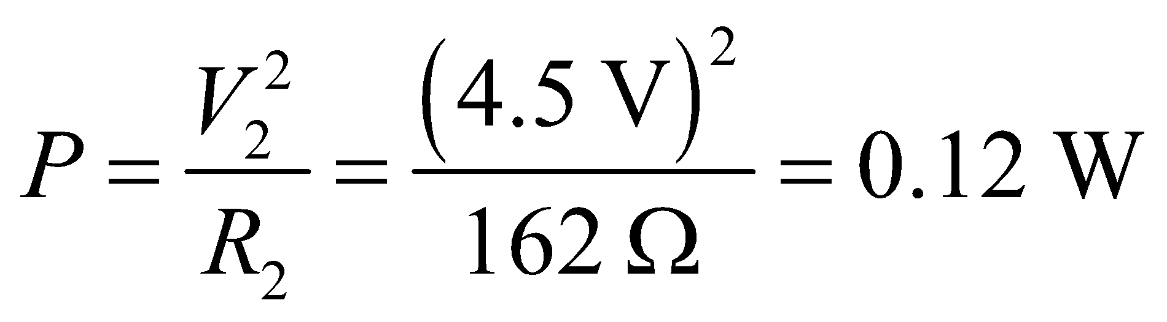

**Assess**  Notice that applying Kirchhoff’s voltage law to the circuit gives the same result.

**45.** **Interpret** The circuit in this problem contains a battery—the emf source, and three resistors. We want to analyze the voltage across the one which is a variable resistor.

**Develop** The resistors in parallel have an equivalent resistance of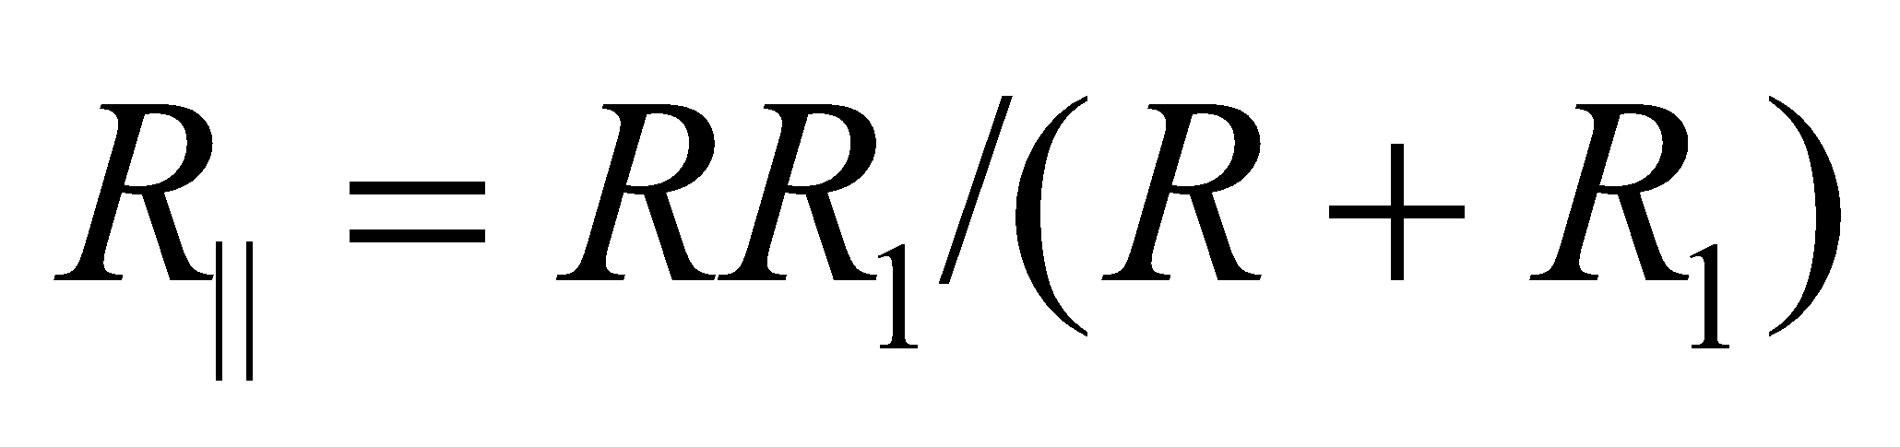 from Equation 25.3b. The other *R*, and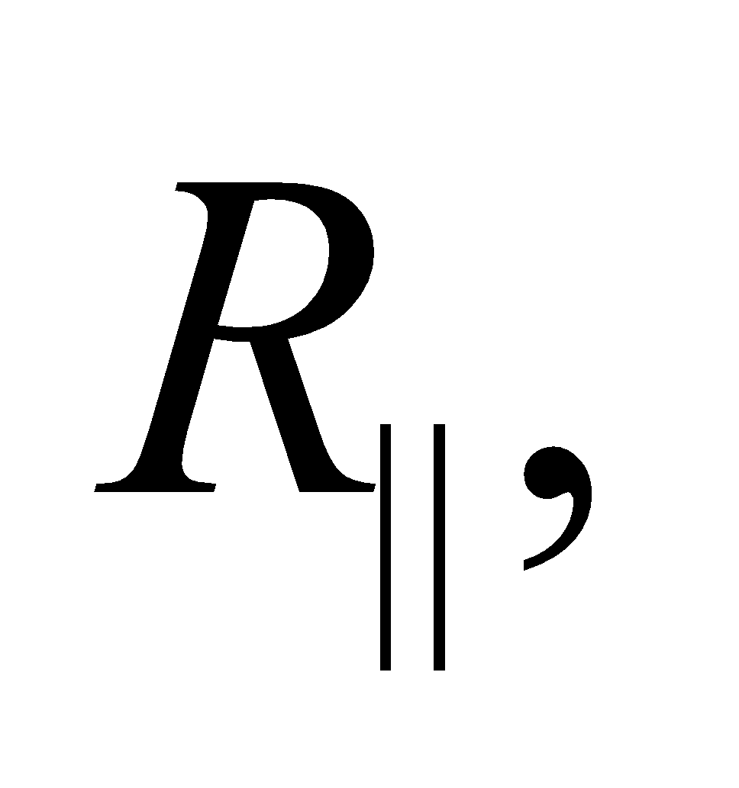is a voltage divider in series with voltage 

**Evaluate**  (a) Using Equation 25.2, we find the voltage acrossto be

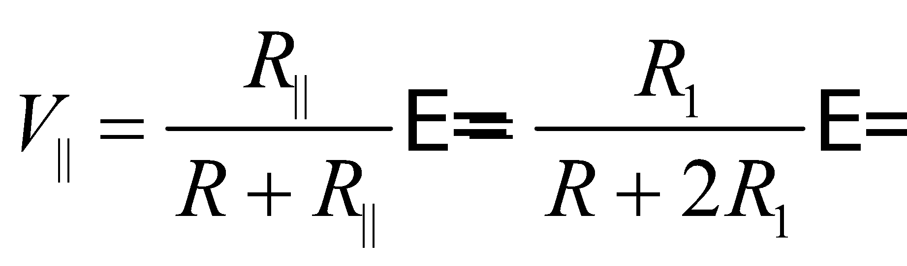

(b) The voltage across  is sketched below.



**Assess** As 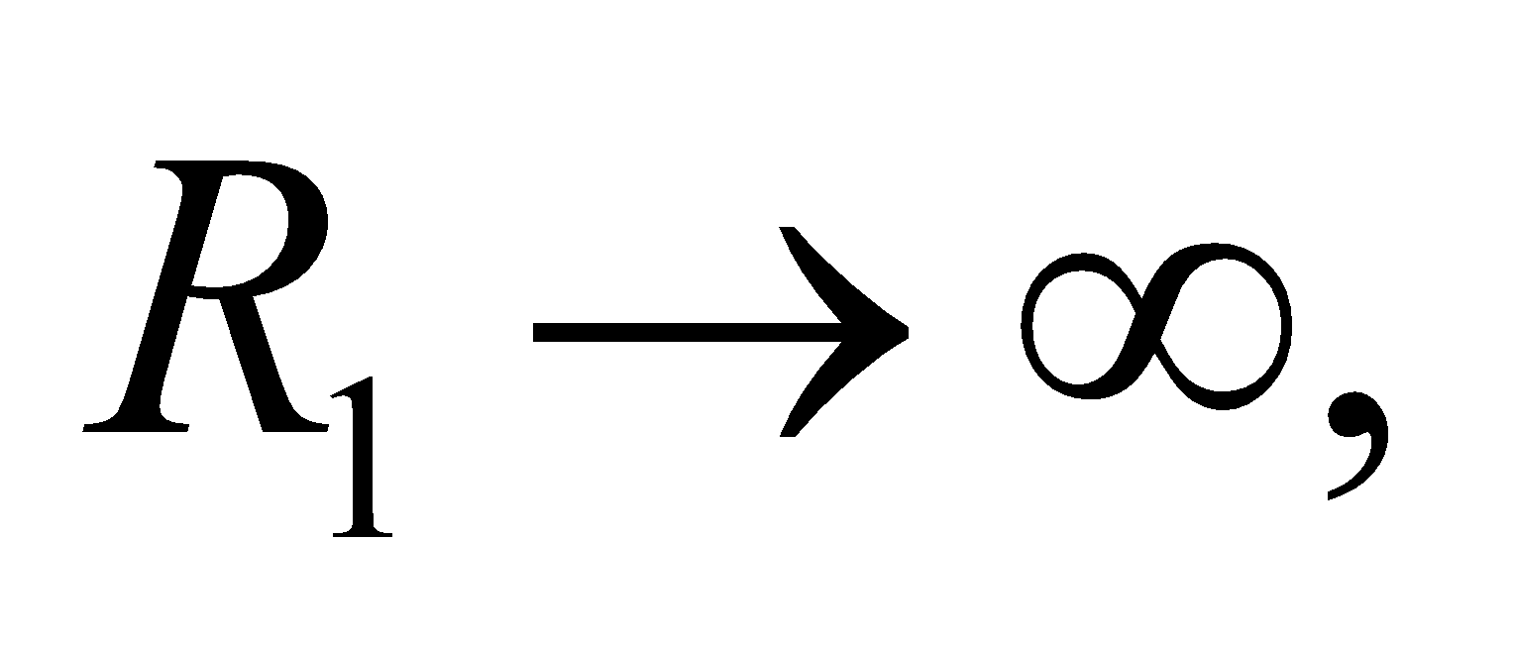the voltage across  goes to 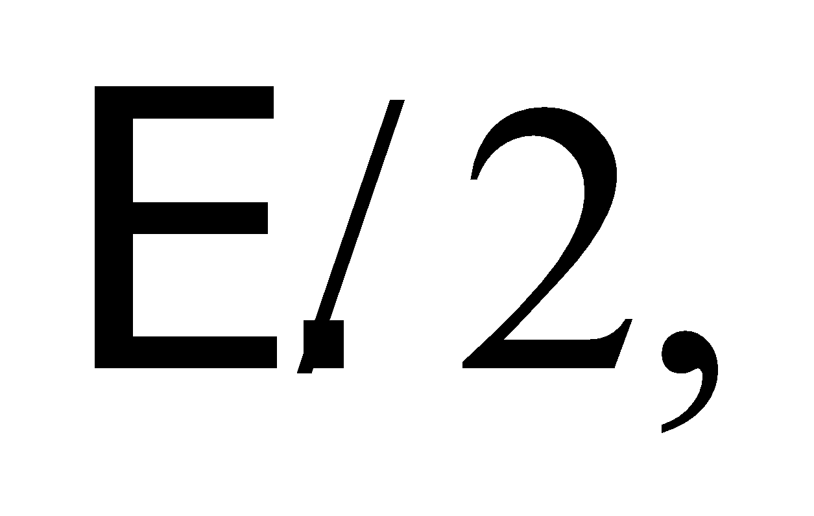 which is what the voltage would be if there were only two equal resistors in series.

**46.** **Interpret** We are given a purely resistive circuit consisting of three resistors in parallel combined in series with a single resistor and are to find the current through the battery and the current through the 6-Ω resistor.

**Develop** Label the resistors as shown below. The current supplied by the battery may be found using Ohm’s law, *V* = *IR*tot, where *R*tot is



where we have used Equation 25.1 and 25.3a to find the total resistance. The voltage drop across all three resistors in parallel is 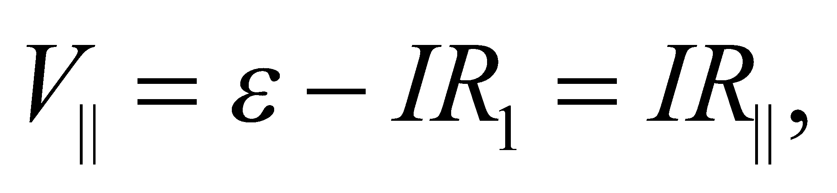 so the current through the 6-Ω resistor can be found using Ohm’s law.



**Evaluate** (a) The current through the battery is

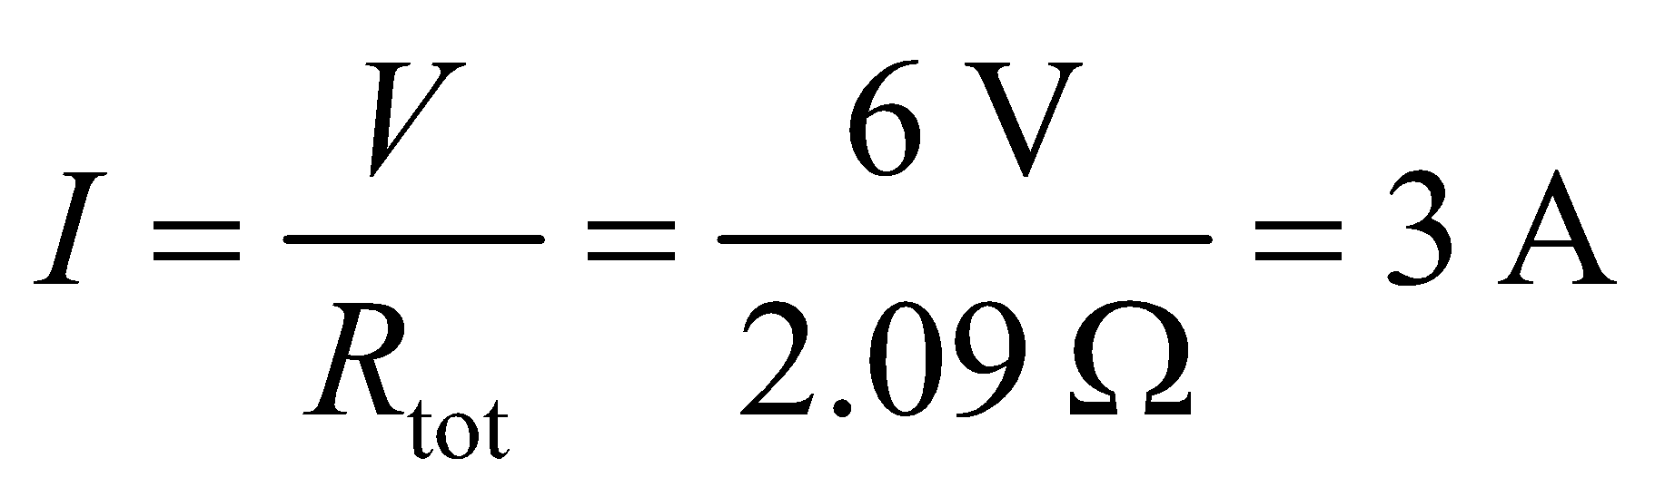

to a single significant figure.

(**b**) To a single significant figure, the current through the 6-Ω resistor is

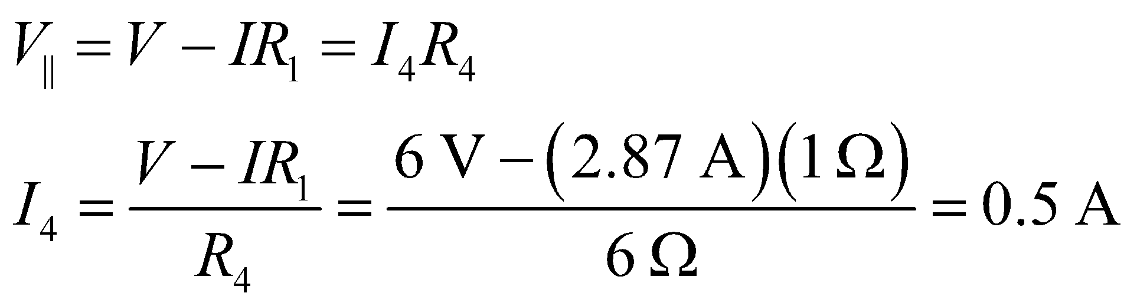

**Assess** The currents passing through *R*2 and *R*3 are

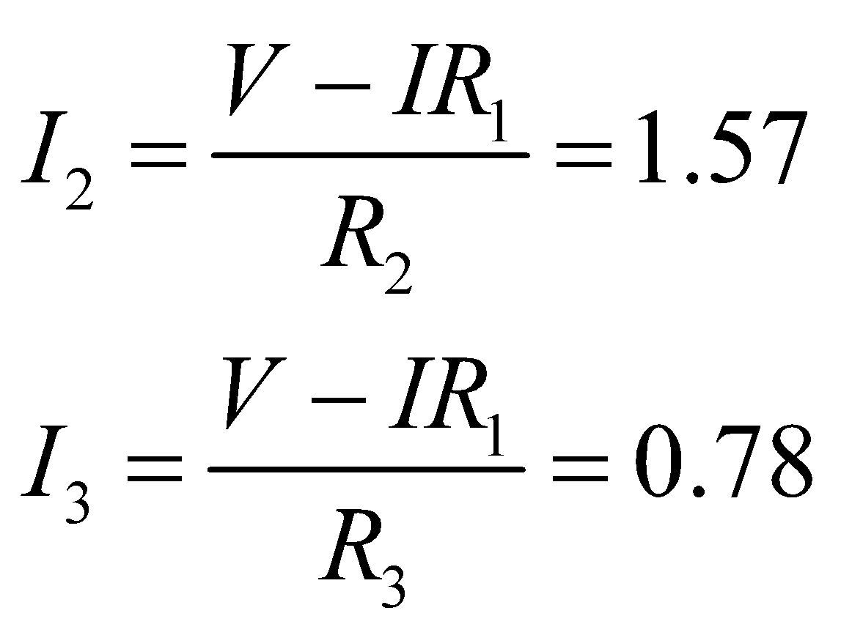

which, when summed with *I*4, give *I*, as expected. Notice that the smallest current runs through *R*4 because it is the largest of the three parallel resistors.

**47. Interpret** This problem asks for the power dissipated in a resistor that is part of a multiloop circuit.

**Develop** The three resistors in parallel have an effective resistance of

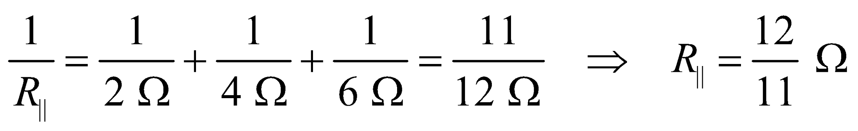

The equivalent resistance of the circuit is 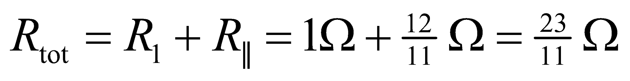. Equation 25.2 gives the voltage across them as

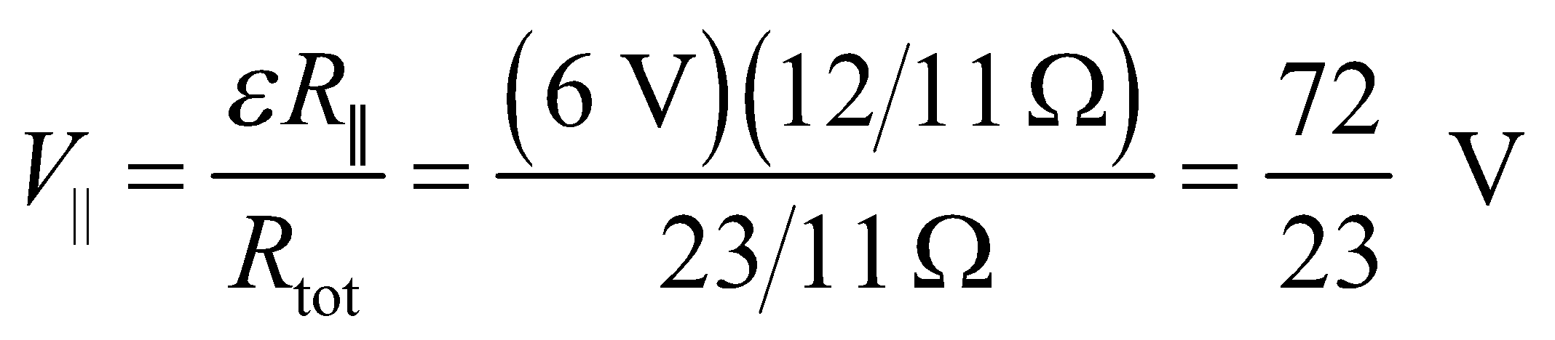

**Evaluate** Using Equation 24.8b, the power dissipated in the 4-Ω resistor is

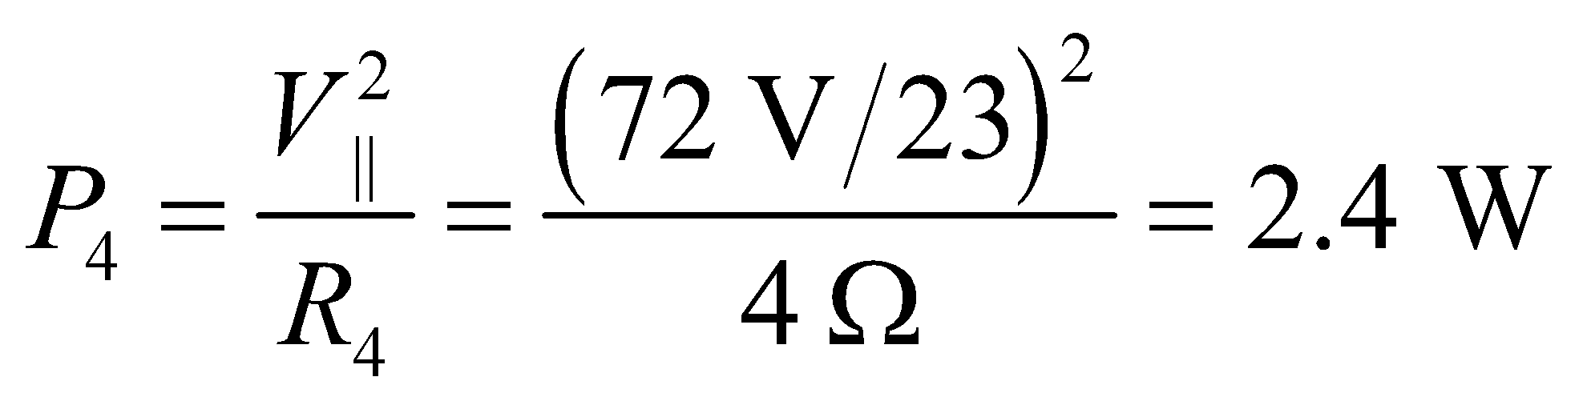

which rounds to 2 W when retaining only a single significant figure.

**Assess** With  held fixed at 6 V, we see that the power dissipated is inversely proportional to the resistance.

**48.** **Interpret** We are to find the ammeter reading when the ammeter is connected between the points of the multiloop circuit shown in the figure below.

**Develop** Make a circuit diagram and label the currents and nodes as shown below. If the ammeter has zero resistance, the potential difference across it is zero, or nodes *C* and *D* are at equal potentials. If *I* is the current through the battery, 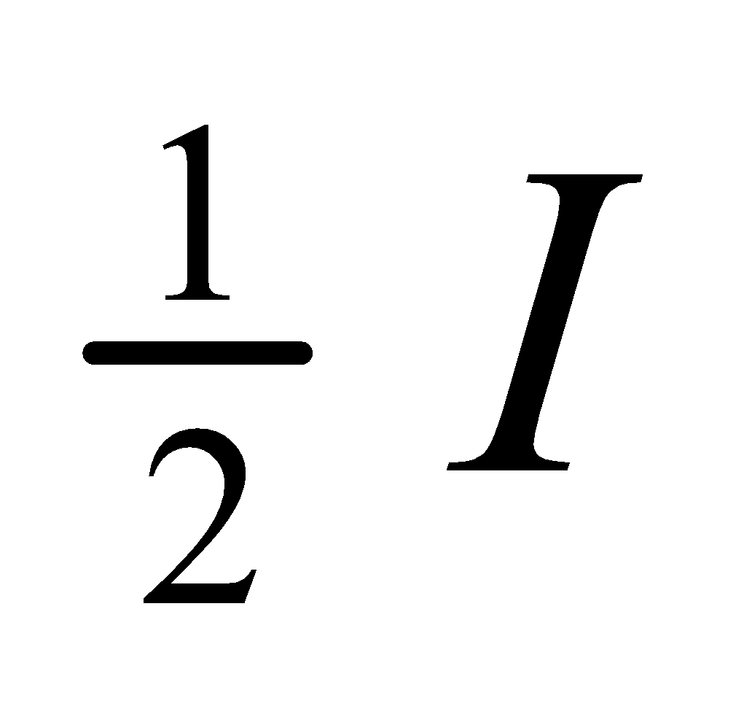 must go through each of the 2-Ω resistors connected at node *A* (Kirchhoff’s current law), because the potential drop across them is the same. At node *B*, the 2-*Ω* resistor accepts twice the current of the 4-*Ω* resistor, or 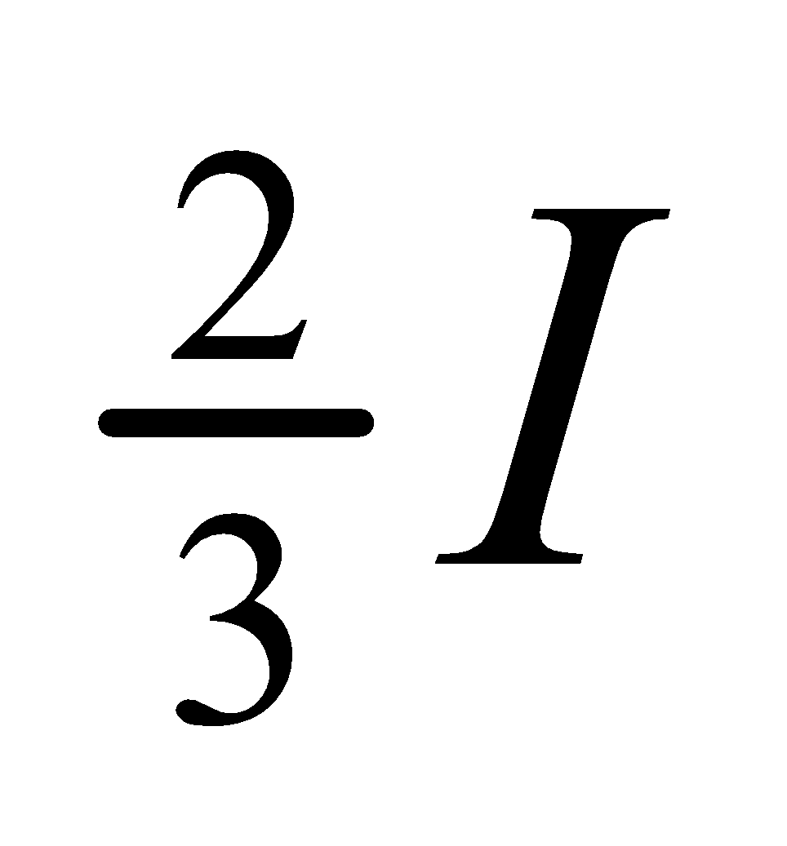 and 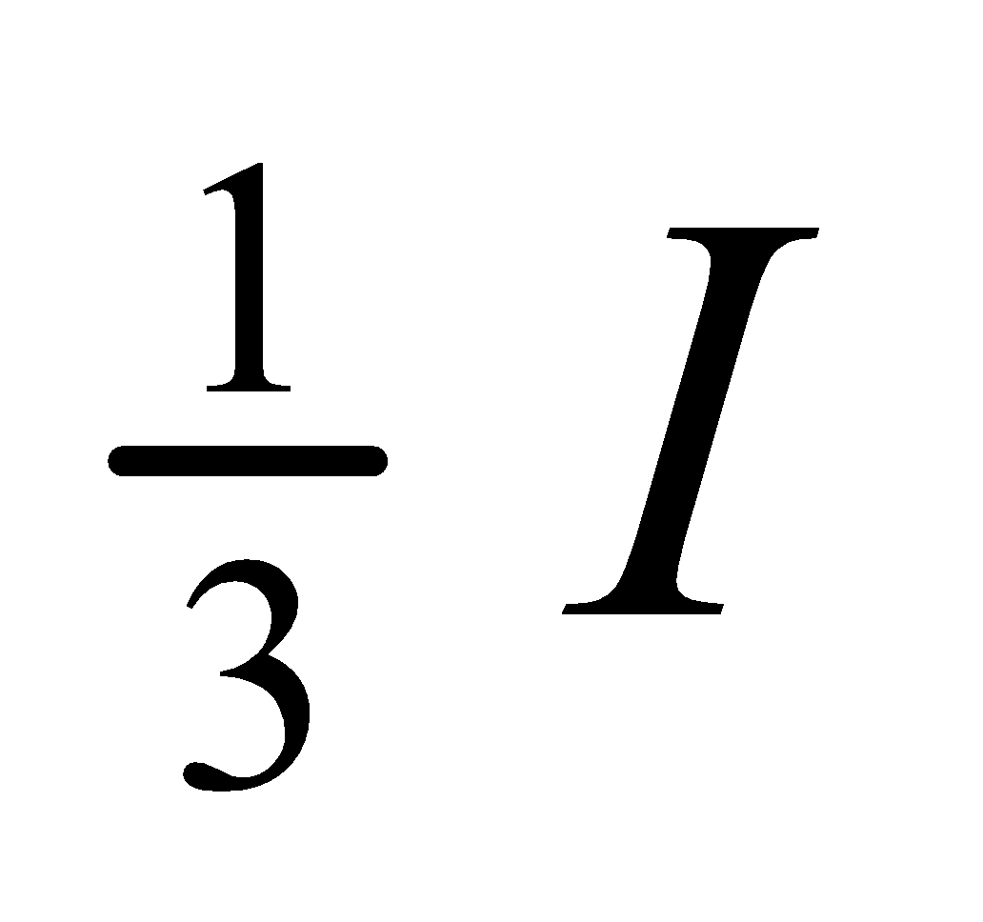, respectively (the total current coming out of node B must be *I*, by Kirchhoff’s current law). We thus know the currents *I*AC and *I*CD. By Kirchhoff’s current law, the current going through the ammeter must be the difference of *I*AC and *I*CD, or

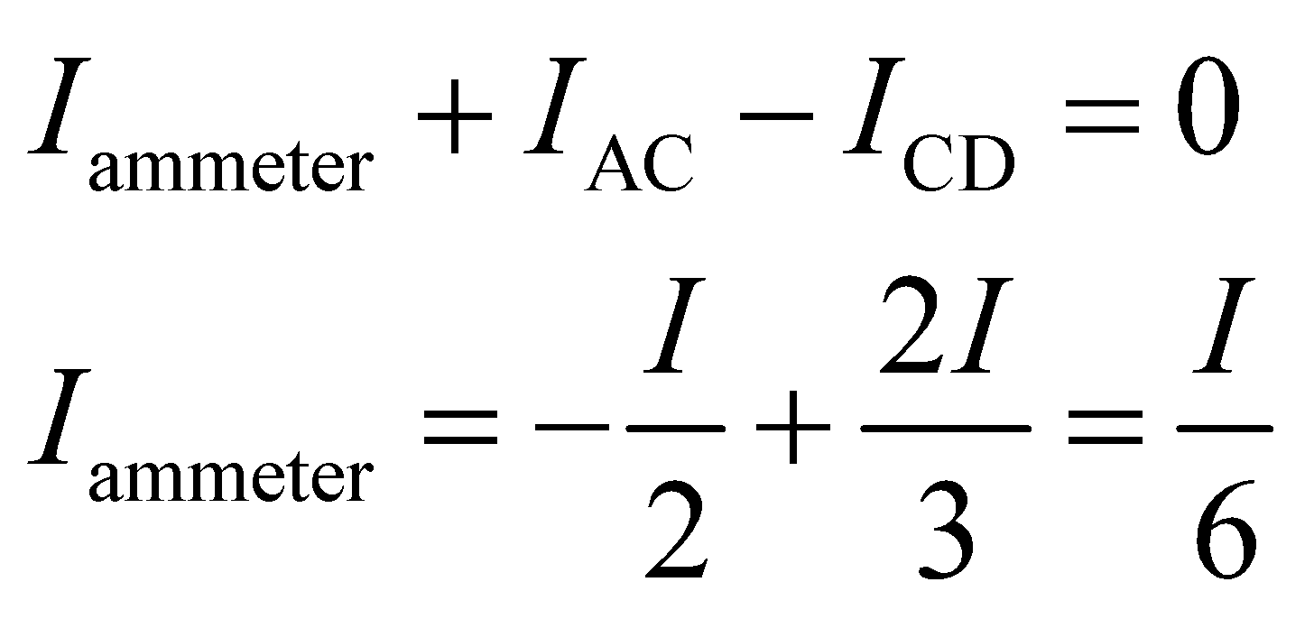

To find the value of *I*, note that the upper pair of resistors are effectively in parallel because *V*C = *V*D, as is the lower pair. The effective resistance between *A* and *B* is therefore

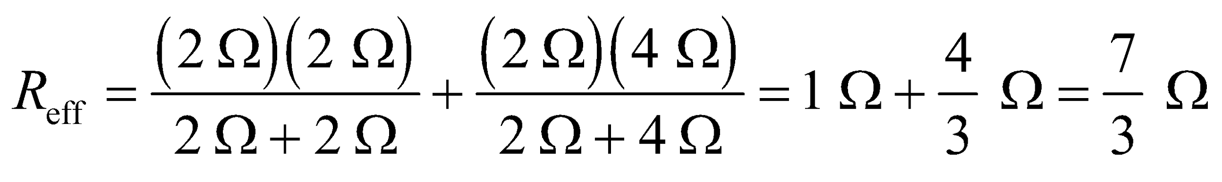



**Evaluate** Using Ohm’s law, we find that the ammeter reads

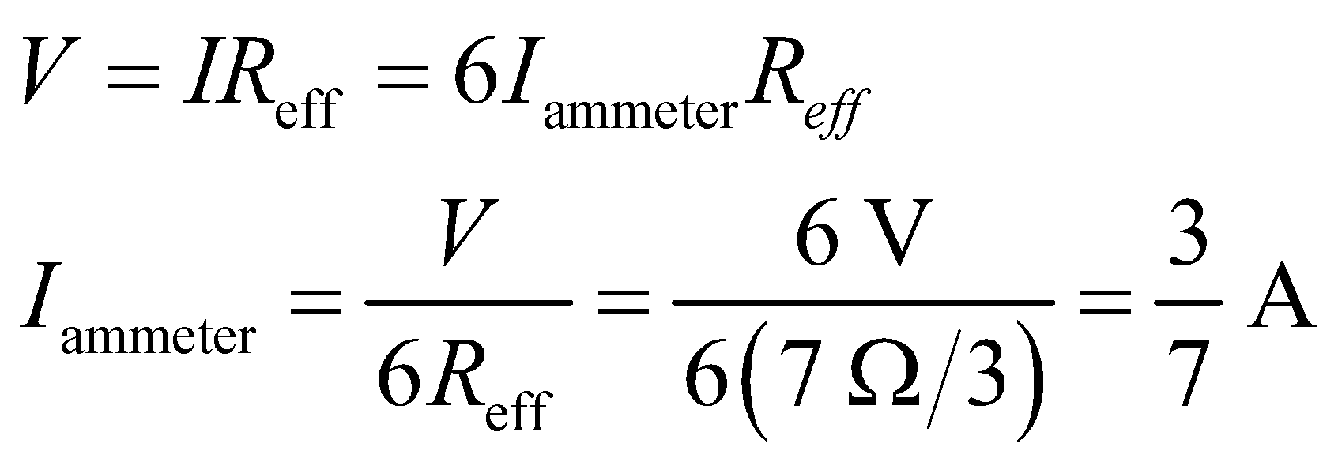

**Assess** To a single significant figure, this is 0.4 A.

**49. Interpret** The problem asks for the equivalent resistance between two points in a multiloop circuit. Make a circuit diagram and label the nodes and currents as shown below.



**Develop** The equivalent resistance is determined by the current which would flow through a pure emf if it were connected between *A* and *B* which, by Ohm’s law, is  Since *I* is but one of six branch currents, the direct solution of Kirchhoff’s circuit laws is tedious (6 × 6 determinants). However, because of the values of the resistors in Fig. 25.32, a symmetry argument greatly simplifies the calculation. The equality of the resistors on opposite sides of the square implies that the potential difference between *A* and *C* equals that between *D* and *B*:

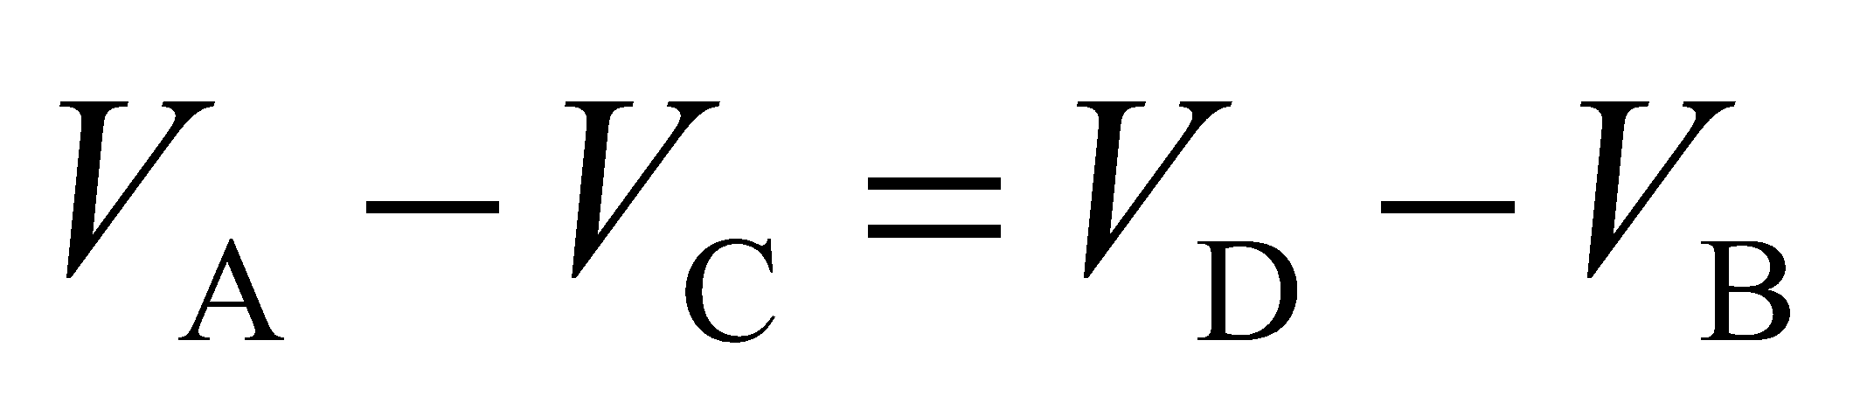

Equivalently, 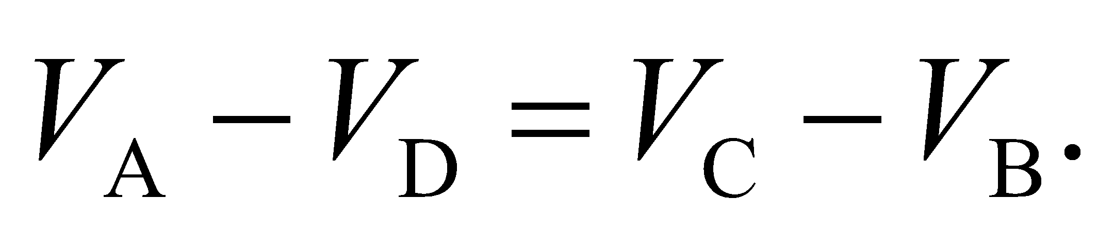 The symmetry argument requires that both *R* resistors on the perimeter carry the same current *I*1 and both 2*R* resistors carry current *I*2. Kirchhoff’s current law then implies that the current through B is *I*1 + *I*2 and the current through the central resistor is *I*1 − *I*2 (as added to Figure 25.34). Now there are only two independent branch currents, which can be found from Kirchhoff’s voltage law:

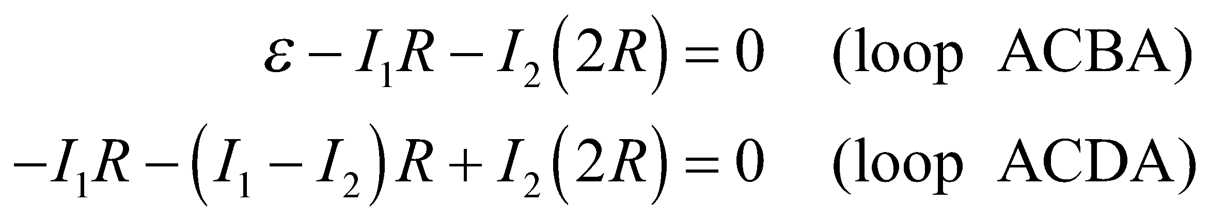

These equations may be rewritten as

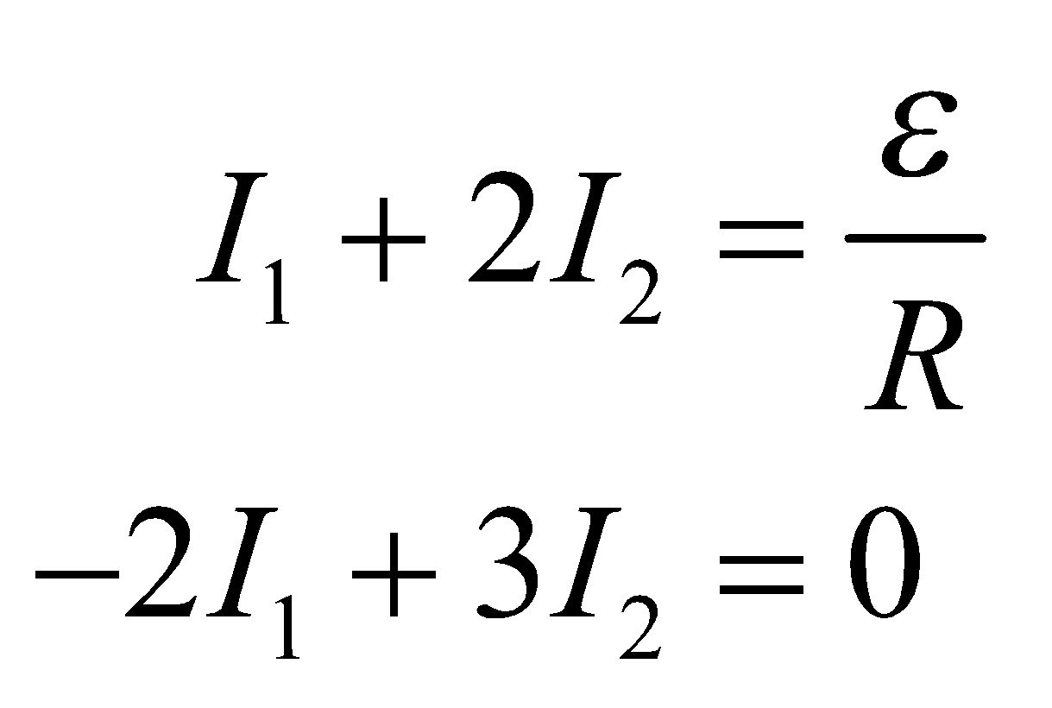

with solution 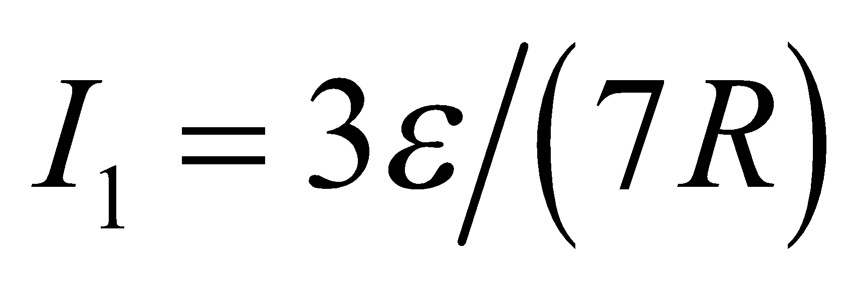 and 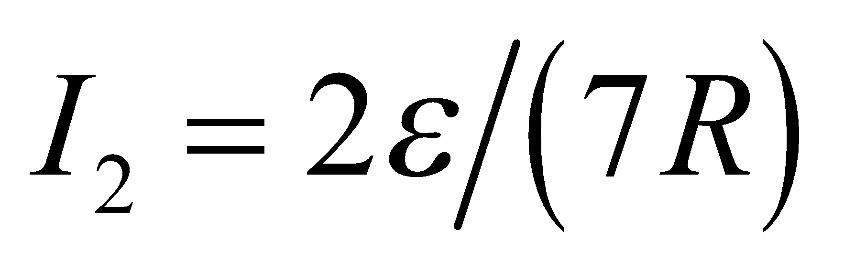.

**Evaluate** The sum of the two currents gives 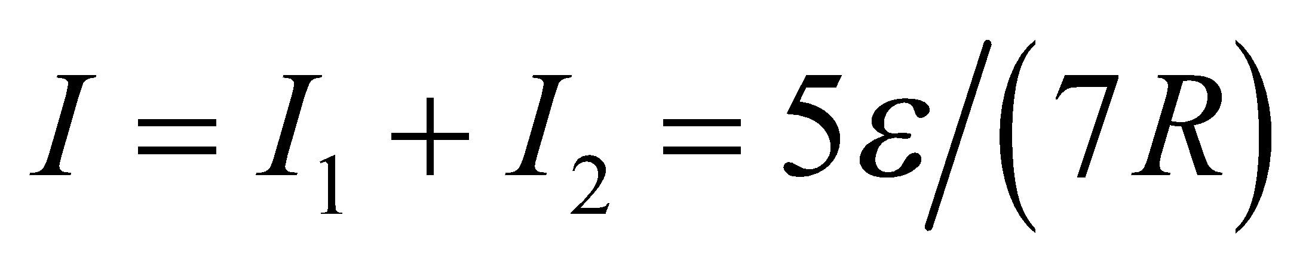 which leads to

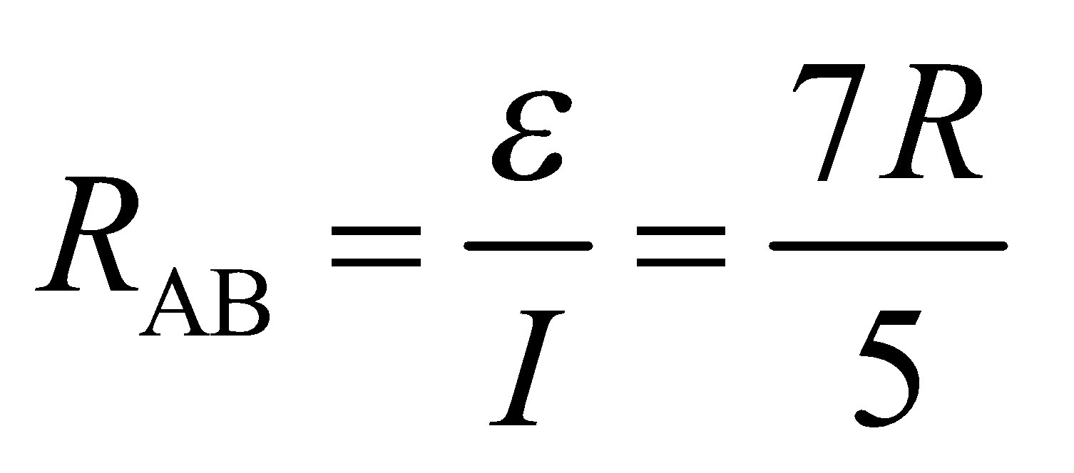

**Assess** The configuration of resistors considered here is called a Wheatstone bridge.

**50.** **Interpret** We are to find the currents through each of the three resistors in the given circuit. We will use the circuit diagram given in Example 25.4.

**Develop** The general solution of the two loop equations and the one node equation given in Example 25.4 can be found using determinants (or *I*1 and *I*2 can be found in terms of *I*3, as in Example 25.4). The equations and the solution are:



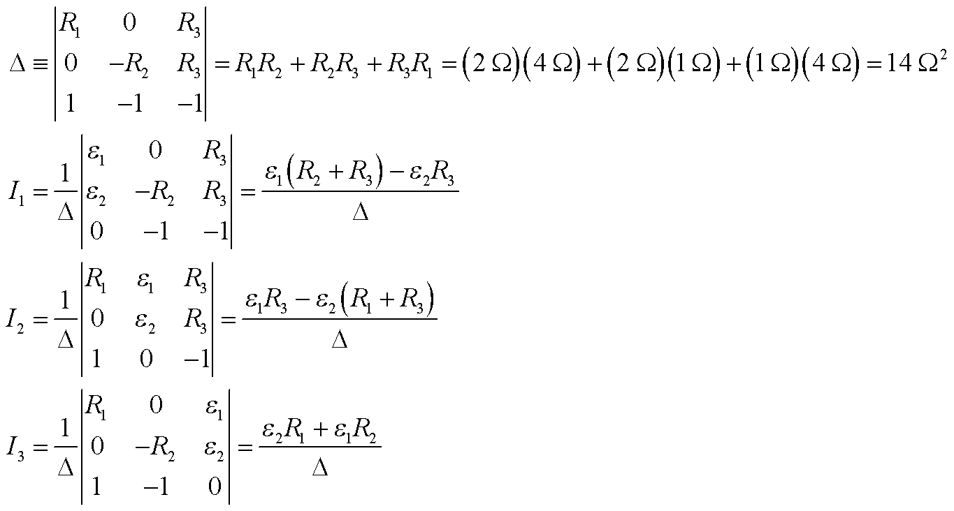

**Evaluate** Using 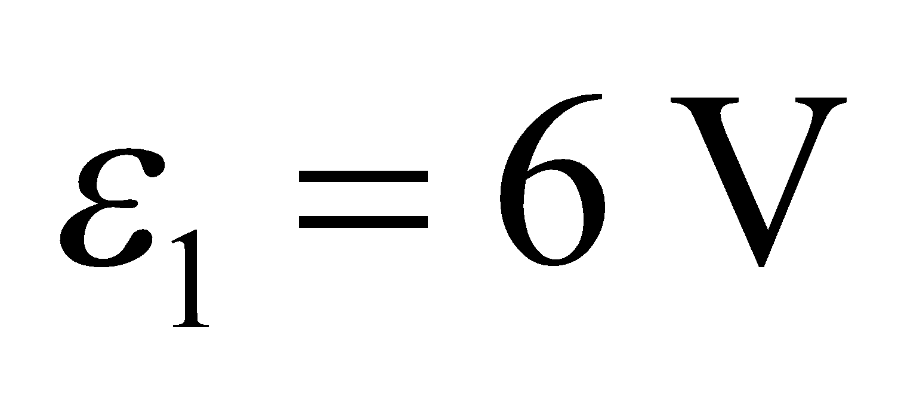 and 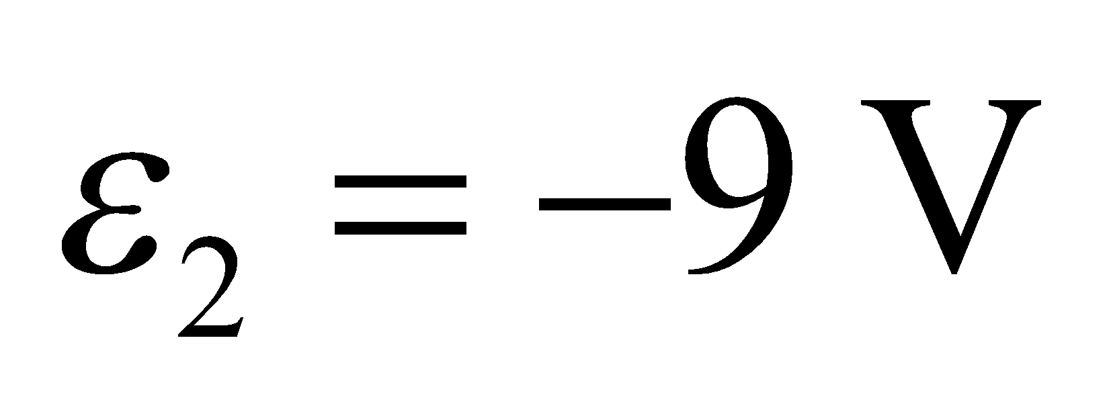, we find

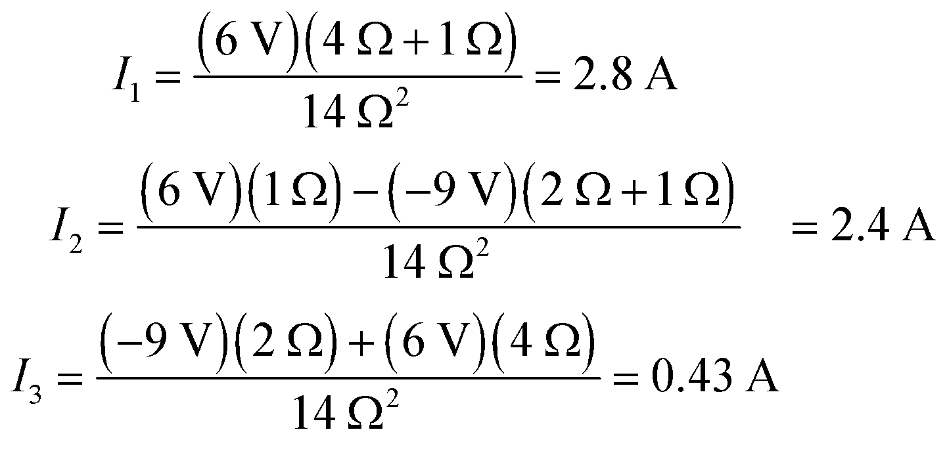

**Assess** From the signs of the currents, we know that *I*1 flows down and *I*2 and *I*3 flow up. This is expected because the polarity of 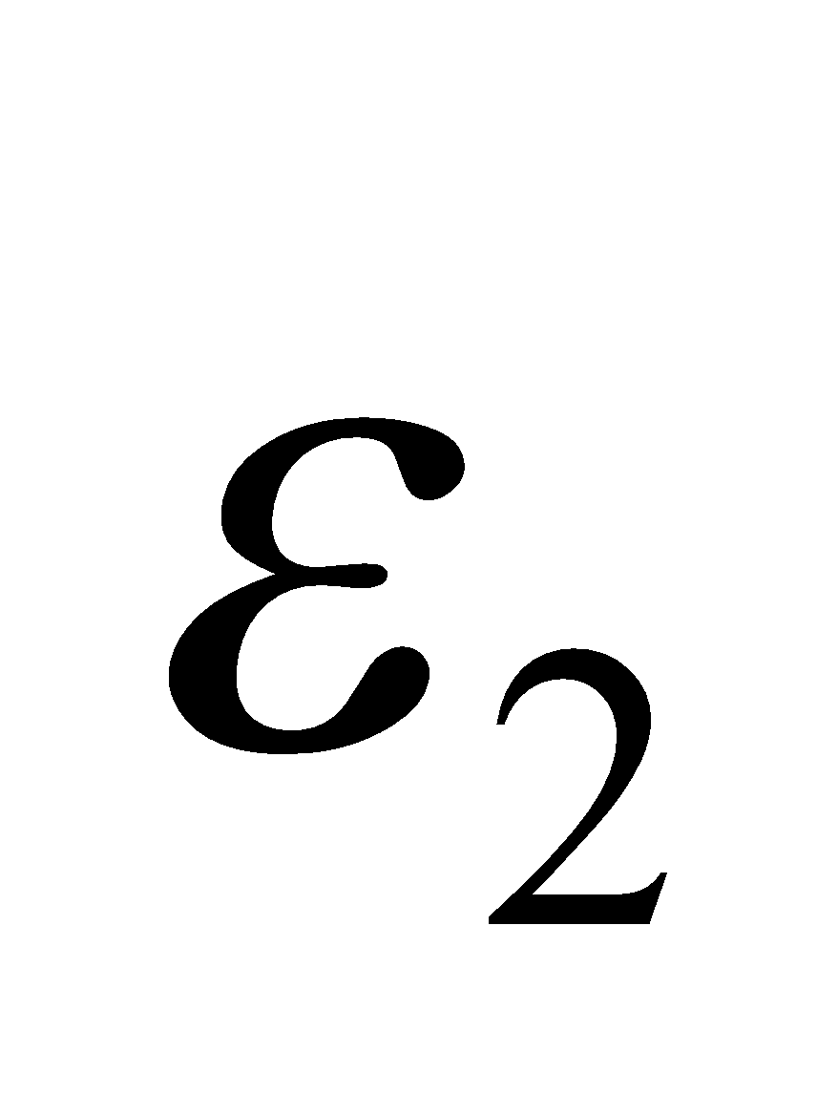 is reversed with respect to Example 25.4, so the positive terminal of 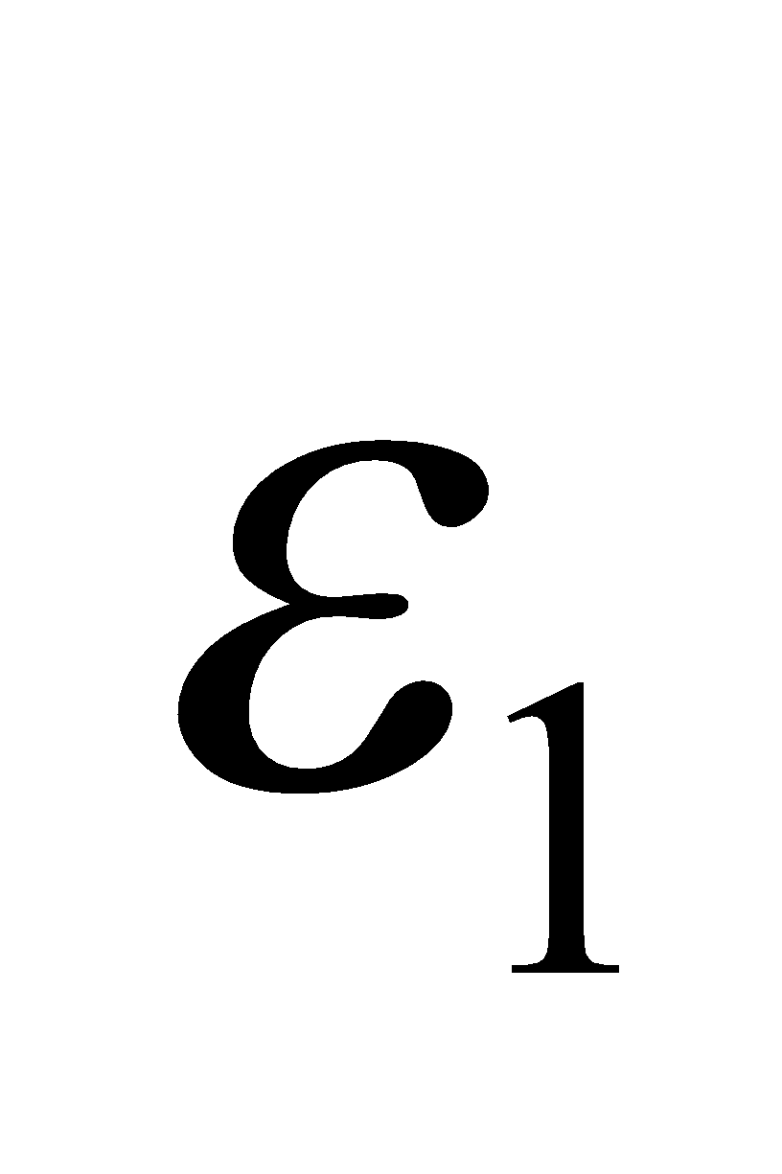 is 15-V above the negative terminal of , and the central node (above *R*3) is at 9 V with respect to the negative terminal of .

**51. Interpret** In this problem, we are to find the voltage across a given resistor as measured using a voltmeter with the given internal resistances. Because the voltmeter is connected in parallel with the 30-kΩ resistor, the voltmeter’s resistance adds in parallel to the resistor’s resistance.

**Develop** With a meter of resistance *R*m connected as indicated in the figure below, the circuit reduces to two pairs of parallel resistors in series. The total resistance is the sum of these parallel resistances (Equations 25.1 and 25.3b):

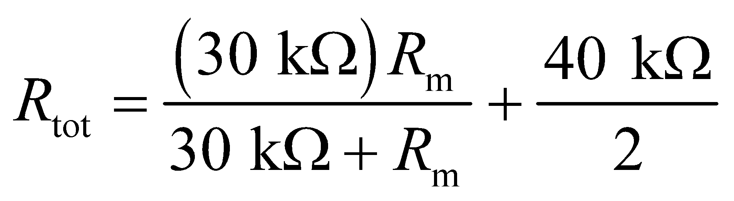

Using Ohm’s law (Chapter 24), the voltage reading is

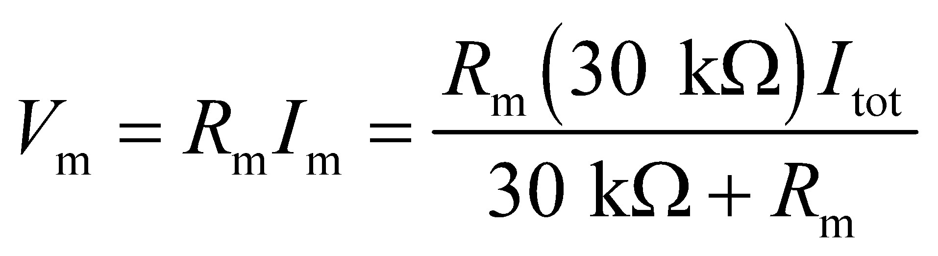

where 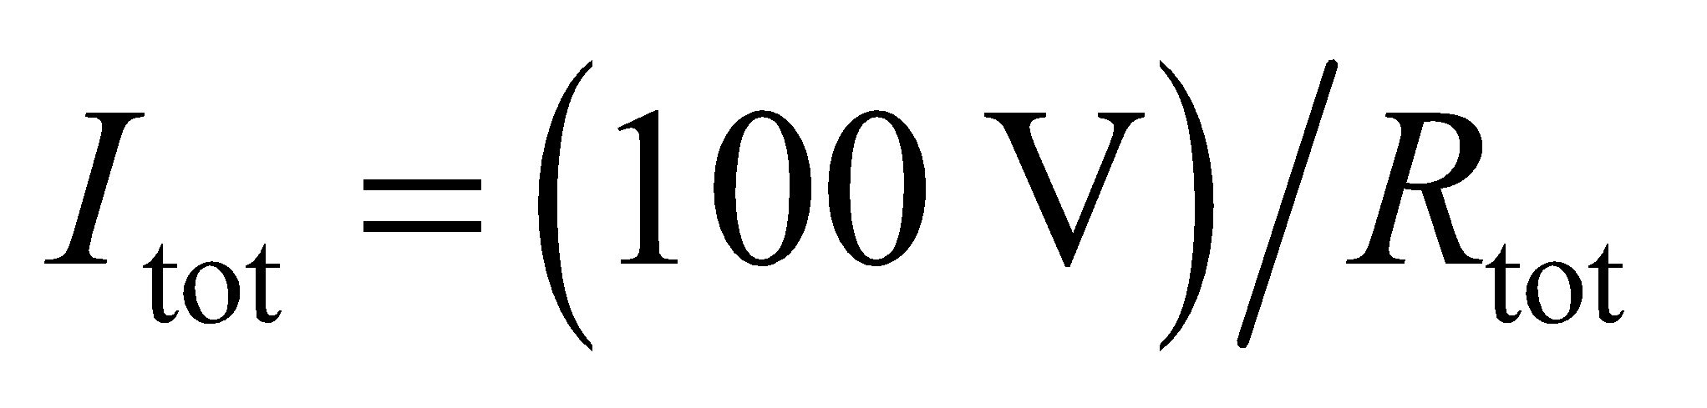 (the expression for *V*m follows from Equation 25.2, with *R*1 and *R*2 as the above pairs, or from *I*m as a fraction of *I*tot).

**Evaluate** For the three voltmeter resistances specified,  2.14 mA, and 2.00 mA, and 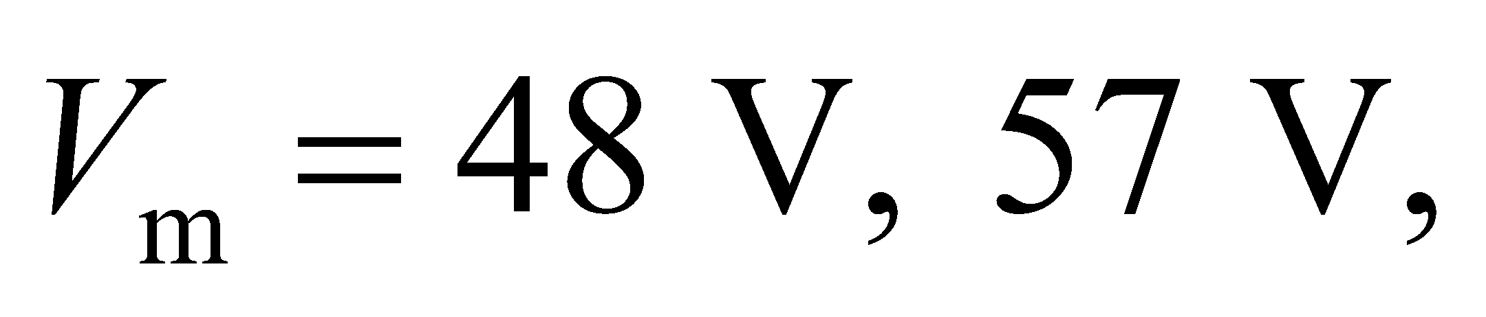 and 60 V, respectively.



**Assess** Of course, 60 V is the ideal voltmeter reading. This reading corresponds to an ideal voltmeter that has infinite resistance. Thus, to two significant figures, the 10-MΩ voltmeter is an ideal voltmeter.

**52.** **Interpret** For this problem we are to find the voltage between points A and B assuming an ideal voltmeter is used and the current from A to B assuming we connect an ideal ammeter between the two points. Recall that an ideal voltmeter has infinite resistance and an ideal ammeter has zero resistance.

**Develop** An ideal voltmeter has infinite resistance, so *AB* is still an open circuit (as shown on Figure 25.34) when such a voltmeter is connected. Thus, the meter will read the voltage across the *R*2 = 20-kΩ resistor. From Ohm’s law, the current passing through the resistors is *I* = *V*/(*R*1 +*R*2), so the voltage across *R*2 will be

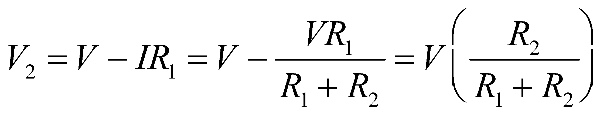

Because an ideal ammeter has zero resistance, it will measure the current through the points *A* and *B* when they are short circuited (i.e., no current flows through the 20-kΩ resistor). We can find this current by applying Ohm’s law to *R*1.

**Evaluate** (**a**) Inserting the values into the expression above, we find the voltage across R2, as measured by an ideal voltmeter, is

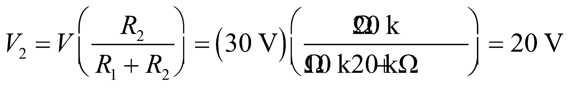

(**b**) The current passing through the ideal ammeter connected to points A and B is

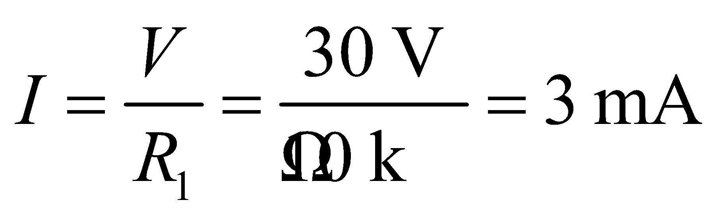

**Assess** The current found in part (b) does not pass through *R*2, because *R*2 seems like an infinite resistance compared to the zero-resistance ammeter. The current passing through *R*2 when the ammeter is not connected is

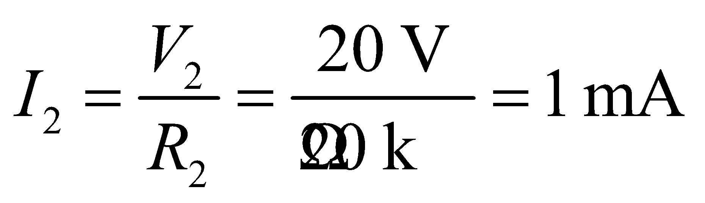

which is less than the 3 mA because *R*2 > 0.

**53.** **Interpret** In this problem an ammeter is used to measure the current in a circuit. The ammeter is connected in series with the resistor.

**Develop** The internal resistance of an ideal battery is zero, so the resistor has a value of 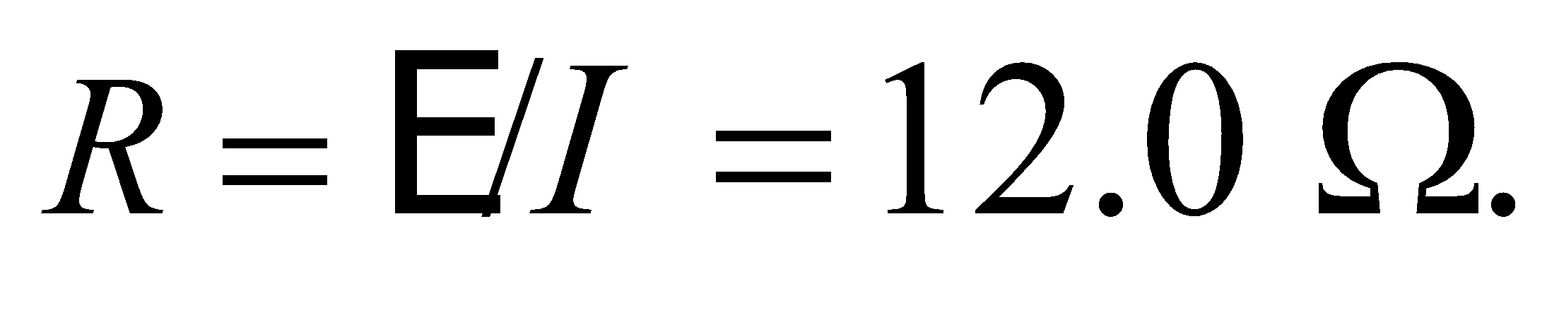With the ammeter in place, the total resistance increases, and the current through the ammeter will be

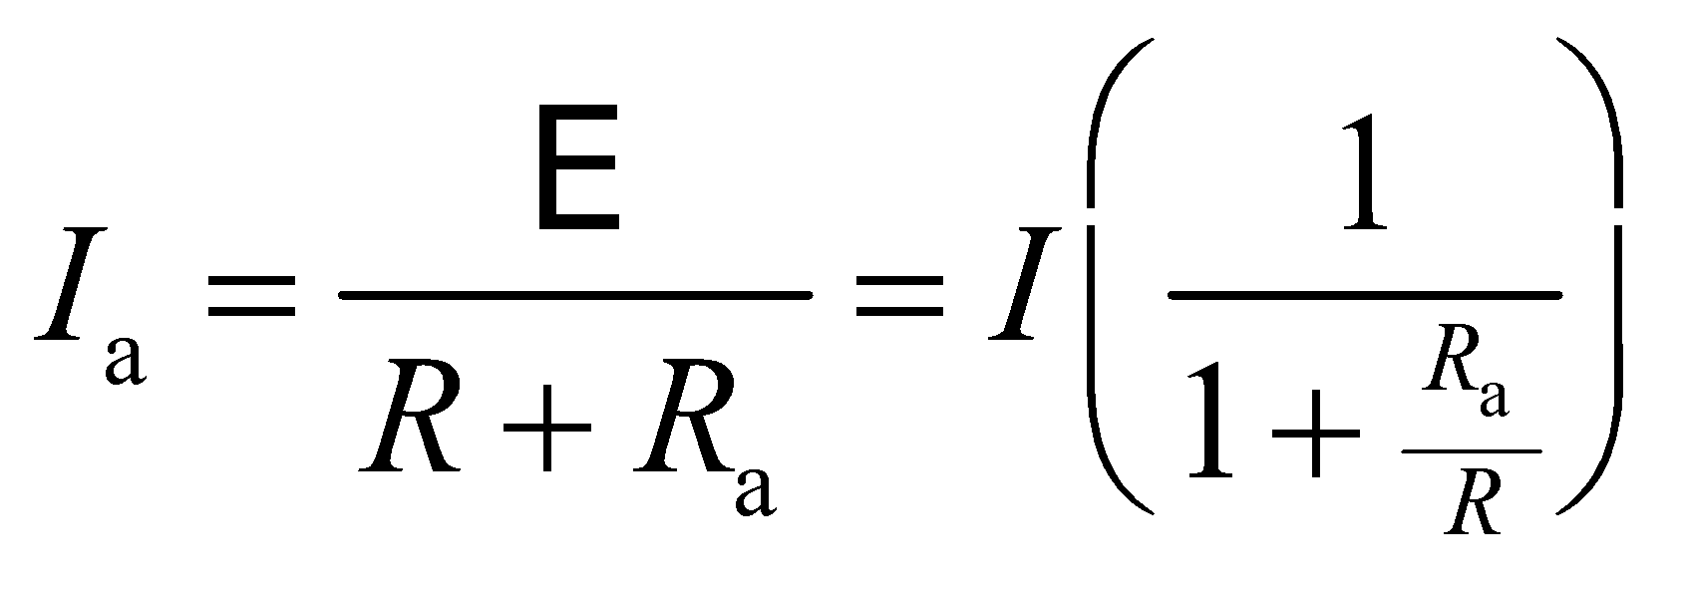

**Evaluate** (a) The ammeter will read whatever current goes through it:

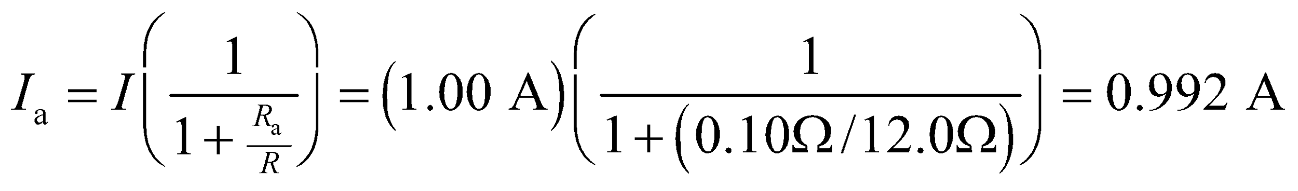

(b) If this current measurement were used to measure the resistance in the resistor, one would arrive at 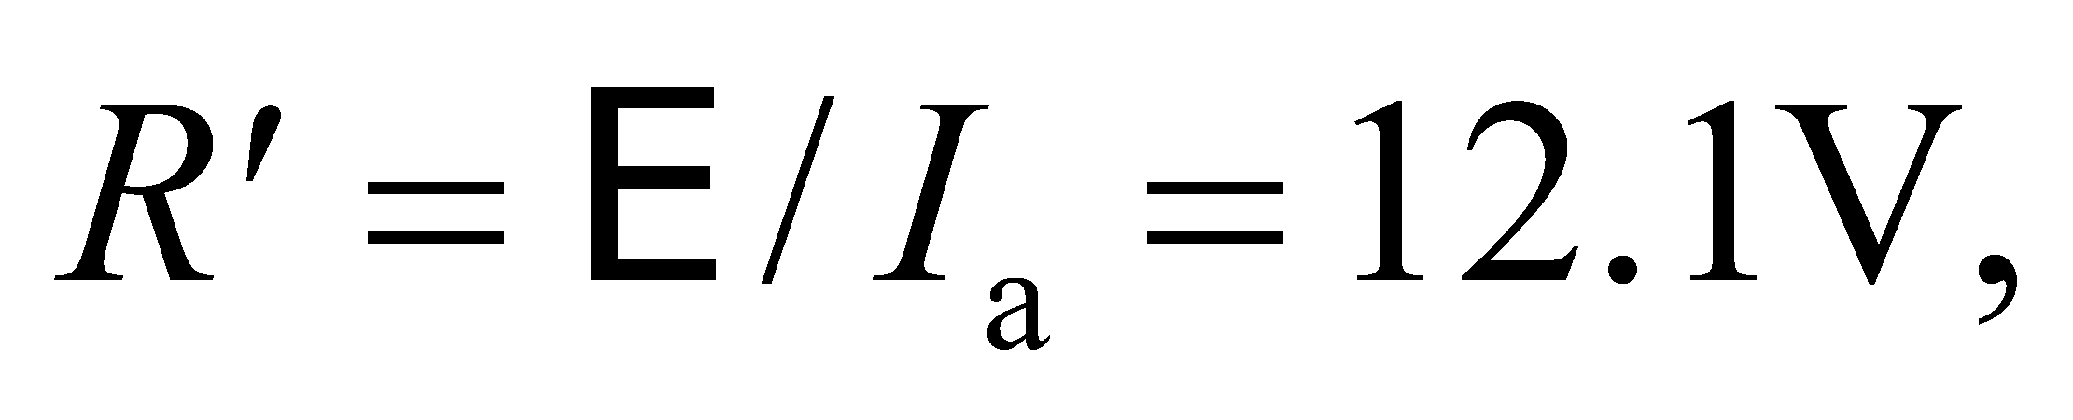which is an error of

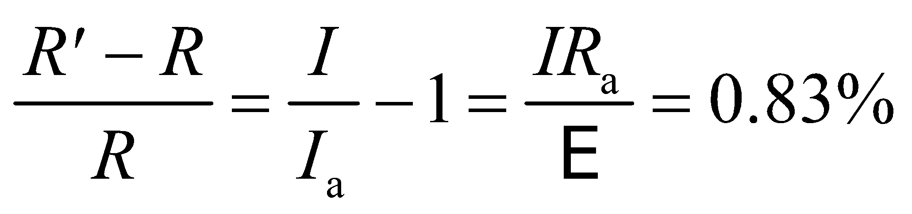

**Assess** This is a small error. If one needed better accuracy, one could calculate the resistance in the resistor by accounting for the resistance in the ammeter.

**54.** **Interpret** This problem involves an *RC* circuit, as shown in Figure 25.18. We are to find the time required for the voltage across the capacitor to reach the given value, given the RC time constant. In addition, we are to find the capacitance given the resistance of the circuit.

**Develop** Equation 25.6 gives the voltage as a function of time for a charging capacitor. Given that the capacitor voltage at *t* = 5 ms is *V*(*t* = 5 ms) = *ε*(1 − 1/*e*), we can write

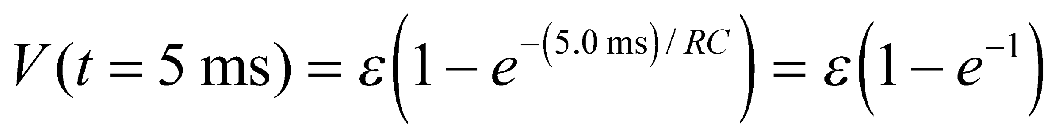

which tells us that (5.0 ms)/(*RC*) = 1, or *RC* = 5.0 ms. This allows us to find the time at which *V*(*t*) = *ε*(1 − *e*−3). To find the capacitance, we use the same result (*RC* = 5.0 ms) and insert *R* = 22 kW.

**Evaluate** (a) When *V*(*t*) = *ε*(1 − *e*−3) = *ε*(1 − *e*−*t*/*RC*), we have *t*/*RC* = 3, or *t* = 3*RC* = 3(5.0 ms) = 15 ms.

(b) For *R* = 22 kΩ, *C* = (5.0 ms)/(22 kW) = 0.23 μF.

**Assess** Thus, at 5.0 ms, the capacitor is 1 − *e*−1 = 63% charged, whereas at 15 ms, the capacitor is 1 − *e*−3 = 95% charged.

**55.** **Interpret** You need to design a defibrillator that meets the desired discharge time. This is essentially an *RC* circuit, where the resistor is the human chest.

**Develop** The defibrillator specs call capacitor to discharge to half its initial voltage in 10 ms. In terms of Equation 25.8, this implies: 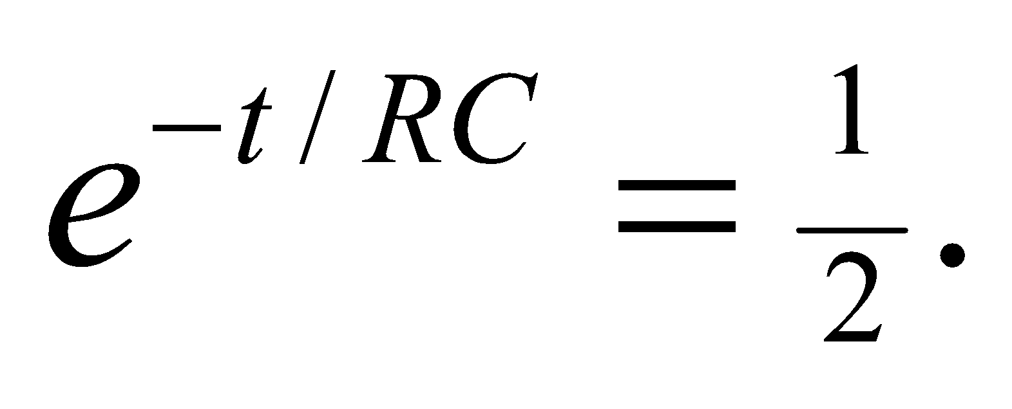You can figure out the initial voltage using Equation 23.3: 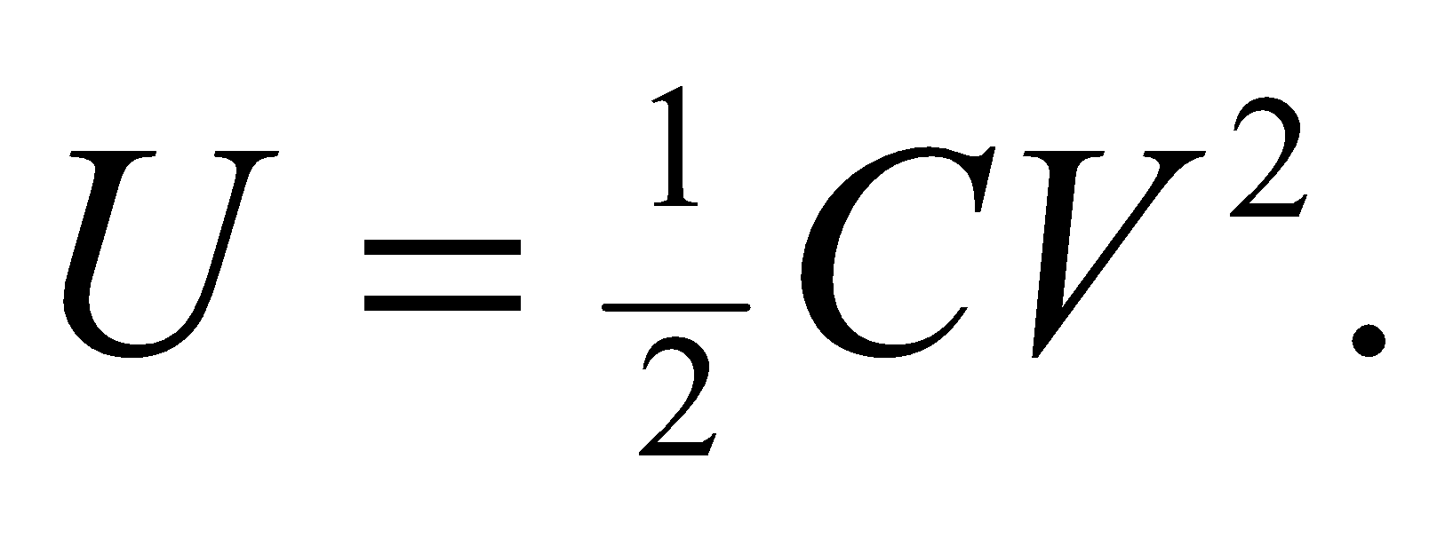

**Evaluate** Using 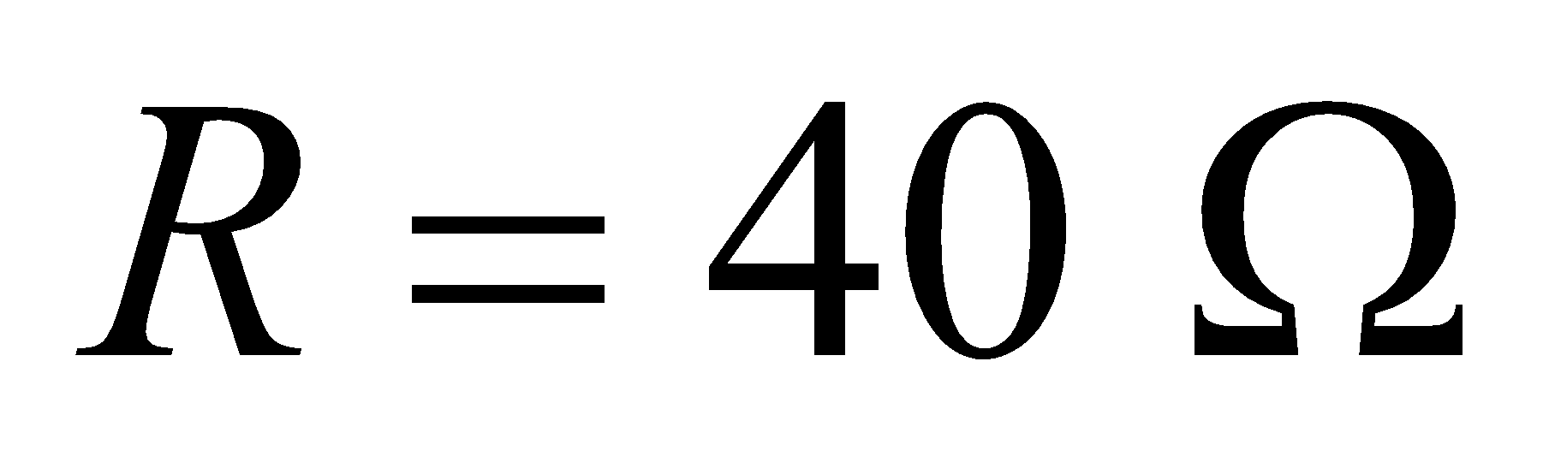for the transthoracic resistance, the needed capacitance is to the nearest 10 μF:

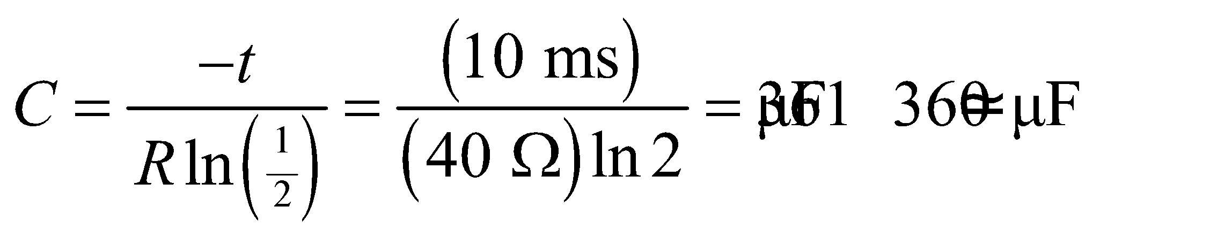

Given that the stored energy in the capacitor is 250 J, the initial voltage must be to the nearest 100 V:

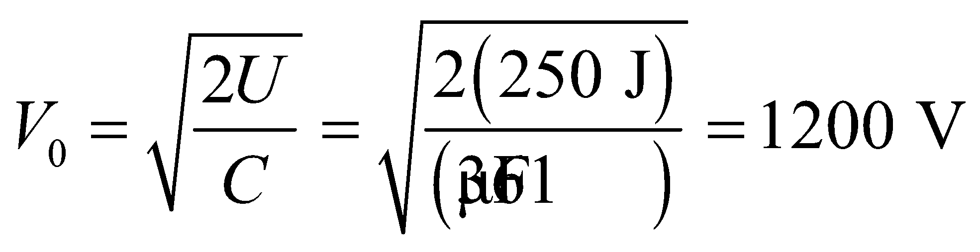

**Assess** The initial current going through the chest is 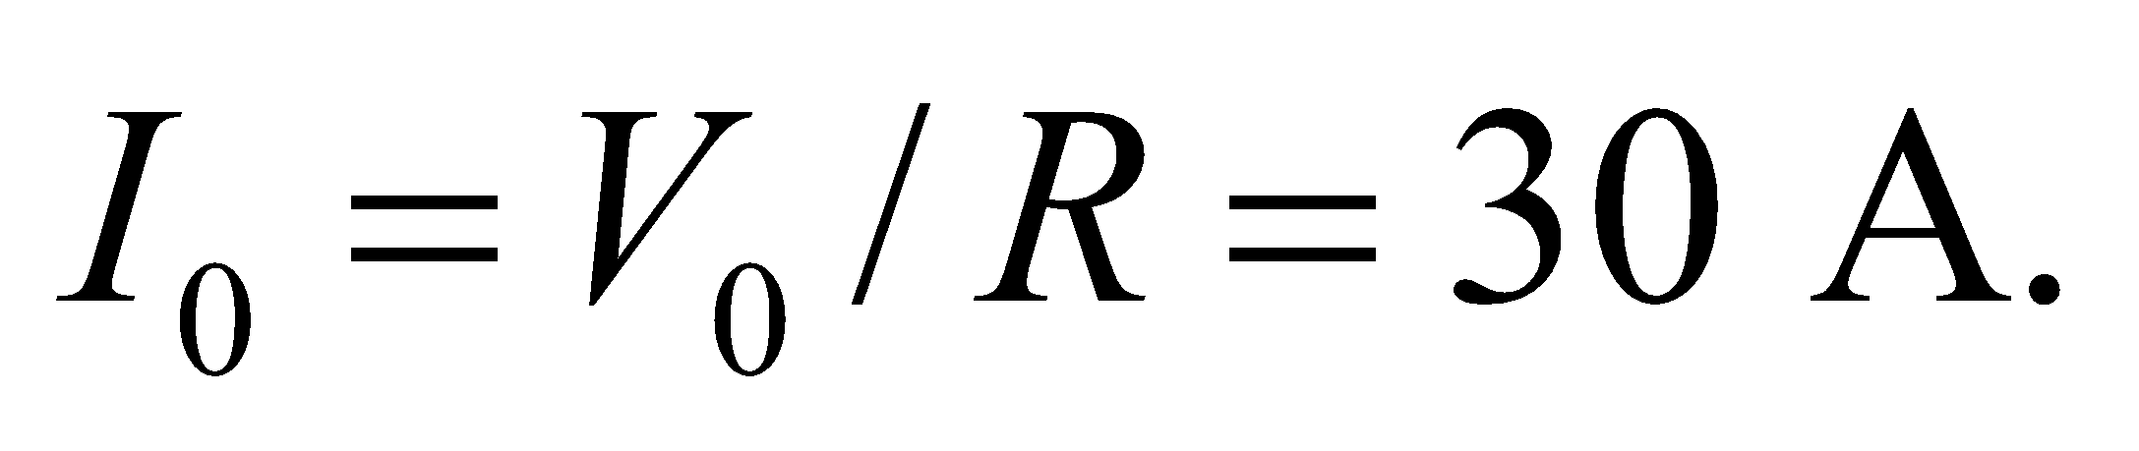Such a huge amount of current can sometimes cause burns (see Table 24.3). But the person will likely die if this "jolt" to the heart is not applied in time.

**56.** **Interpret** This problem involves an RC circuit, for which we are to find the resistance and then find the capacitance required to maintain the voltage across the capacitor to within 1 V for 1/60 s.

**Develop** The effective resistance can be found using Ohm’s law, given a voltage of *V* = 35 V and a current of *I* = 1.2 A. To find the capacitance needed to maintain the voltage above 34 V, apply Equation 25.8, which describes the rate of discharge of a capacitor. To keep the voltage within the prescribed range for the discharging capacitor, the time constant must satisfy 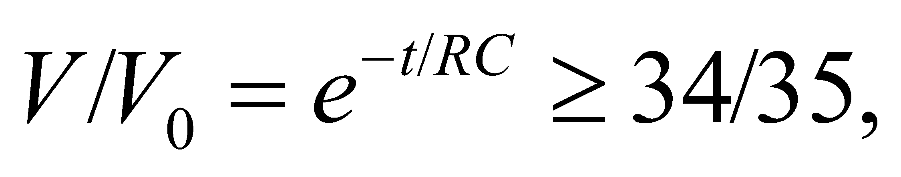 which allows us to solve for C using the value of R from part (a).

**Evaluate** (**a**) The effective resistance of a circuit that draws 1.2 A from a constant 35 V supply is

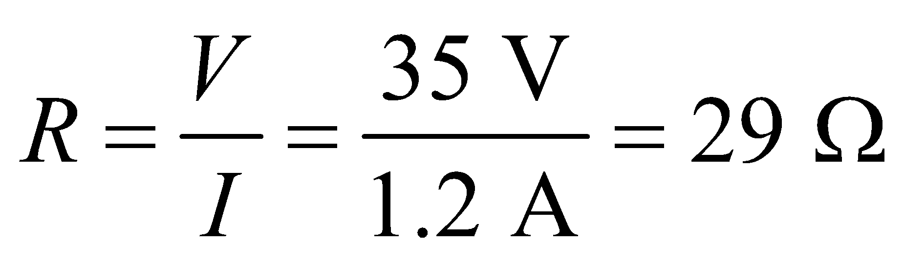

(**b**) Solving Equation 25.8 for the time constant, we find 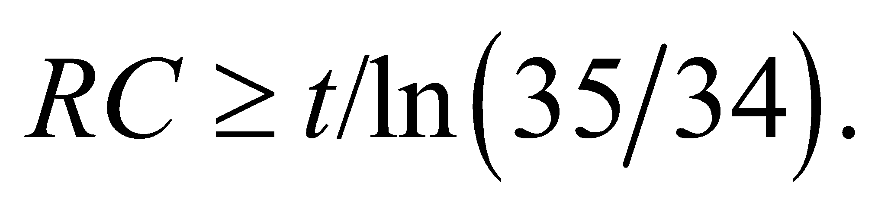 For *t* = 1/60 s and *R* = 29.2 W, the capacitance is 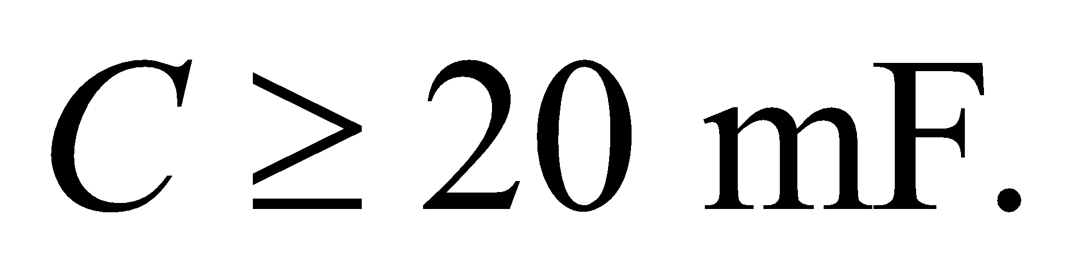

**Assess** This is a rather large capacitance, which is necessary because it must discharge a large current of 1.2 A for 1/60 s.

**57. Interpret** This problem involves energy dissipation in an *RC* circuit. Given the energy dissipated in the given time, we are to find the capacitance.

**Develop** A capacitor discharging through a resistor is described by exponential decay, with time constant *RC* (Equation 25.8):

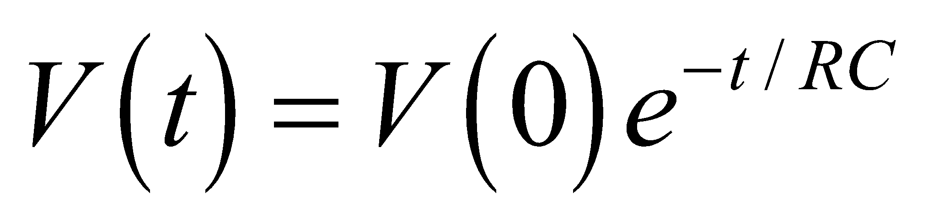

The energy in the capacitor is given by Equation 23.3:

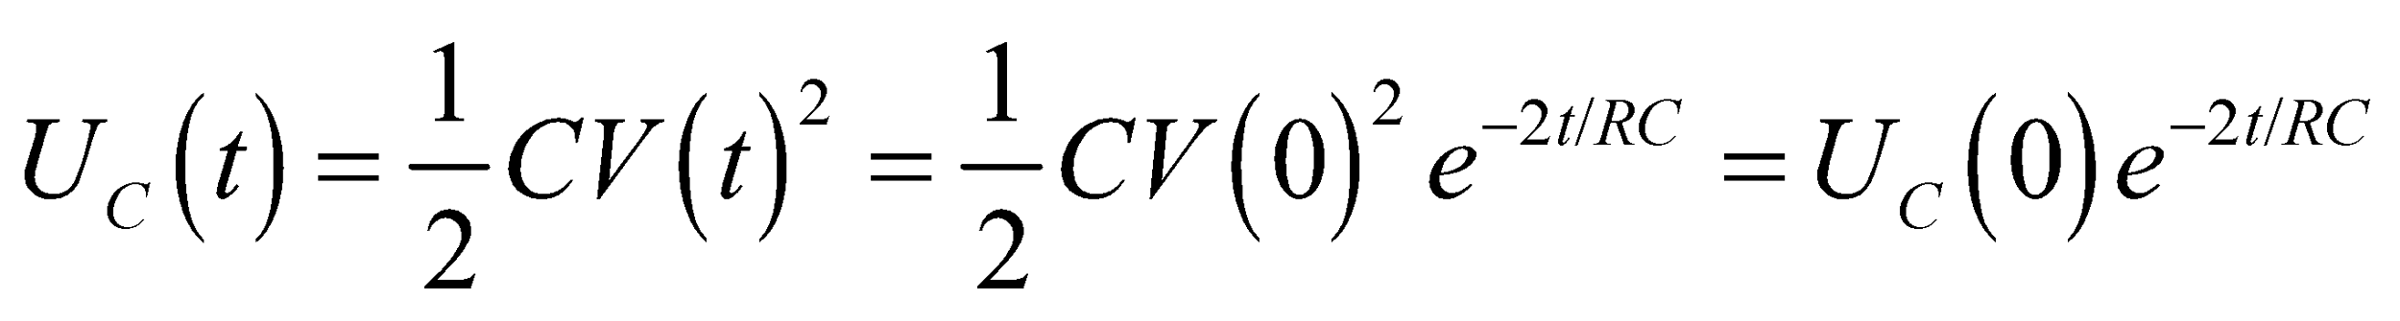

**Evaluate** If 2 J is dissipated in time *t*, the energy stored in the capacitor drops from  to  (assuming there are no losses due to radiation, etc.). From the equation above, the capacitance is

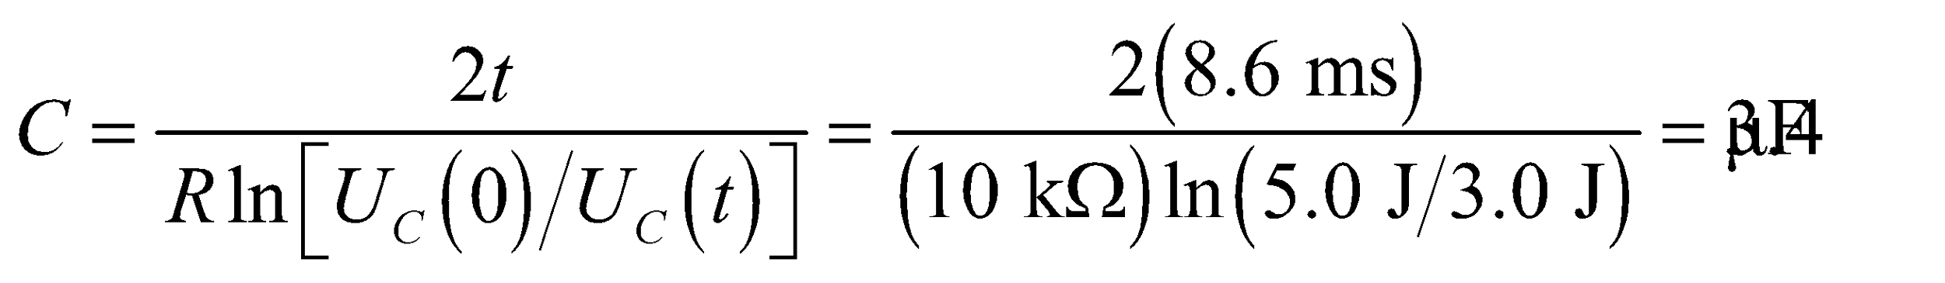

**Assess** In this problem the time constant is  Therefore, at 8.6 ms (about 0.255 *RC*) the energy decreases by a factor 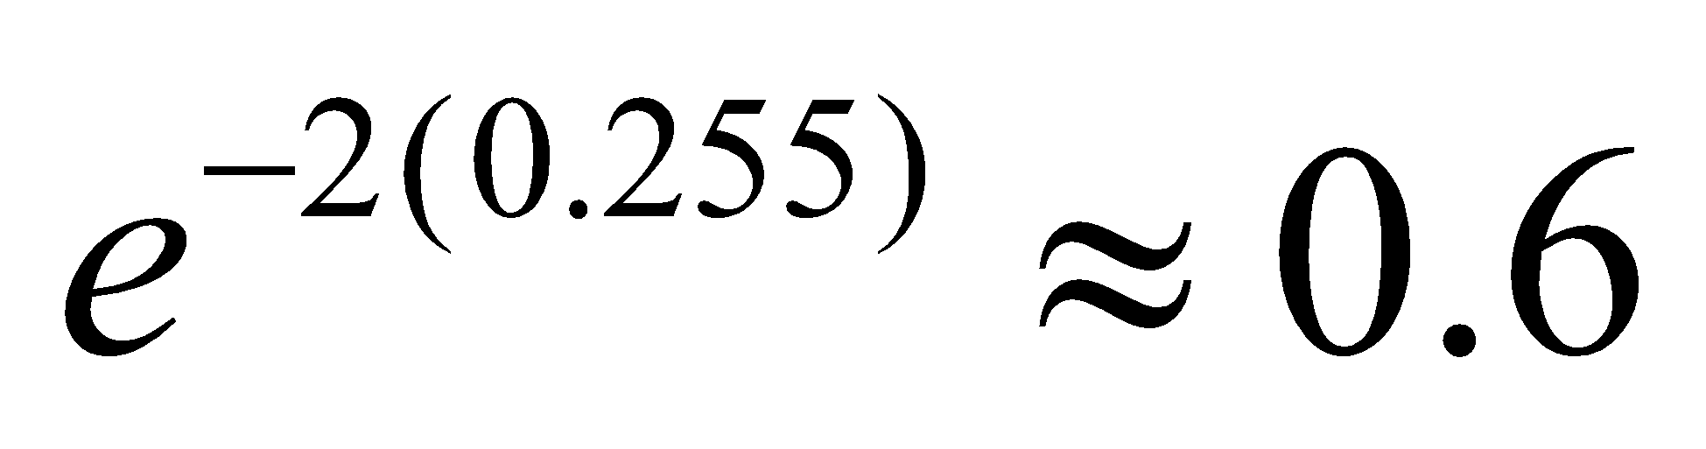, which is precisely what we found (i.e., from 5.0 V to 5.0 × 0.6 = 3.0 V).

**58.** **Interpret** The problem concerns what happens when a charged capacitor is connected to an uncharged capacitor. We'll only worry about the long-term behavior, i.e. after the current has stopped flowing.

**Develop** The charged capacitor initially has a charge of 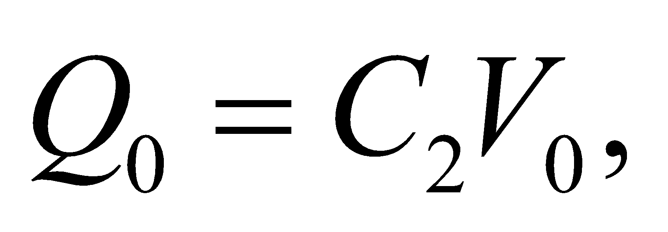where the "2" subscript refer to the 2-μF capacitor. When the switch is closed, charge will flow from the charged capacitor to the uncharged capacitor until the voltage across both is equal. Since the final charge on each capacitor must sum up to the initial charge: 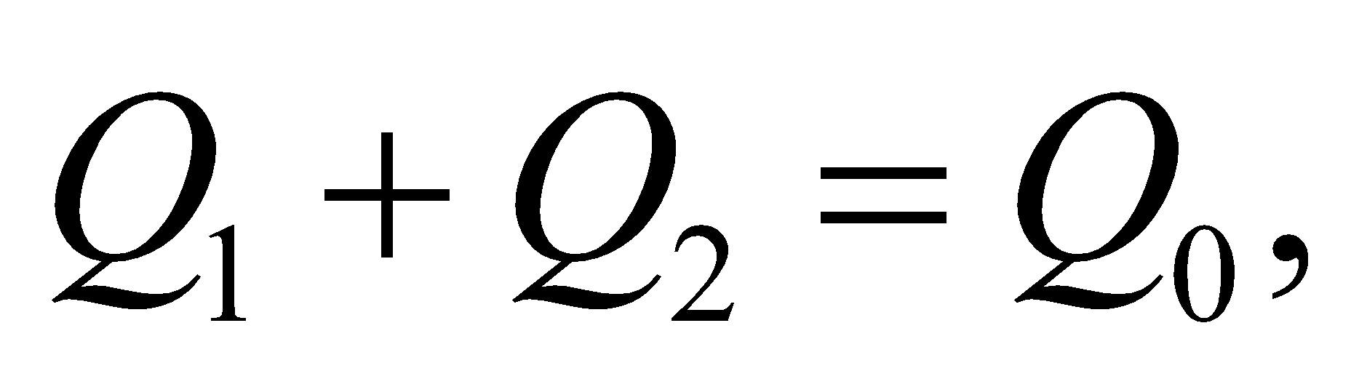the final voltage must be

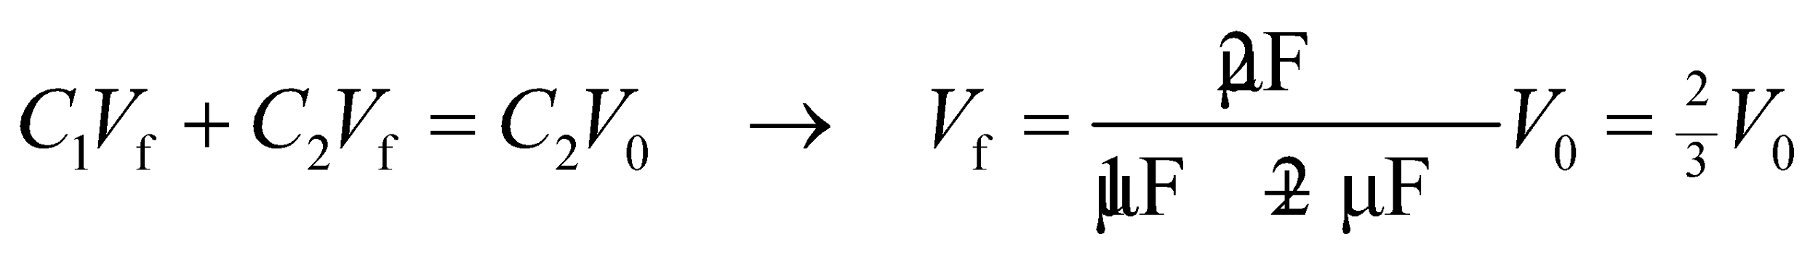

To find the total energy dissipated in the resistor, we find the difference in the stored energy between the initial and final states.



**Evaluate** Plugging in the values for the capacitors and the initial voltage, the energy dissipated in the resistor is

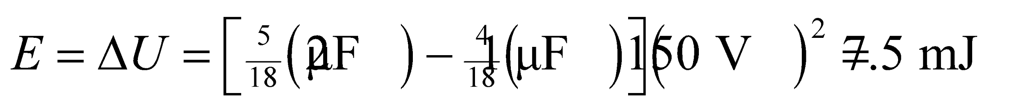

**Assess** Notice that the answer does not depend on the resistor's resistance. We might convince ourselves that this makes sense by looking at a simpler situation: a single capacitor discharging through a resistor, as in Figure 25.22. The total energy dissipated by the resistor is the time integral of the power:

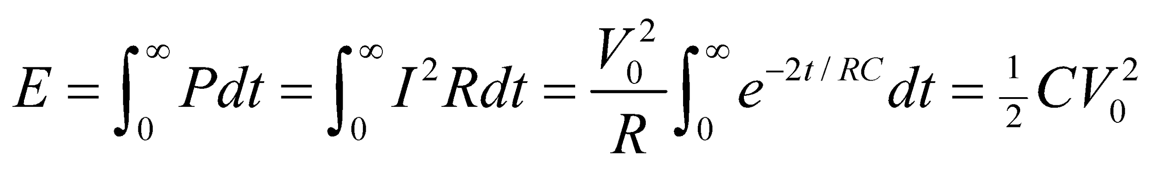

This is the initial energy stored in the capacitor. We can imagine therefore that the two-capacitor situation is similar: the resistor dissipates the energy lost by the charged capacitor. The amount of resistance in the resistor will only affect how fast the energy is dissipated.

**59. Interpret** This problem is about the long-term and short-term behavior of an RC circuit. For each extreme, we are to find the voltage and current in both resistors of the RC circuit of Example 25.6.

**Develop** In addition to the explanation in Example 25.7, we note that when the switch is closed, Kirchhoff’s voltage law applied to the loop containing both resistors yields 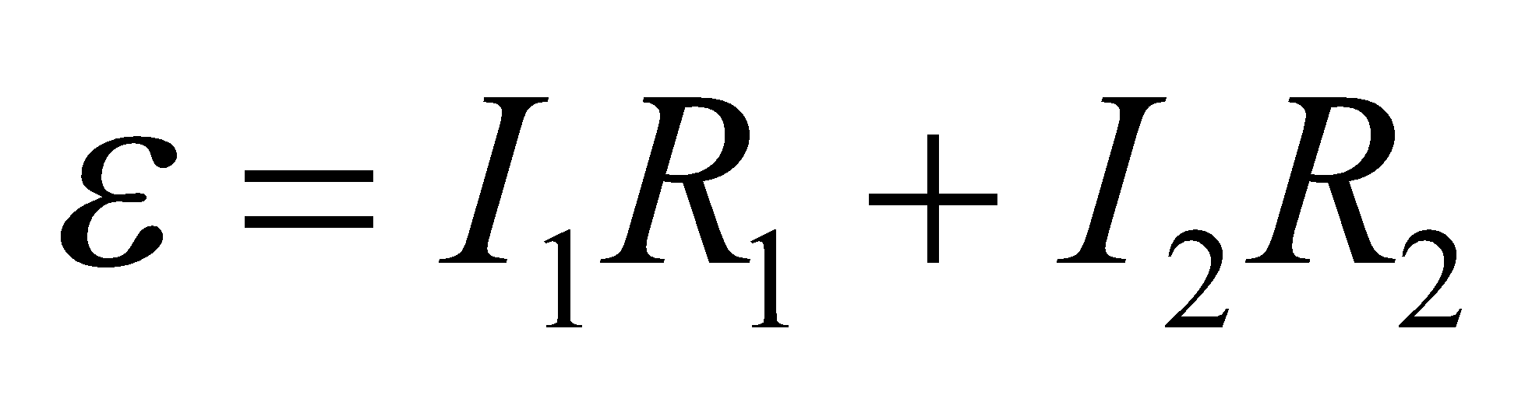, and Kirchhoff’s law applied to the loop containing just *R*2 and *C* is 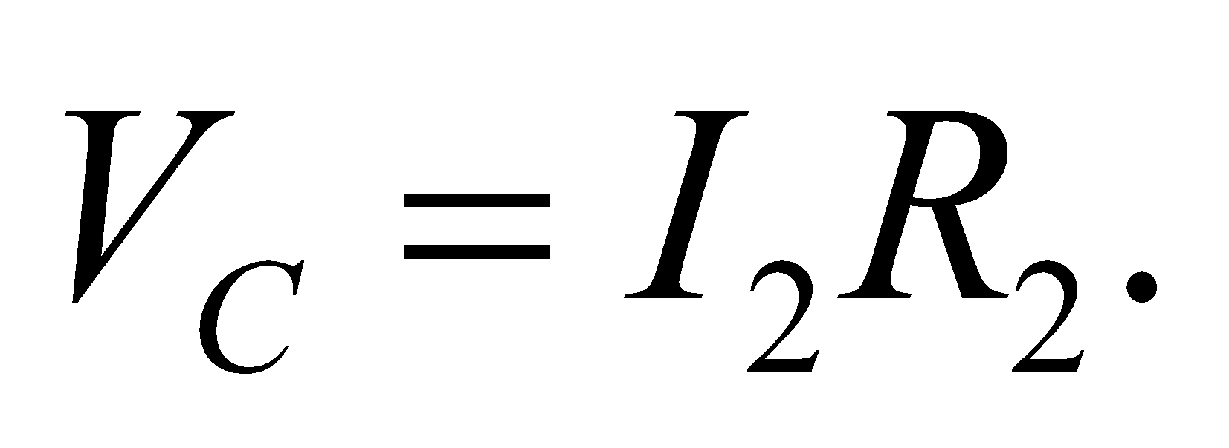

**Evaluate** **(a)** If the switch is closed at *t* = 0, the circuit behaves as if it were the circuit of Figure 25.23b, and Example 25.6 explains that 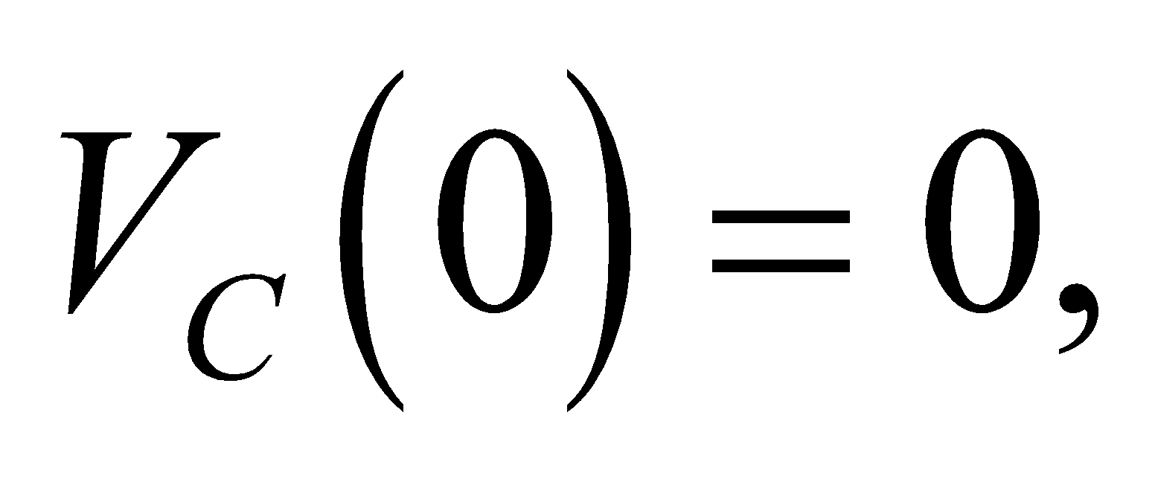 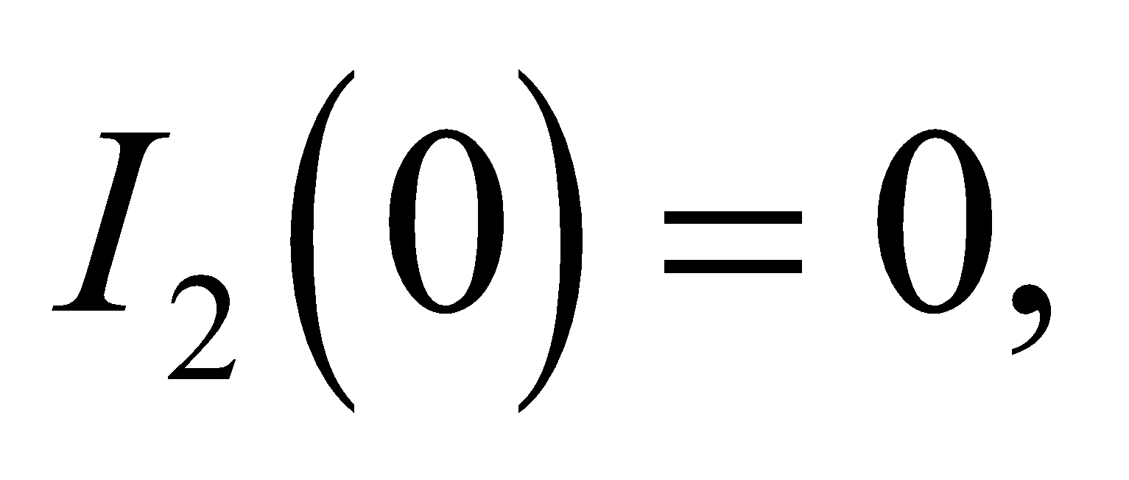 so

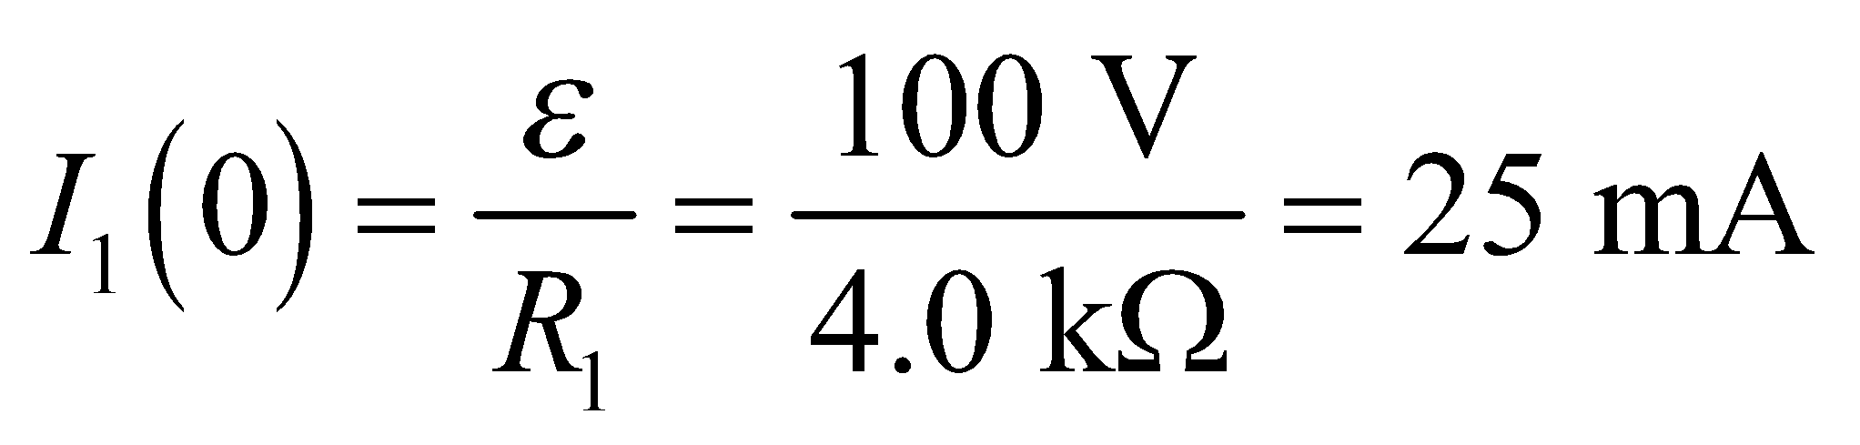

**(b)** As 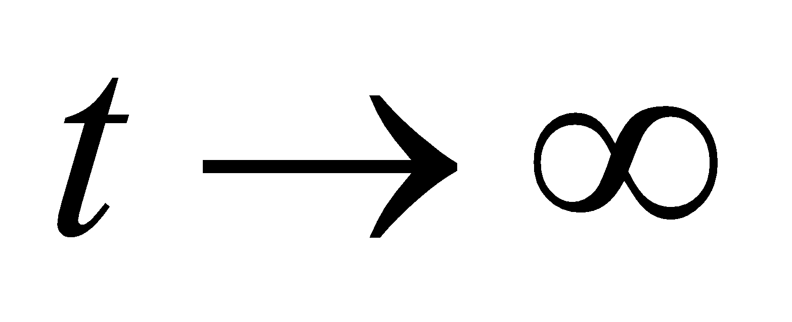, the circuit behaves like the circuit of Figure 25.23c, and Example 25.7 shows that

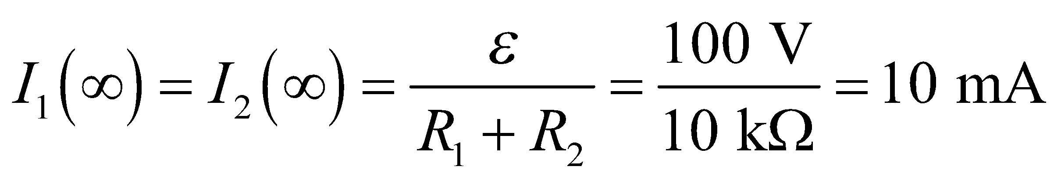

and 

**(c)** Under the conditions stated, the fully charged capacitor  simply discharges through *R*2. (*R*1 is in an open-circuit branch, so 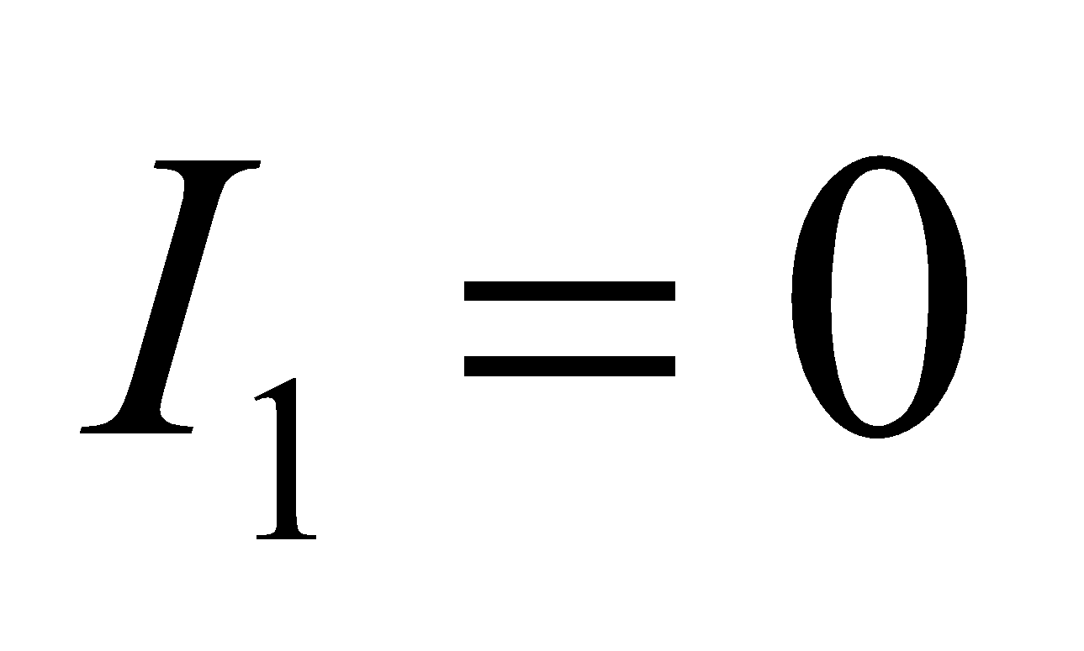 for the entire discharging process.) The initial discharging current is

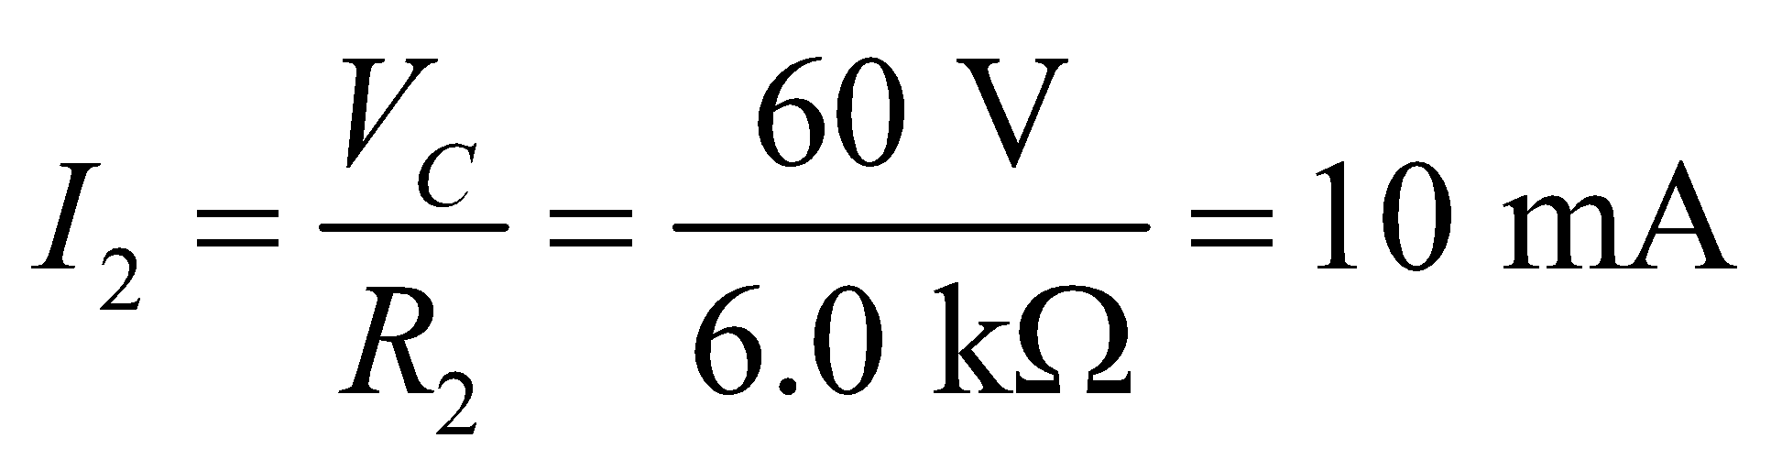

**(d)** After a very long time, *I*2 and *VC* decay exponentially to zero.

**Assess** We deduced the short-term and long-term behavior of the *RC* circuit without having to solve a complicated differential equation. A long time after the circuit has been closed, the capacitor becomes fully charged an no more current can cross it, so it behaves as an open circuit. When the circuit switch is reopened, the capacitor starts to discharge and eventually loses all its stored energy. It is now capable of storing charge again, and behaves like a short circuit for times much less than its *RC* time constant.

**60.** **Interpret** We're asked to find the short-term and long-term behavior of a complicated *RC* circuit.

**Develop** Right after the switch is closed, the two capacitors will act like short-circuits, i.e. like wires with zero-resistance. Current will flow through them in preference to any parallel resistors. Much later, the capacitors will be nearly fully charged, in which case they will act like an open circuit. No more current will flow through them.

**Evaluate**  (a) When the switch is closed, the capacitor 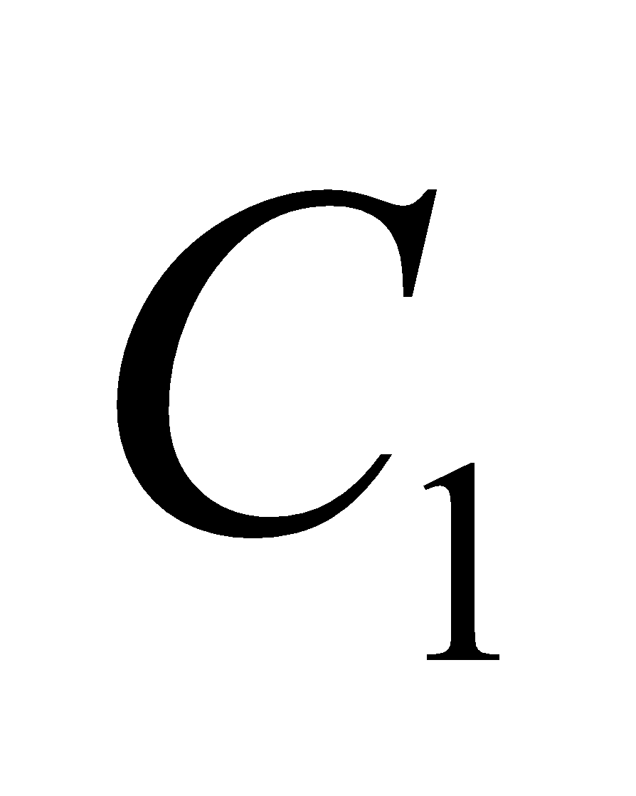 in Figure 25.36 will offer an essentially zero-resistance pathway for current from the emf to flow. Therefore, no current will flow through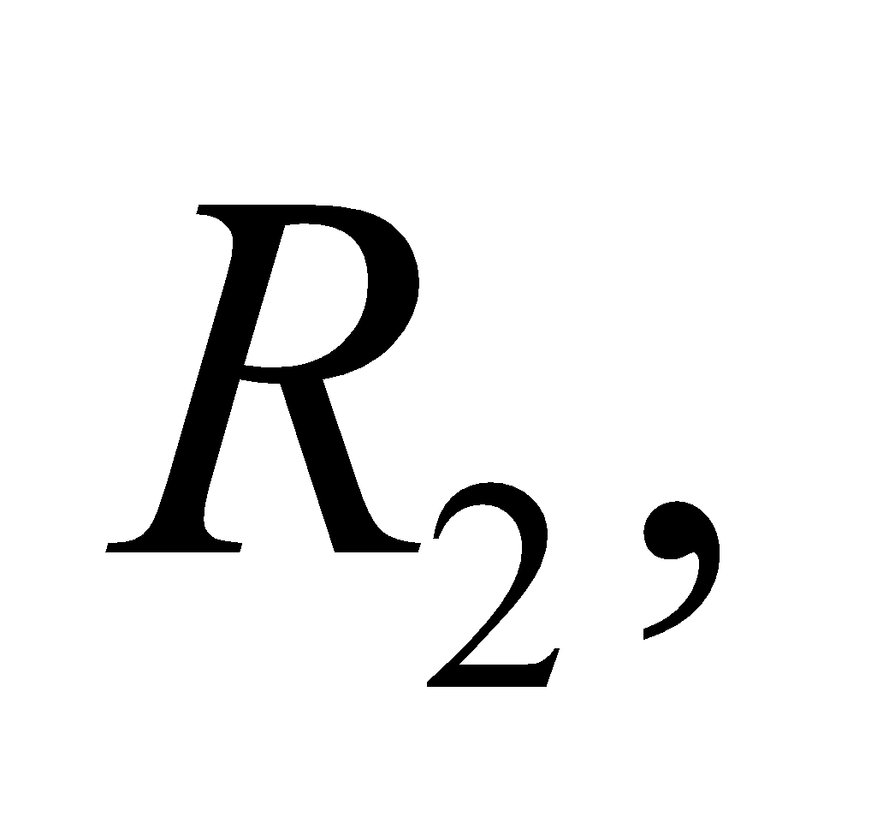or 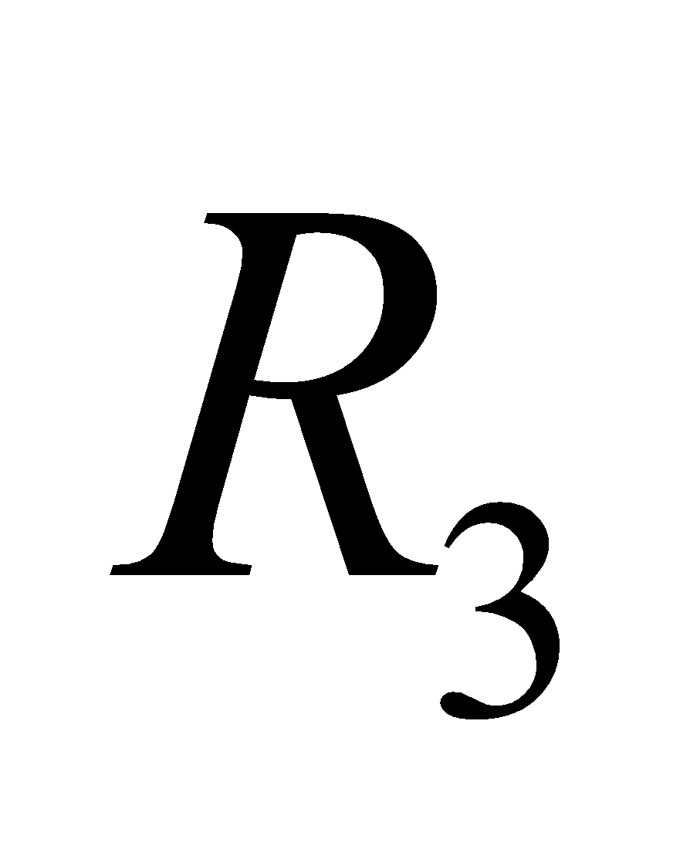 for that matter. If we label the currents by the resistor they go through: 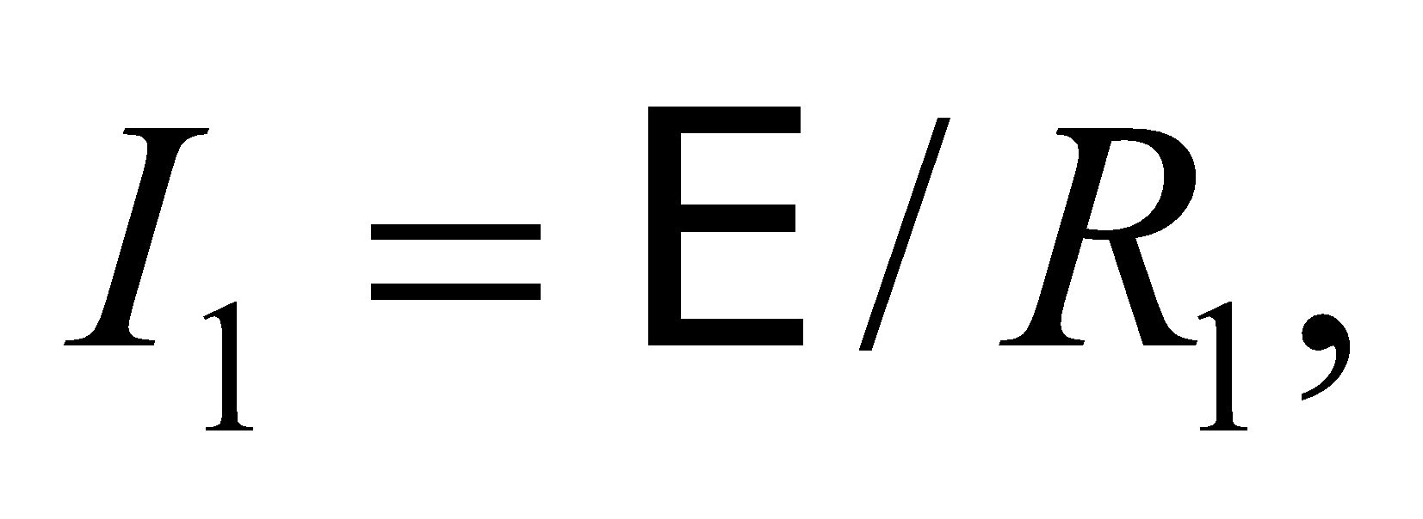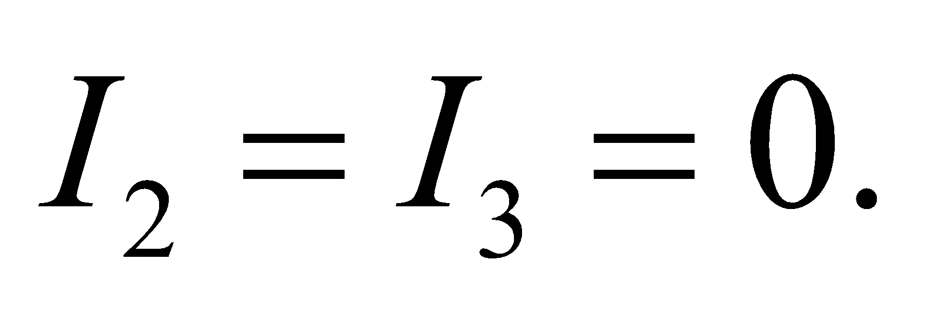

(b) Long after the switch is closed, both capacitor and 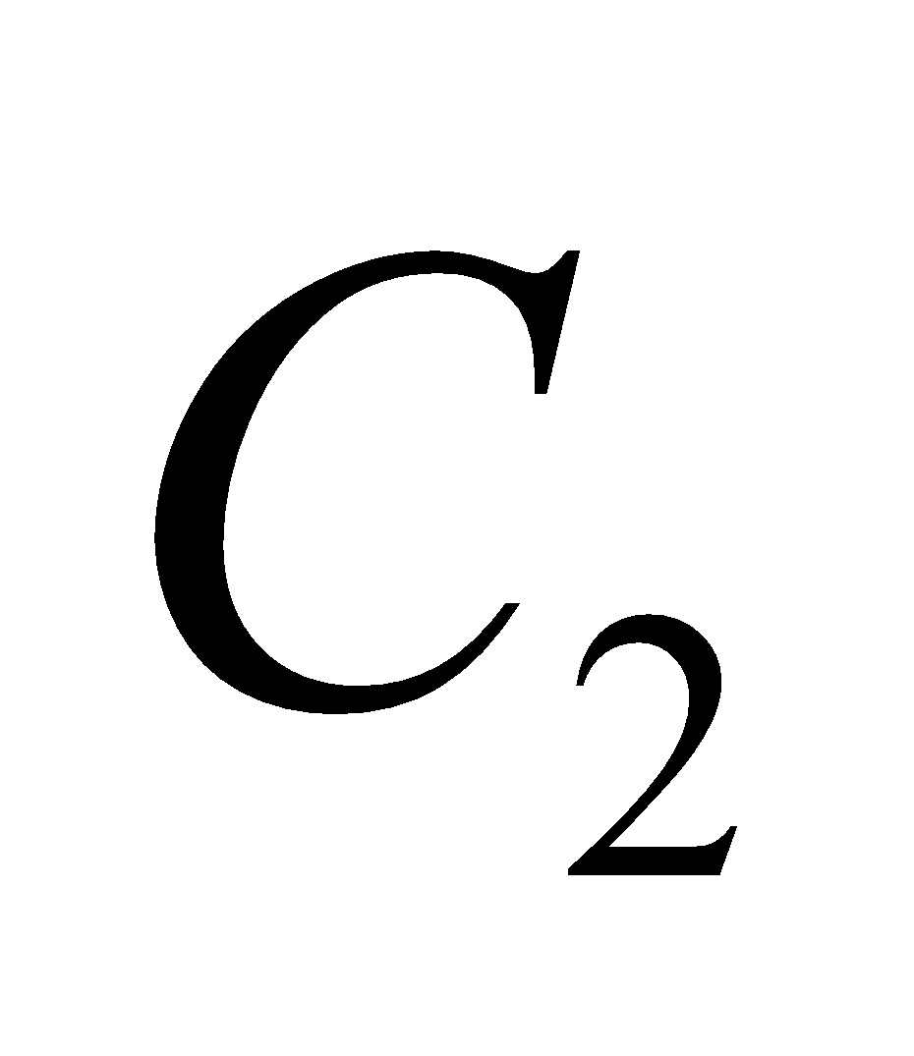will be charged, so no more current will flow into these two branches of the circuit. All of the current from the emf will now flow through which means 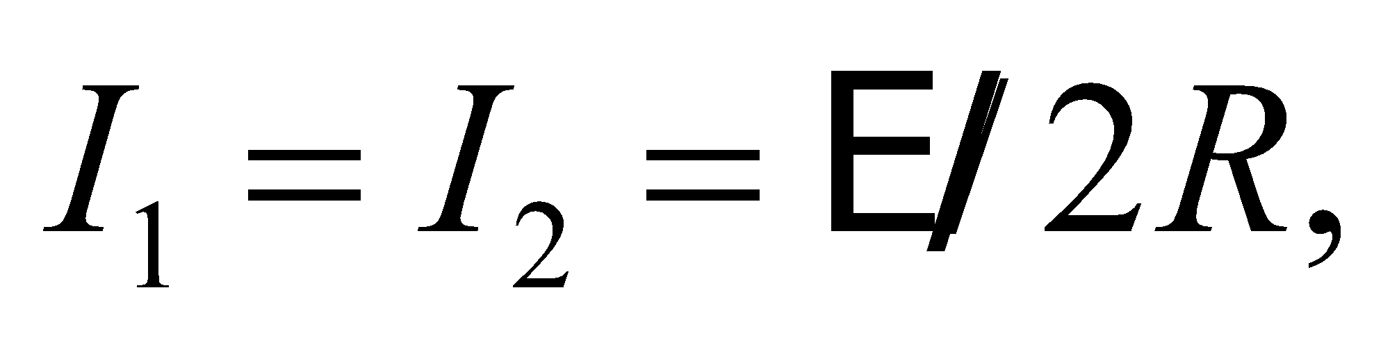and 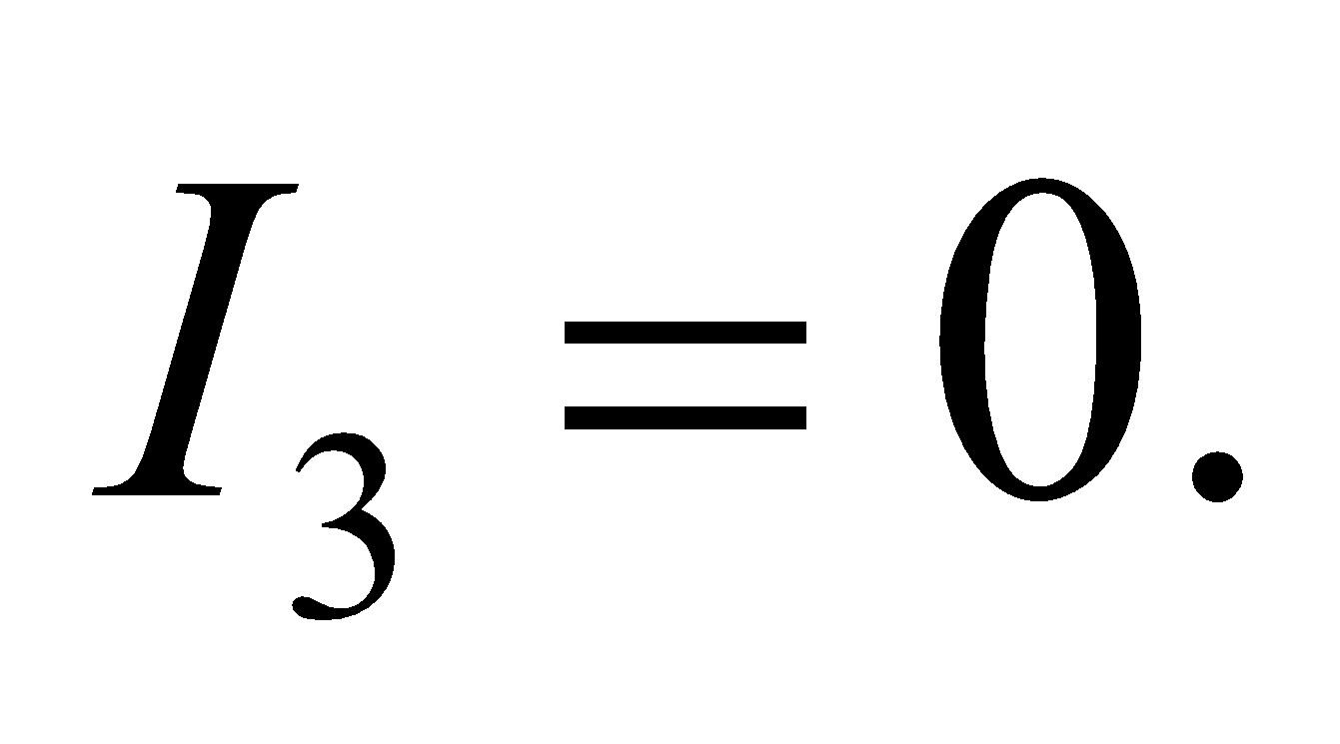

**Assess** One can easily guess that *I*1 and *I*2 respectively decrease and increase monotonically from their initial to their final values, and that *I*3 first increases from, and then decreases to zero.

**61. Interpret** We are asked to find the voltage and internal resistance of a battery using the measured voltage values of two voltmeters with different internal resistances.

**Develop** The internal resistance *R*i of the battery and the resistance *R*m of the voltmeter are in series with the battery’s emf (see circuit below), so the current is 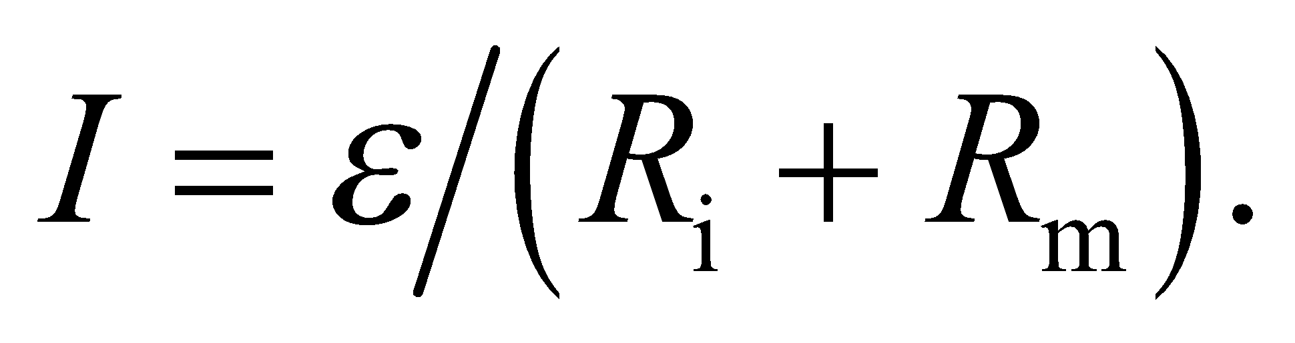 The potential drop across the meter (its reading) is

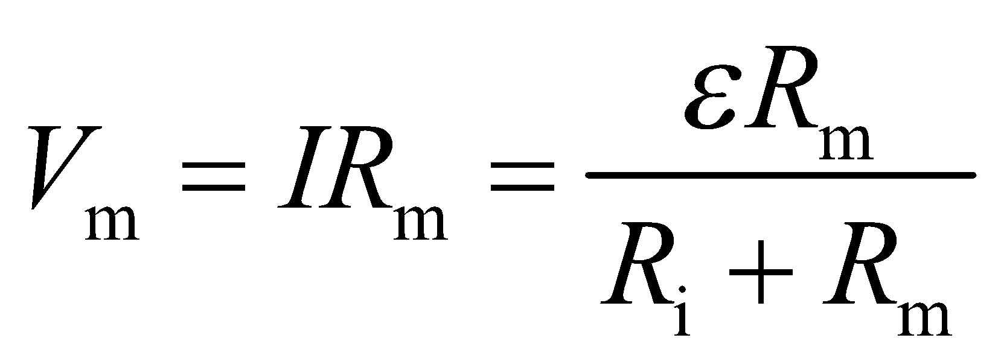

From the given data, we can write

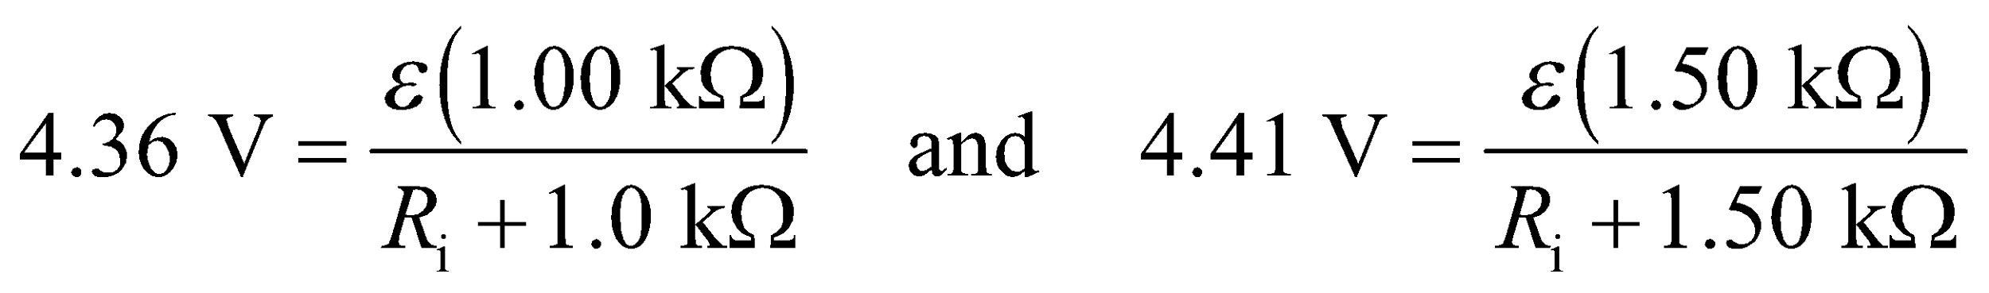

or 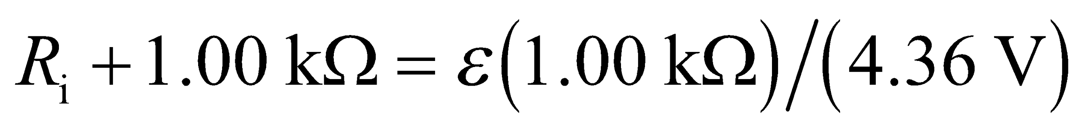 and 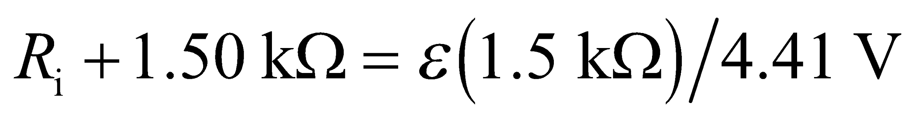.



**Evaluate** Solving the simultaneous equations for  and *R*i gives

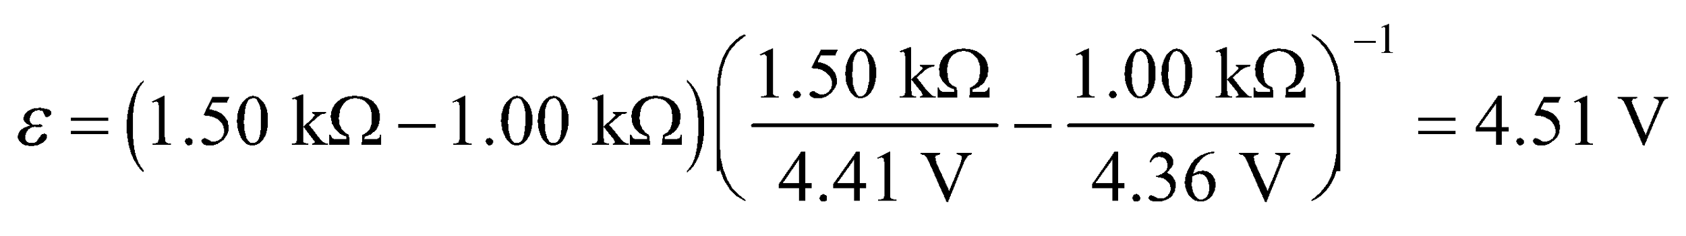

and .

**Assess** An ideal voltmeter has infinite resistance. Thus, when we let  its reading approaches the battery voltage .

**62. Interpret** We are to find the resistance necessary in an RC circuit (see Figure 25.18) to charge the given capacitor to 45% charge in 140 ms.

**Develop** Apply Equation 25.6, which describes the voltage across a capacitor as a function of time.

**Evaluate** Setting VC/e = 45% and solving for the *RC* time constant in Equation 25.6, we find

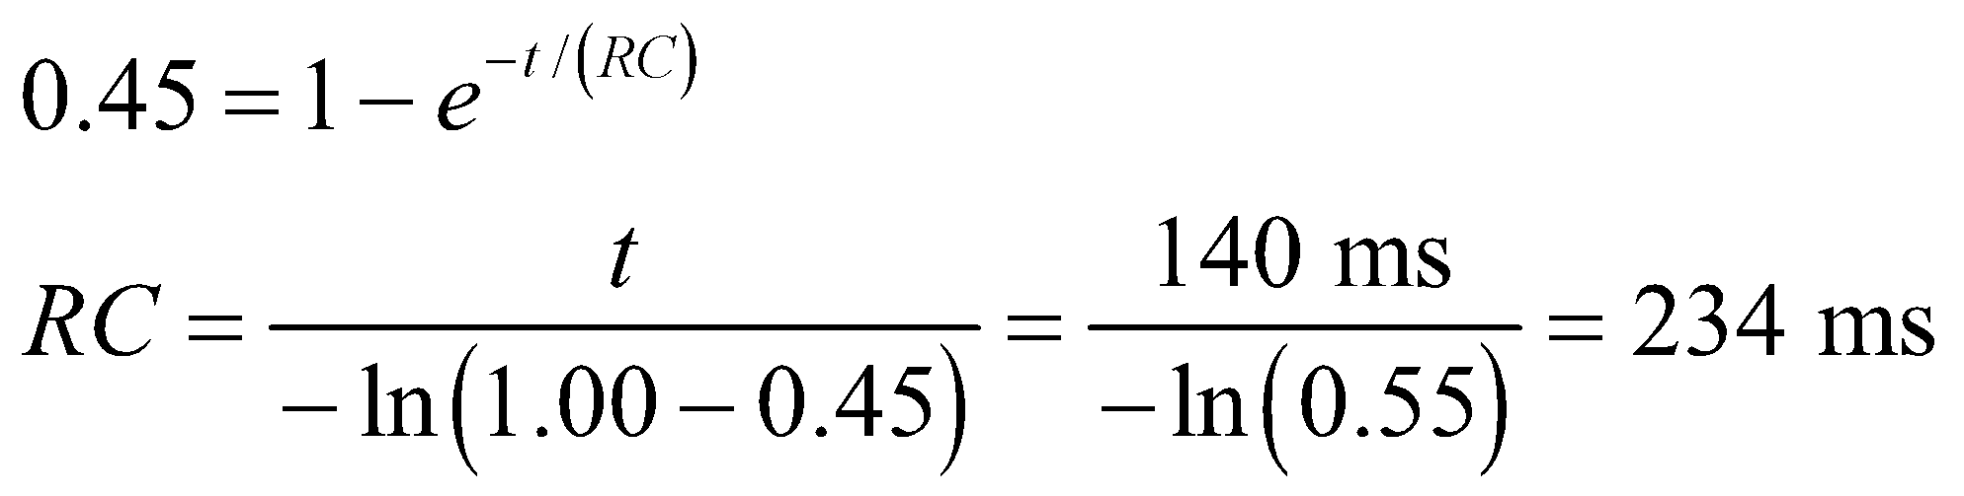

for a 20 μF capacitor, the resistance must be

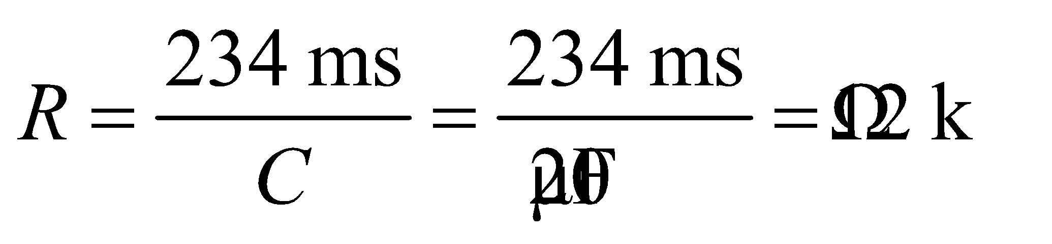

**Assess** Notice that a higher resistance would increase the time constant, so that it would take longer to charge the capacitor, whereas a small resistance would have the reverse effect.

**63. Interpret** The electric field at the node increases due to charge accumulation and eventually reaches the breakdown field strength. We are to find how long this process will take given the rate at which charge accumulates on the sphere.

**Develop** The charge on the node (whether positive or negative) accumulates at a rate of 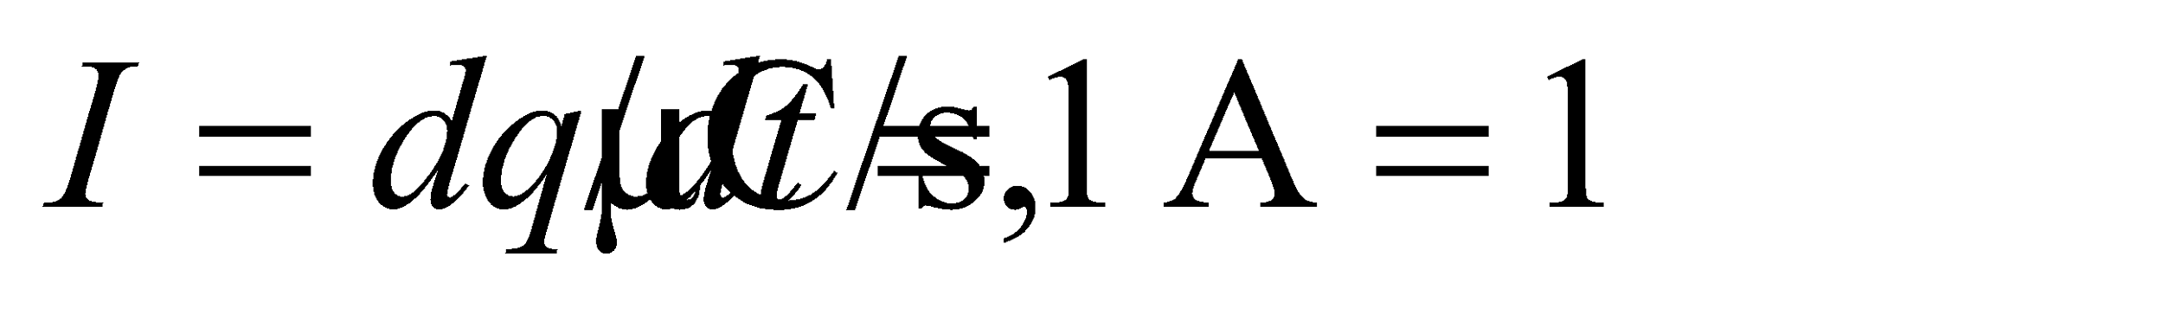 so 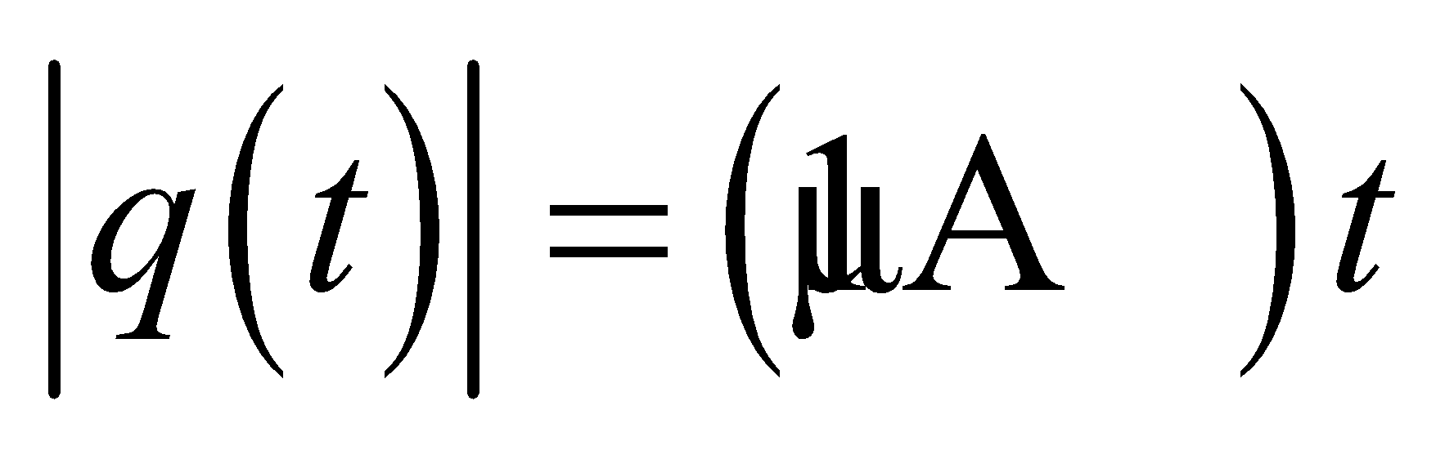 (where we assume that *q*(0) = 0). If the node is treated approximately as an isolated sphere, and if we assume that the charge distribution on the sphere becomes uniform at a rate much higher than the input current (so that we can treat it as a static distribution), then we can apply Gauss’s law and the results of Example 21.1. Under these conditions, the electric field strength at the surface of the sphere is given as

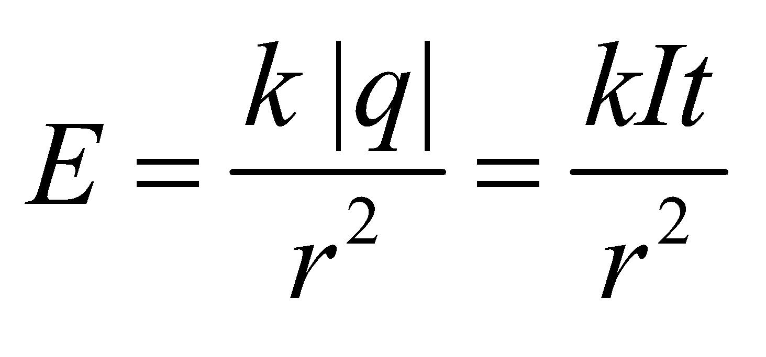

Electric breakdown occurs when 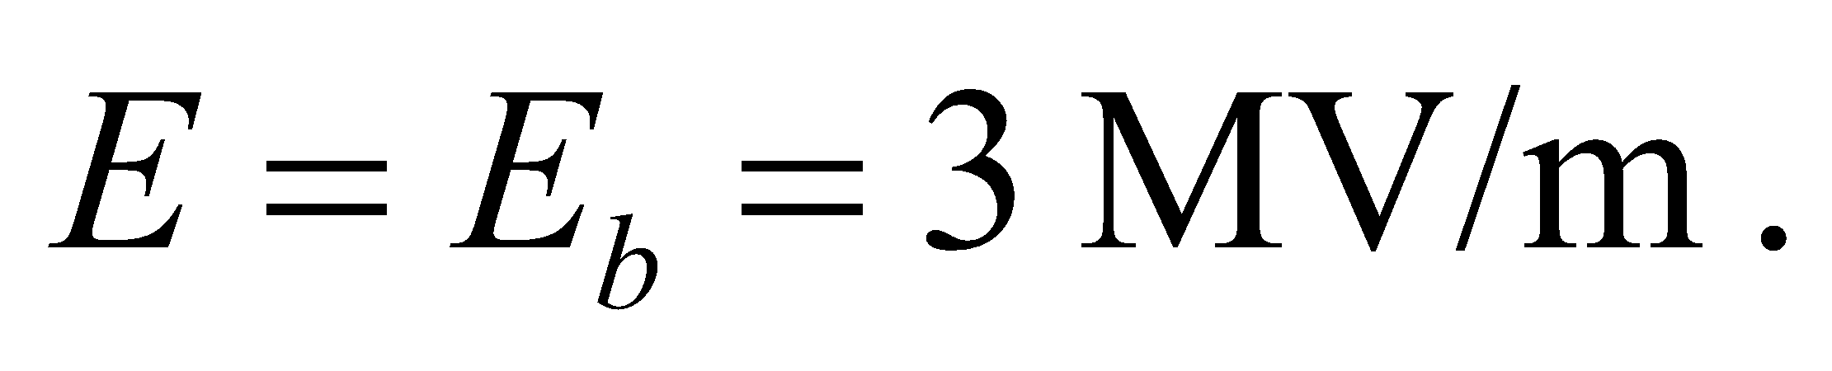

**Evaluate** The time when the breakdown happens is

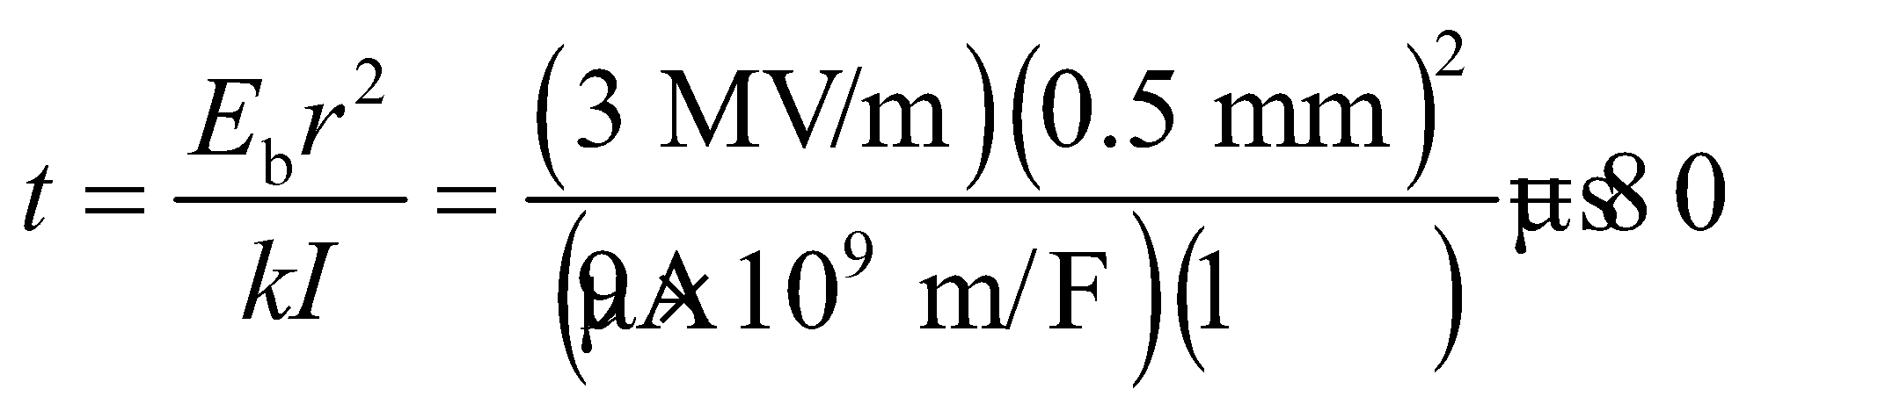

to a single significant figure.

**Assess** This problem shows that Kirchhoff’s node law must hold, or else there would be a charge buildup at the node which quickly leads to an electric breakdown.

**64.** **Interpret** We want to find what load resistance connected to a battery will result in the greatest power output.

**Develop** A real battery has an internal resistance, as shown in Figure 25.8. When an external load is connected to the battery, the current that flows out will be 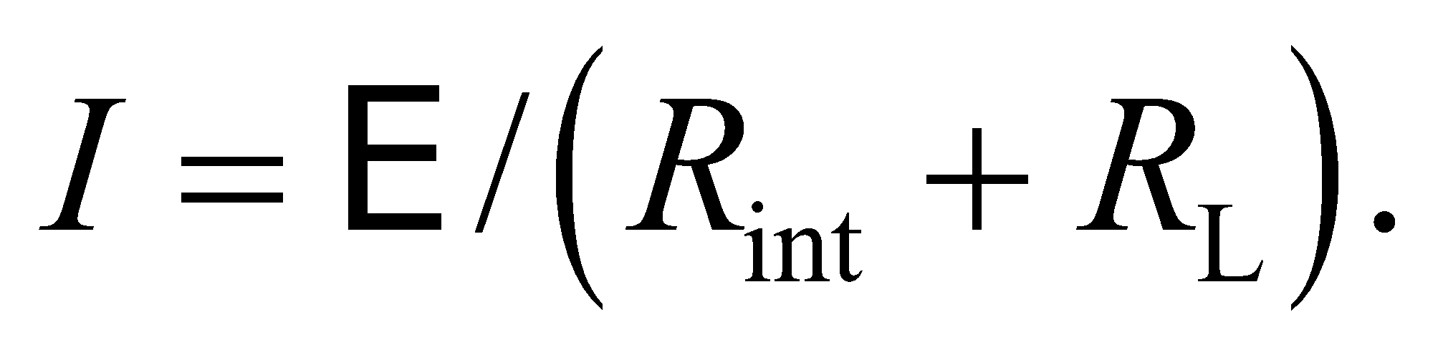 We want to find what will give the maximum power: 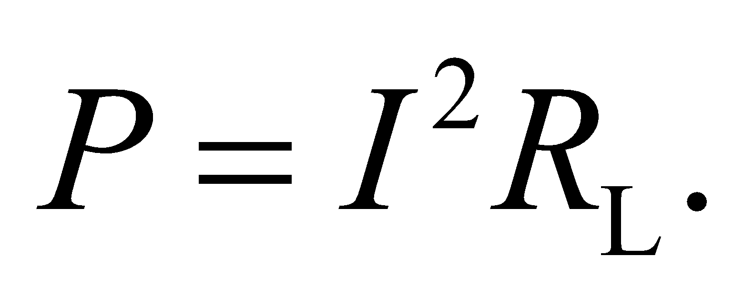

**Evaluate** The power will be a maximum when its derivative with respect to is zero:

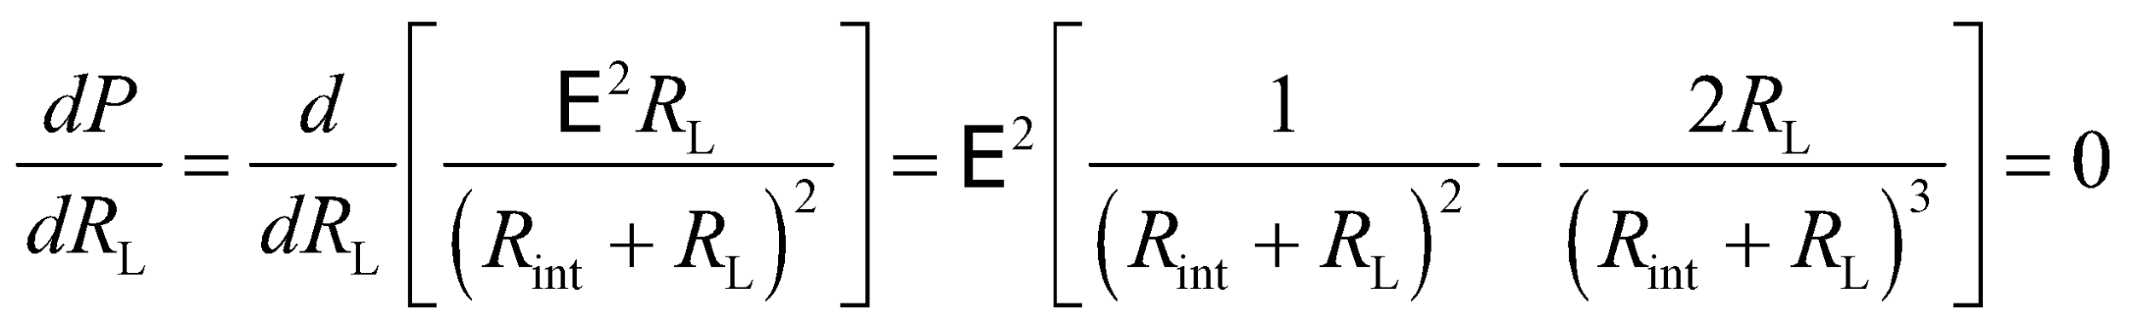

The equation is solved when 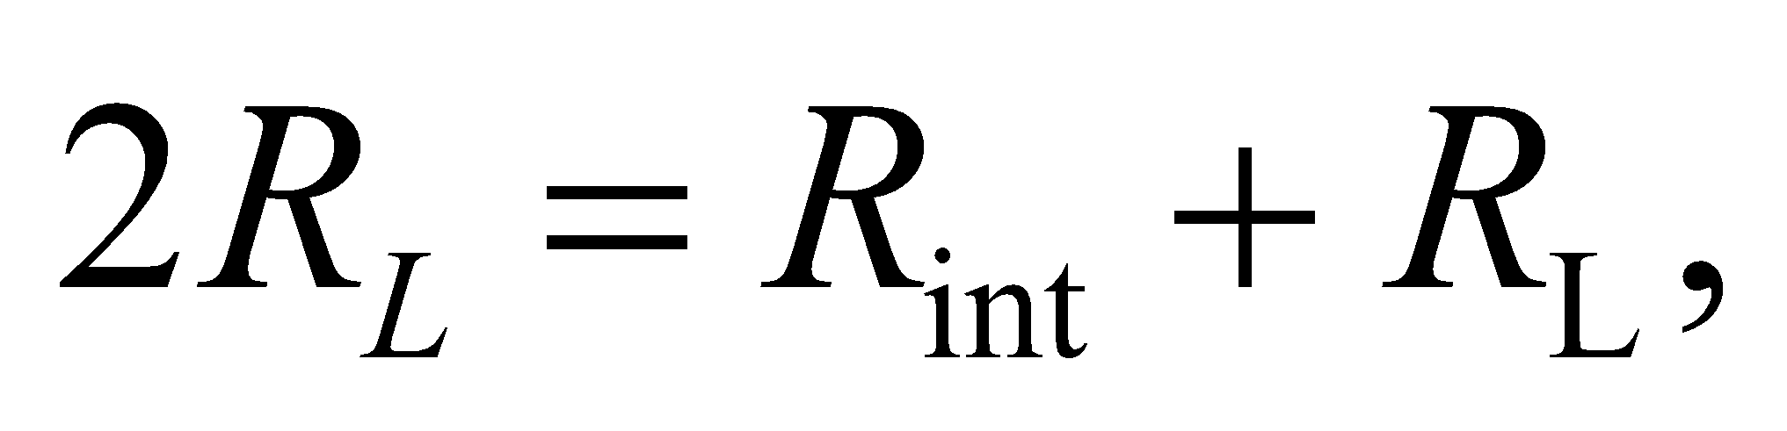or 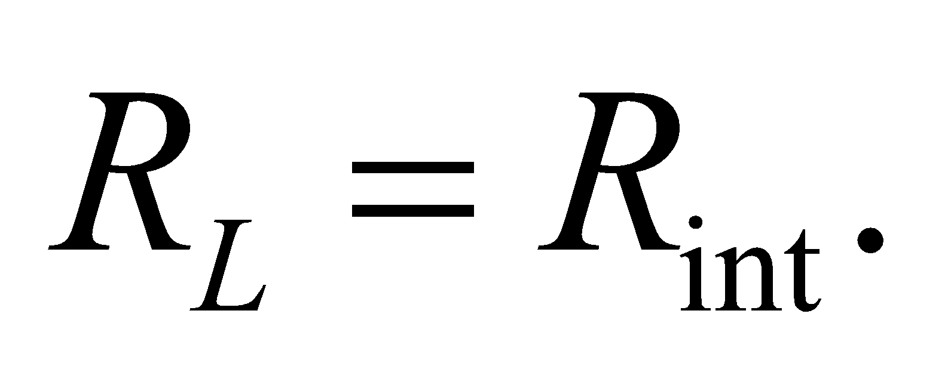

**Assess** The internal resistance of a battery is typically pretty low, so connecting a load with the same resistance would be essentially short-circuiting the battery. This could cause the battery to heat up and explode.

**65.** **Interpret** You need to specify what loudspeaker resistance is needed to get the maximum power output from an amplifier.

**Develop** The loudspeaker resistance will be in series with the amplifier's internal resistance. This is similar to the previous problem, where it was shown that the maximum power in the load (the loudspeaker in this case) occurs when its resistance matches the internal resistance of the power supply.

**Evaluate** From the above arguments, the optimum resistance for the loudspeaker is Since this is the same as the internal resistance of the amplifier, the power output will be:

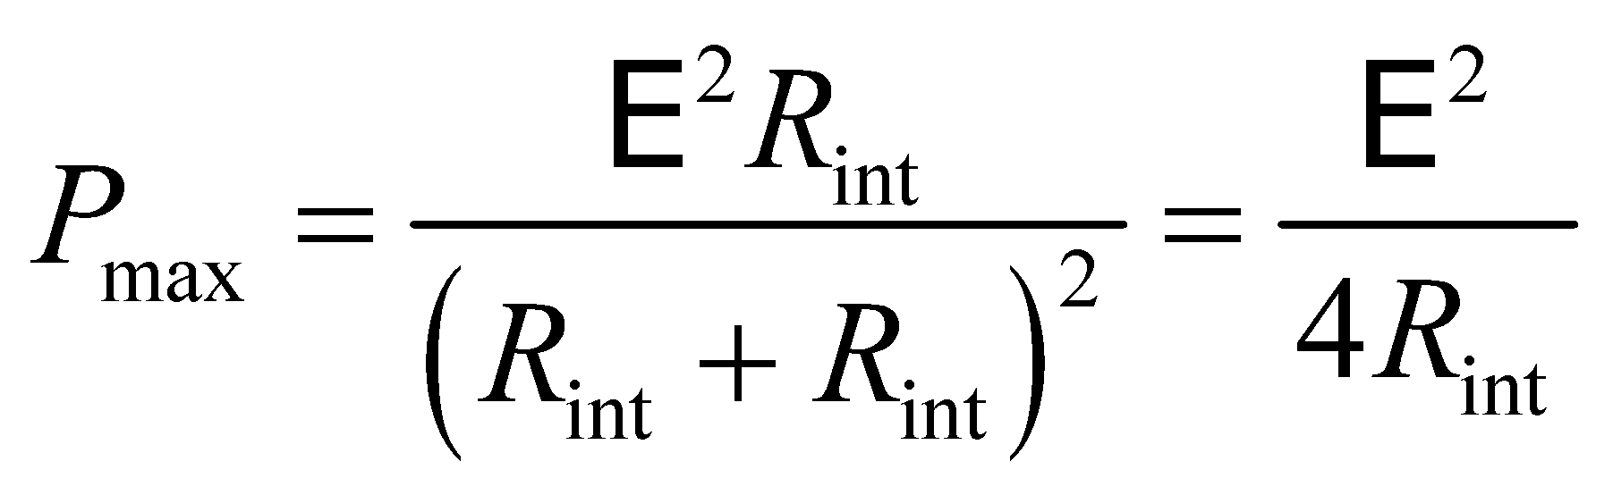

If a loudspeaker with 4 Ω of resistance is connected instead, the power is reduced by

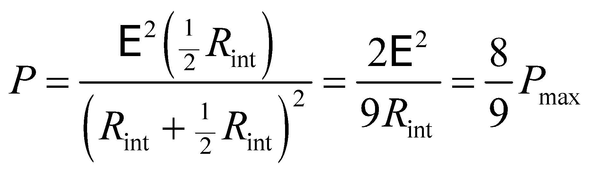

The maximum power is specified as 100 W, so a 4-Ω loudspeaker will output 89 W.

**Assess** A loudspeaker with half the optimum resistance still produces almost 90% of the maximum power. This shows that it's not necessary to exactly match the load to the amplifier.

**66. Interpret** This problem explores the energy stored in the capacitor of an *RC* circuit. We are asked to show that the capacitor stores only half the energy supplied by the battery.

**Develop** The power supplied by the battery in charging an initially uncharged capacitor in an *RC* circuit is (Equation 24.7)

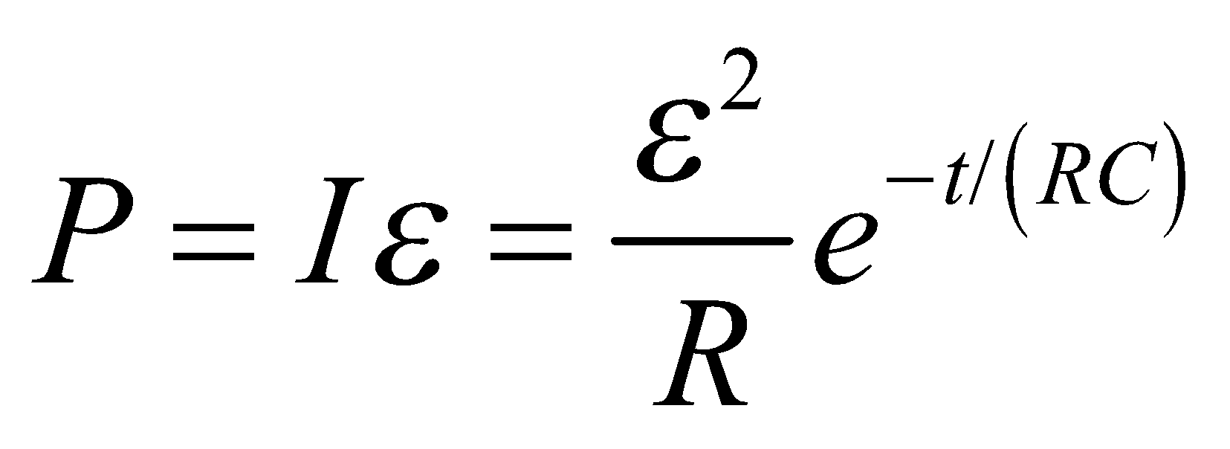

where the current is given by Equation 25.5, 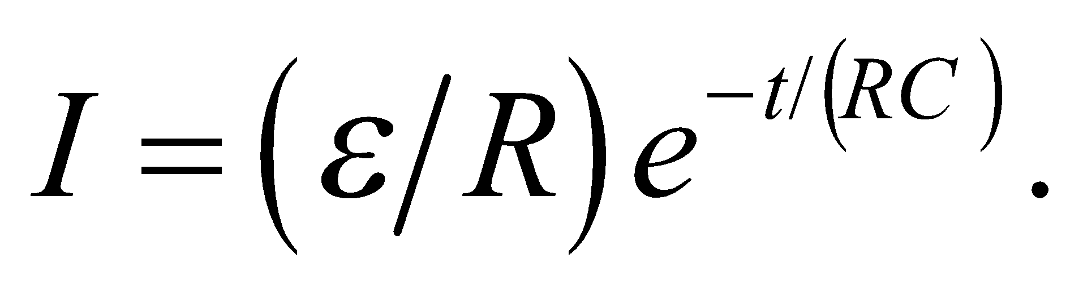 The total energy supplied by the battery is thus

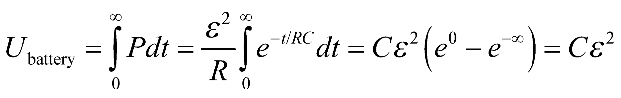

which we can compare with the energy stored in the capacitor (Equation 2.3.3), *U* = *CV*2/2, where *V* is the final voltage across the capacitor.

**Evaluate** The energy stored in the fully charged capacitor is

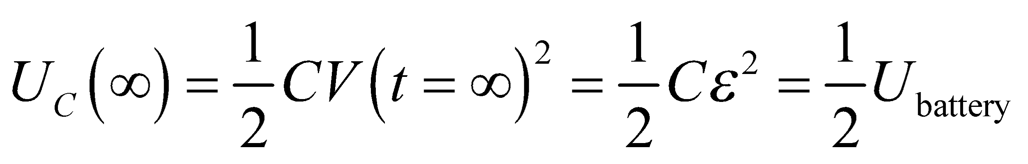

Thus, we see that the energy stored in the capacitor is only half of that supplied by the battery.

**Assess** The other half of the energy supplied by the battery is dissipated in the resistor:

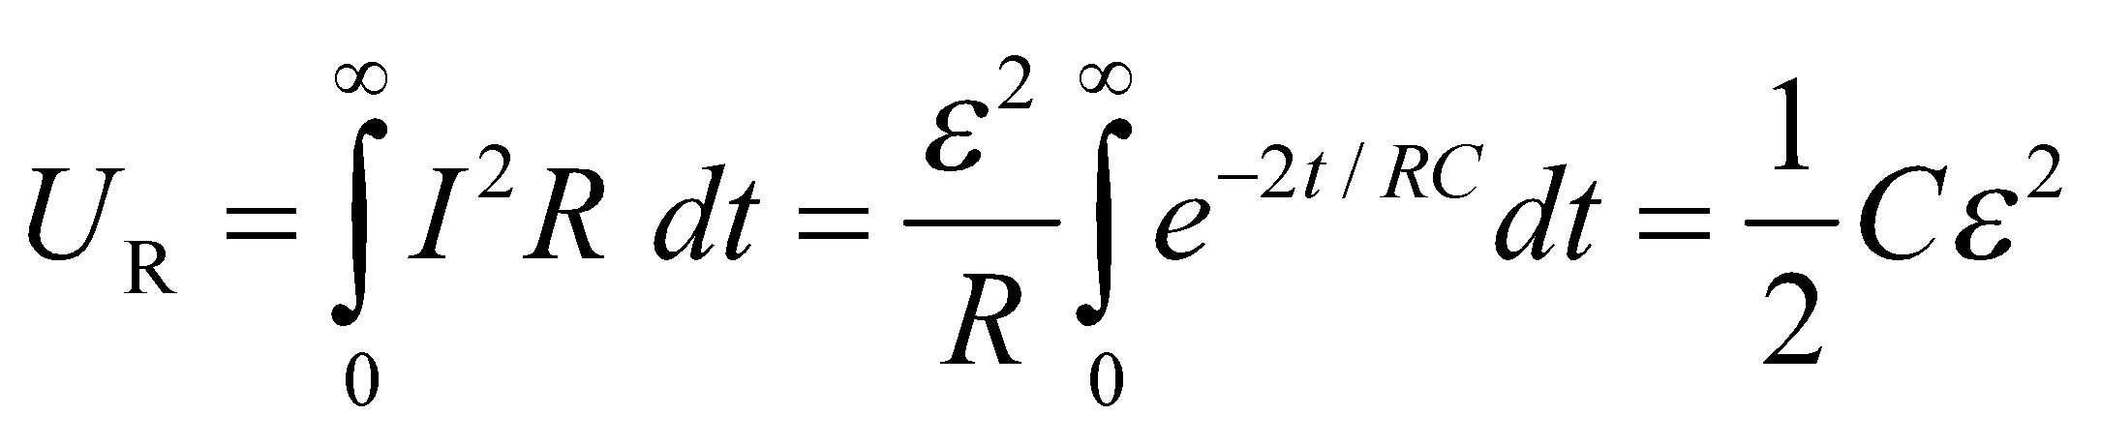

Notice that this result is independent of the value of the resistance and capacitance of the circuit.

**67.** **Interpret** We're asked to determine the equivalent resistance for several complex systems of resistors.

**Develop** The circuit in (a) can be seen as two resistors in parallel followed in series by another pair of resistors in parallel. See the figure below. The circuit in (b) can be seen as two parallel branches, each with two resistors in series. The circuit in (c) is symmetric across a plane through the middle, so the same amount of current should flow through each side.



**Evaluate** (a) Each pair of parallel resistors has an equivalent resistance of 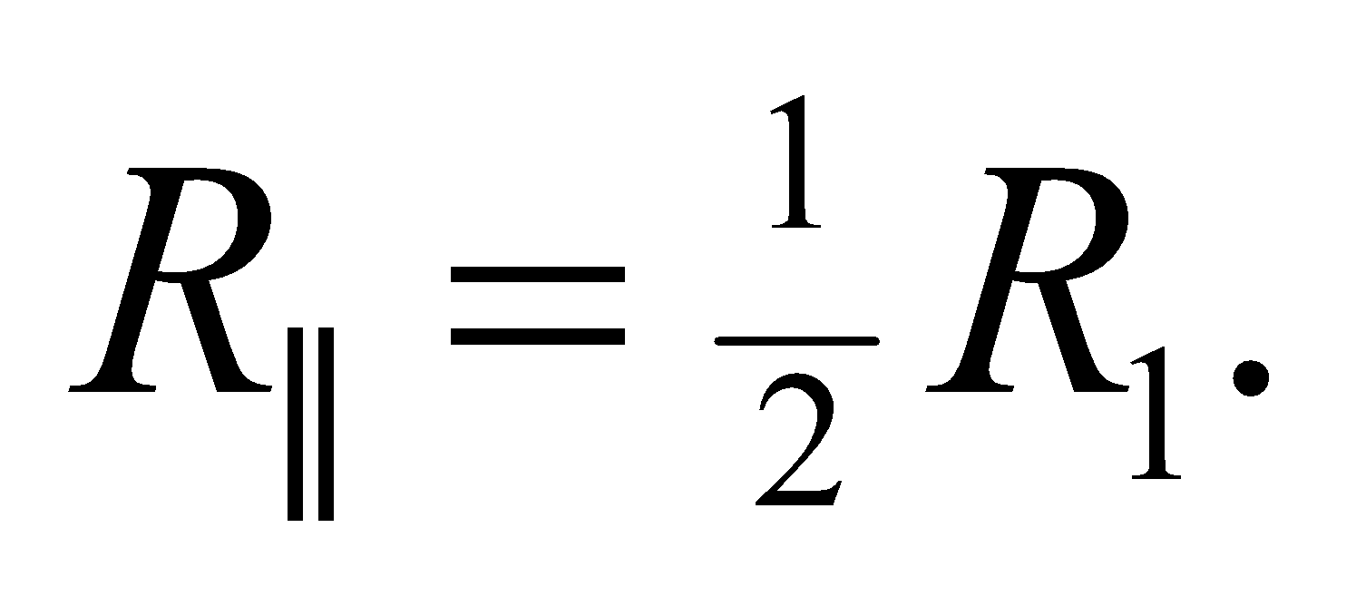Added together in series, the total resistance is (Equation 25.1):

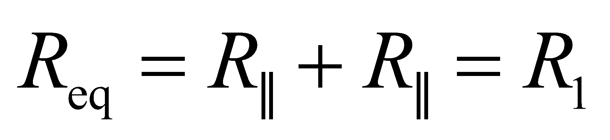

(b) Each branch of resistors in series has an equivalent resistance of 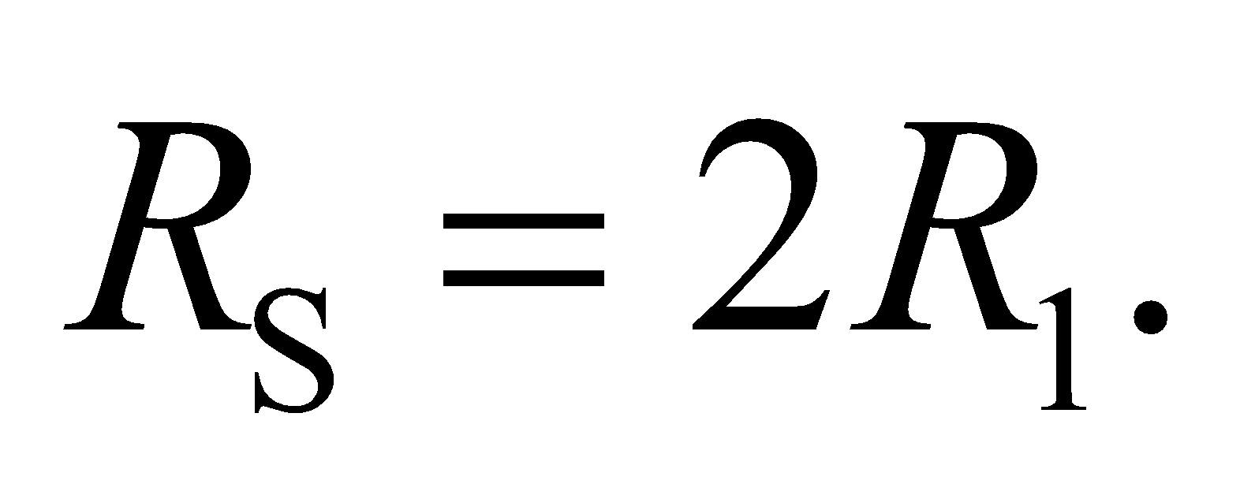Added together in parallel, the total resistance is (Equation 25.3b):

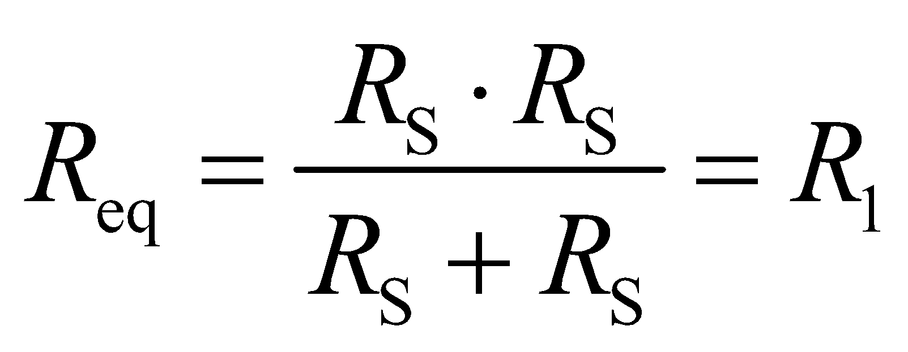

(c) Due to the symmetry, the potential will be the same on both sides of therefore no current will flow through this resistor. If there's no current through this branch, then the circuit is identical to the one in part (b), which means 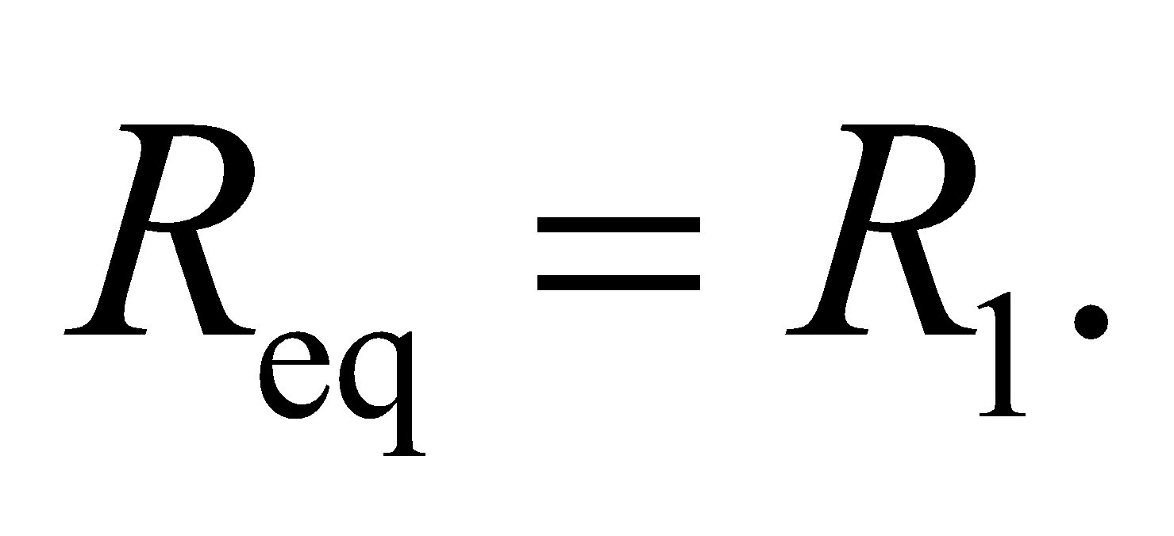

**Assess** Note that the reasoning in parts (a) and (b) is easily generalized to resistances of different values; the generalization in part (c) requires the equality of ratios of resistances which are mirror images in the plane of symmetry.

**68. Interpret** This problem involves finding the voltage and internal resistance of a battery. We are given the current values when the battery is connected to two resistors of known resistance. This problem is similar to Problem 25.61, with the resistor here replacing the resistance of the voltmeter’s internal resistance in Problem 25.61.

**Develop** The circuit diagram is like Fig. 25.8, and Kirchhoff’s voltage law gives

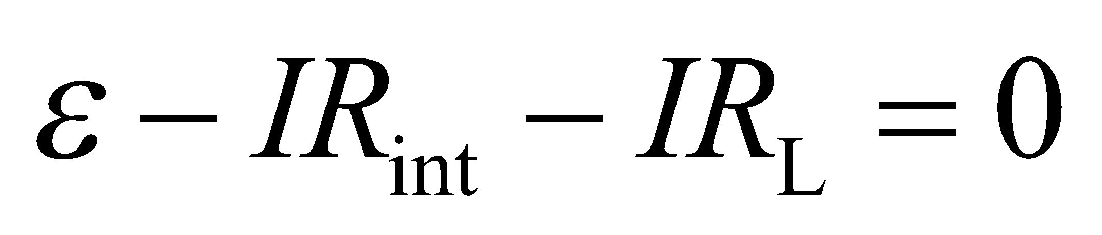

For the two different resistors given, this may be written as

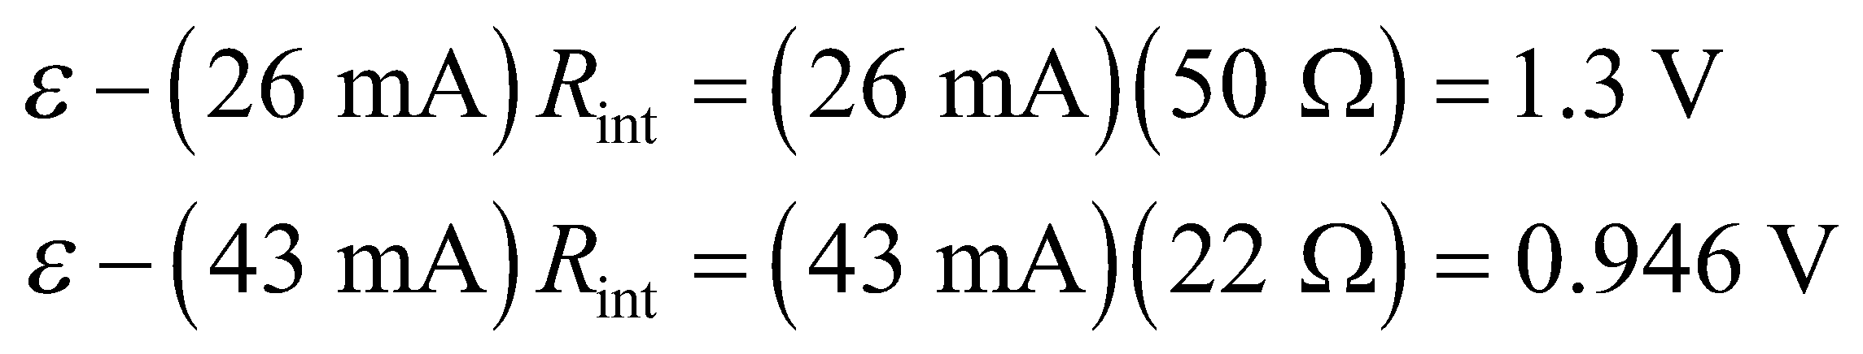

**Evaluate** Solving for  and 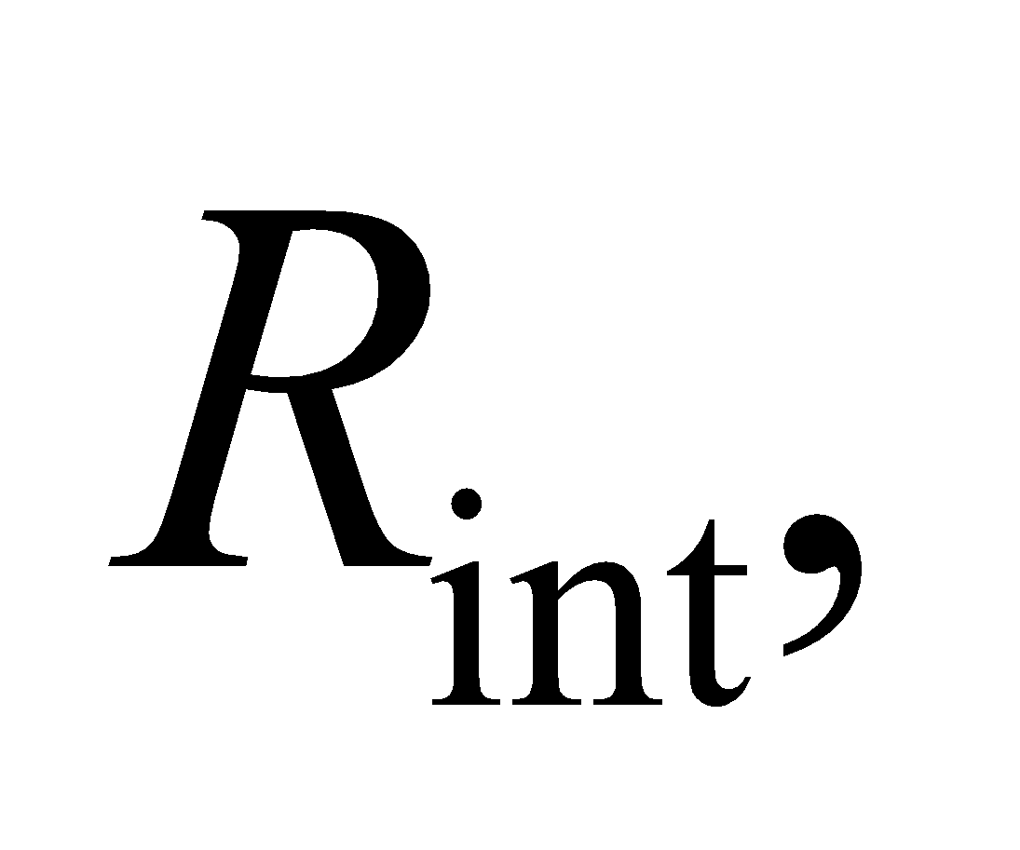 we find

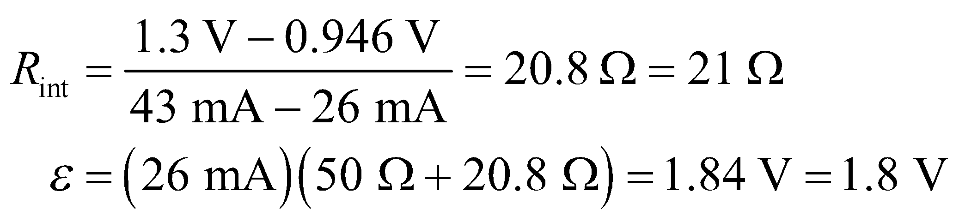

to two significant figures.

**Assess** The terminal voltage of the battery is 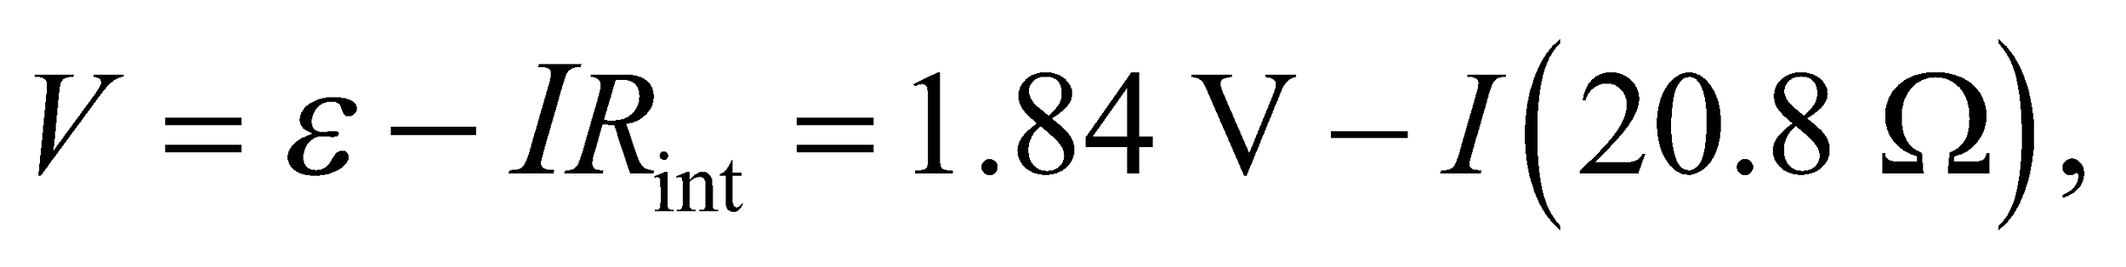 which is lower than . When the battery is connected to a resistor of resistance *R*, the current in the circuit is 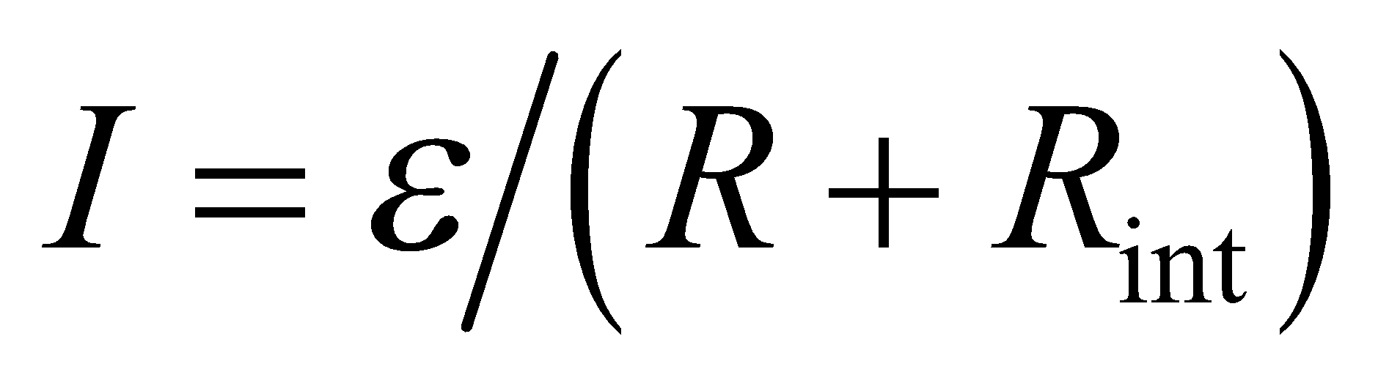.

**69.** **Interpret** This problem explores the rate of increase in voltage across the capacitor of an *RC* circuit. We are to show that if the capacitor were to charge at its initial rate of charging (i.e., the rate at *t* = 0), then it would charge completely in a single time constant *τ* = *RC*.

**Develop** Kirchhoff’s loop law for a battery charging a capacitor through a resistor is

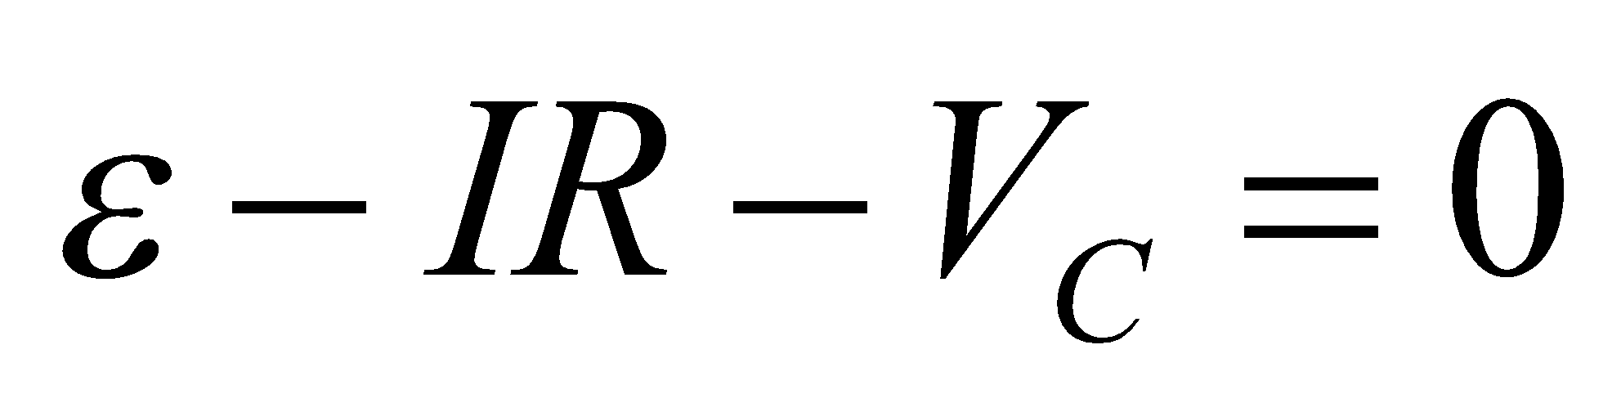

Differentiate this and use Equation 25.4 to obtain

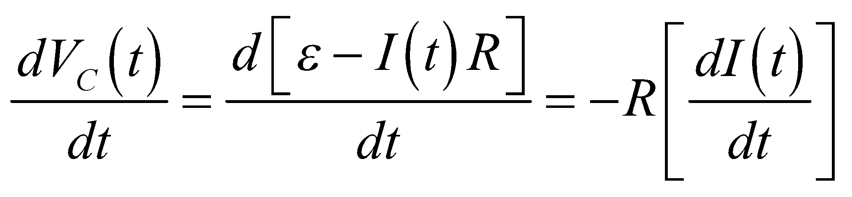

Using 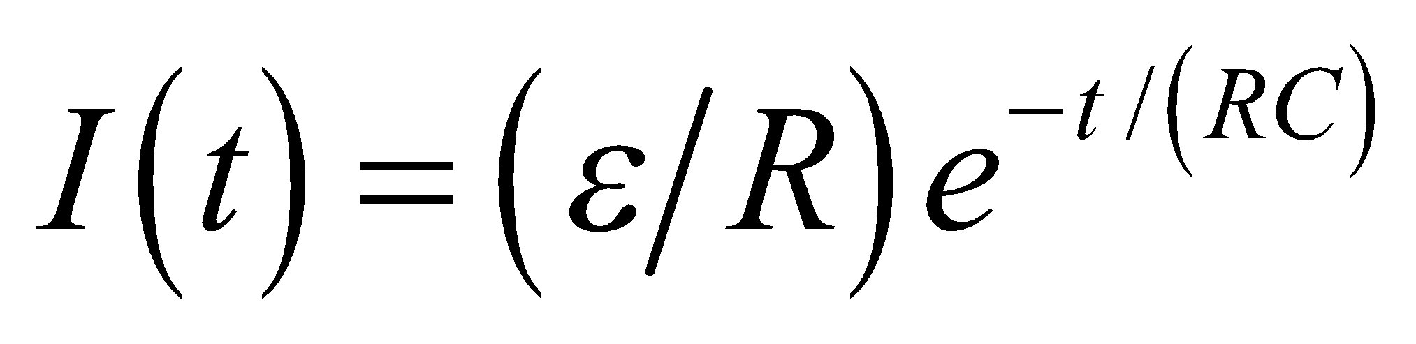 for a charging capacitor (Equation 25.5), we find

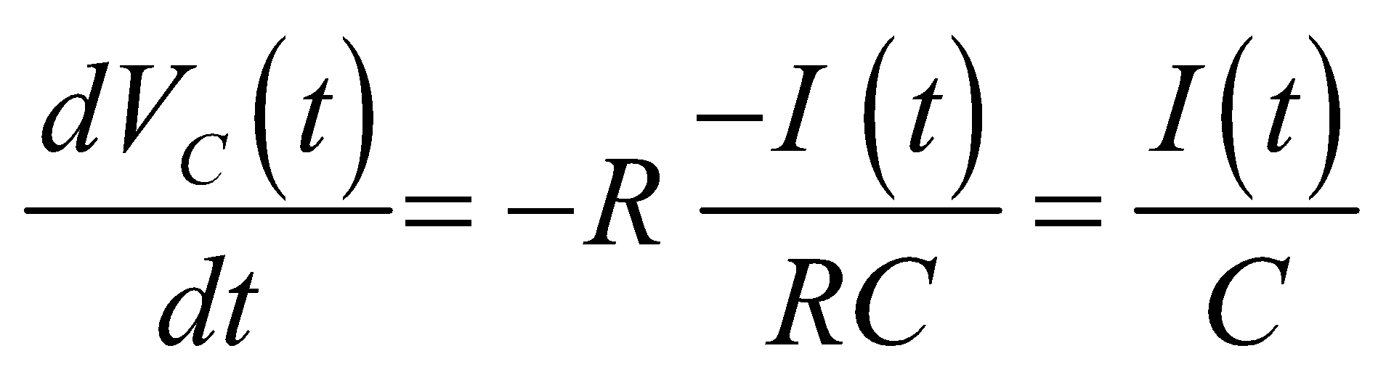

For an initially uncharged capacitor, 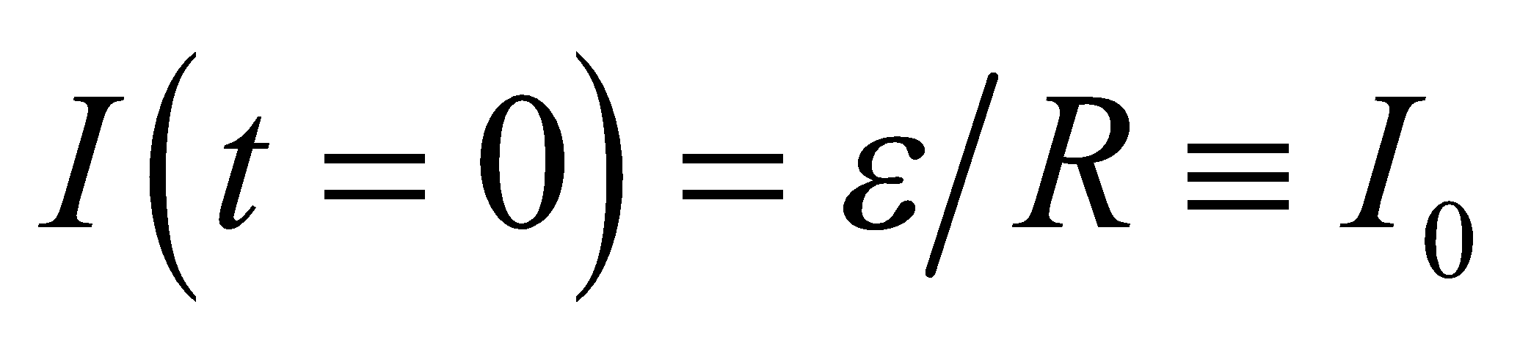, because an uncharged capacitor acts like a short circuit. Thus, the initial rate of increase in voltage across the capacitor is

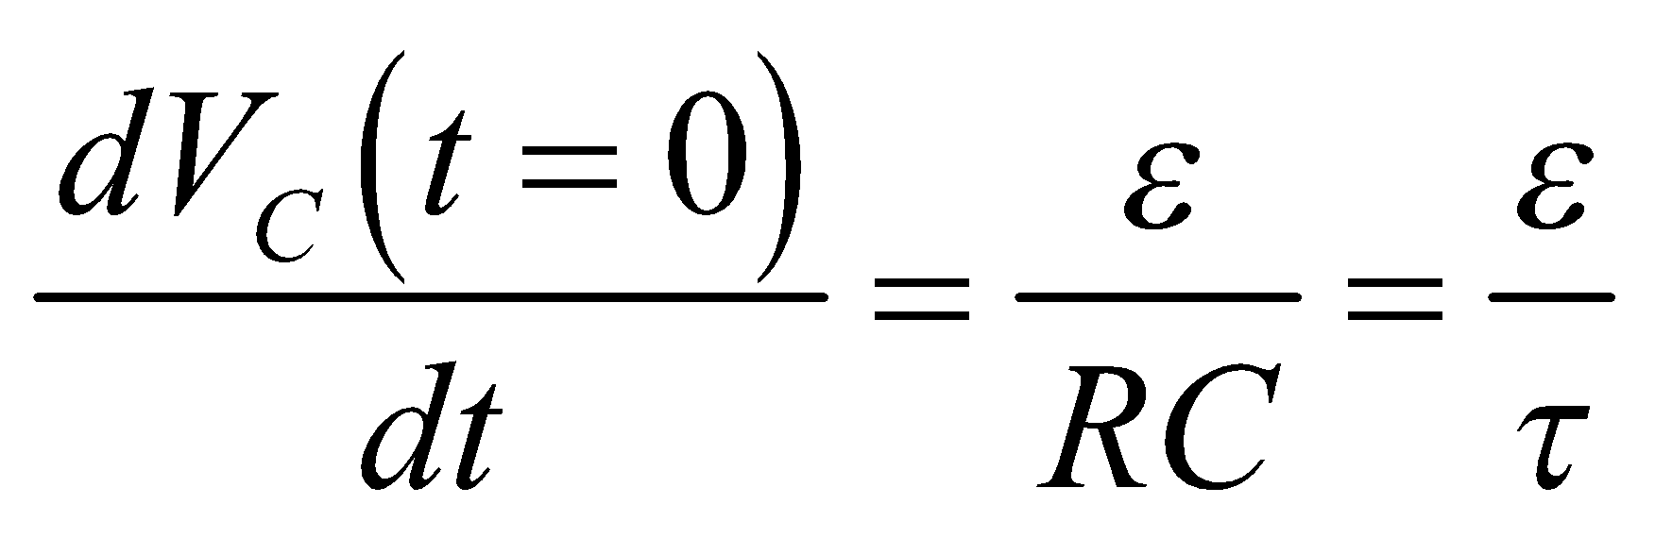

so we find how long it takes at this rate for the capacitor to be fully charged [i.e., to reach 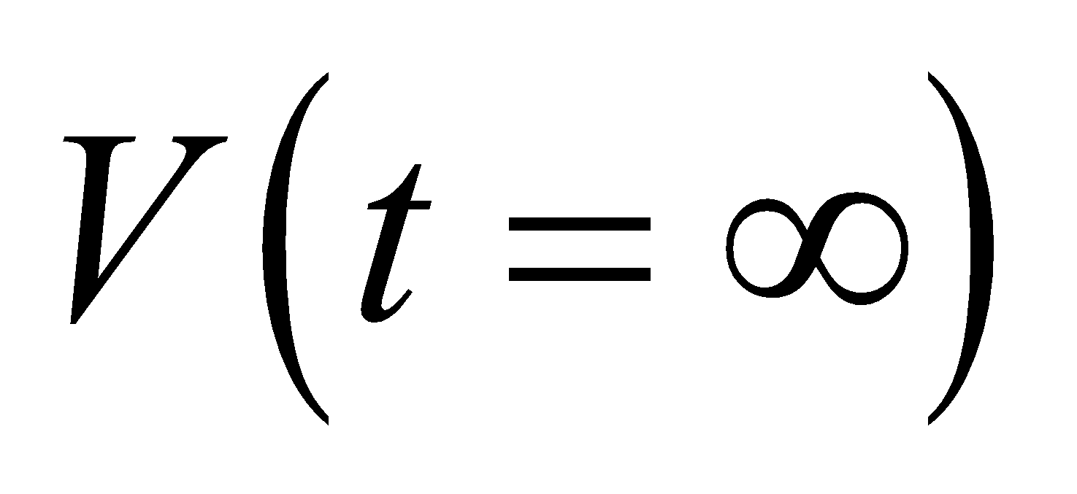].

**Evaluate** From Equation 25.6, we see that 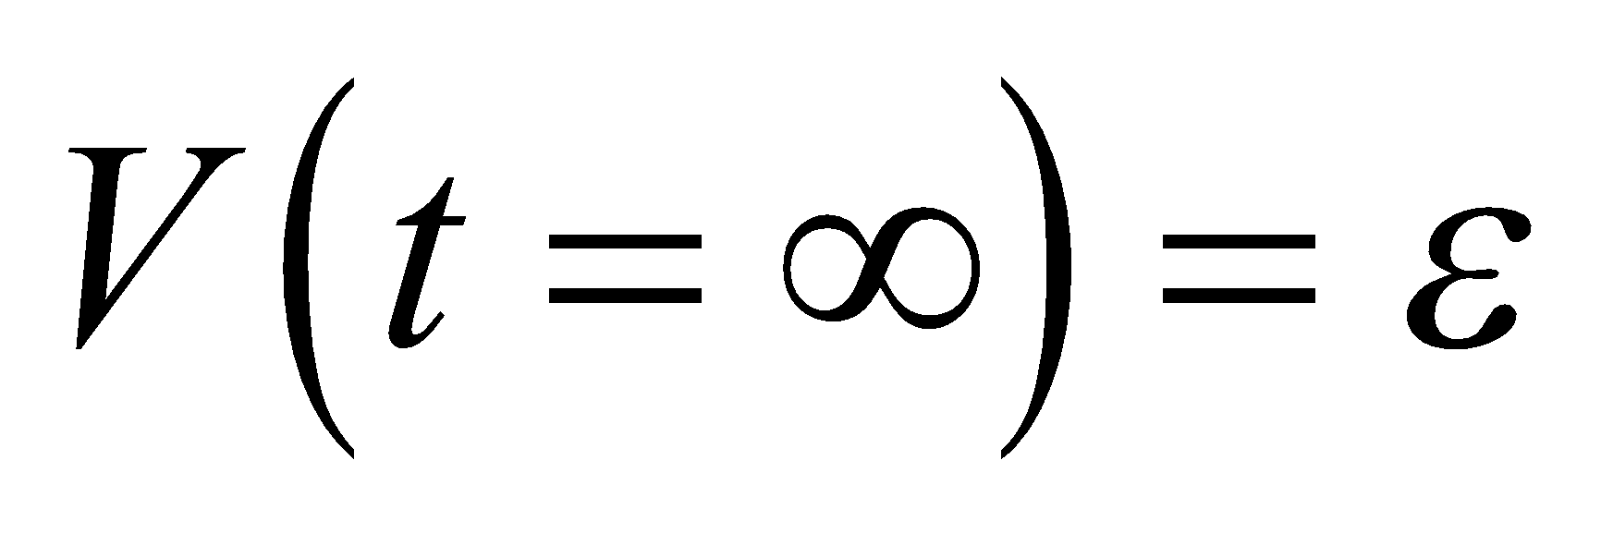, so charging at the above rate, the time *t* it would take to reach this voltage is

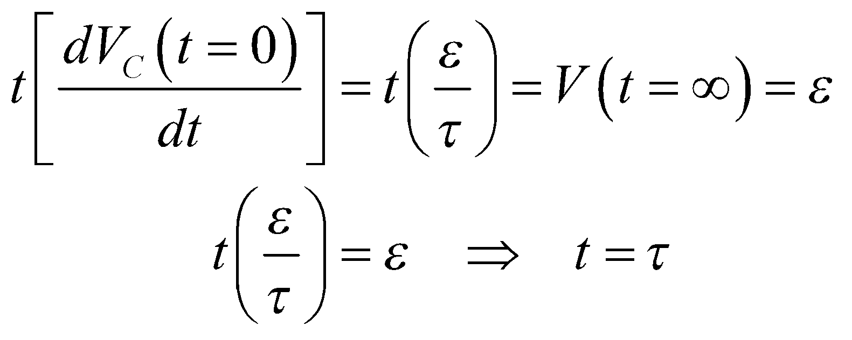

**Assess** The real time it takes to reach full charge is longer than one time constant because the rate of change in the voltage is not constant.

**70. Interpret** Our circuit consists of an array of resistors of infinite extent, and we’re asked to find the equivalent resistance.

**Develop** Since the circuit line is infinite, the addition or deletion of one more element leaves the equivalent resistance unchanged. This can be represented diagrammatically as



The right-hand picture represents *R* in series with the parallel combination *R* and *R*eq. Thus,

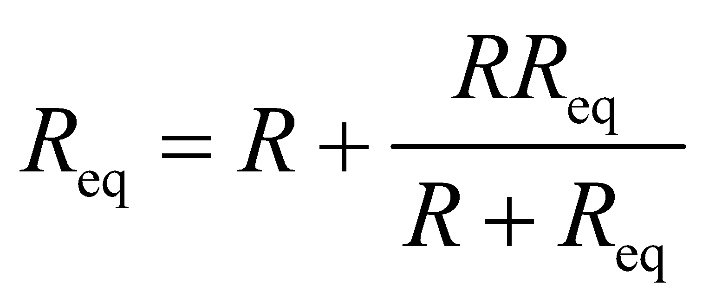

**Evaluate** Solving for 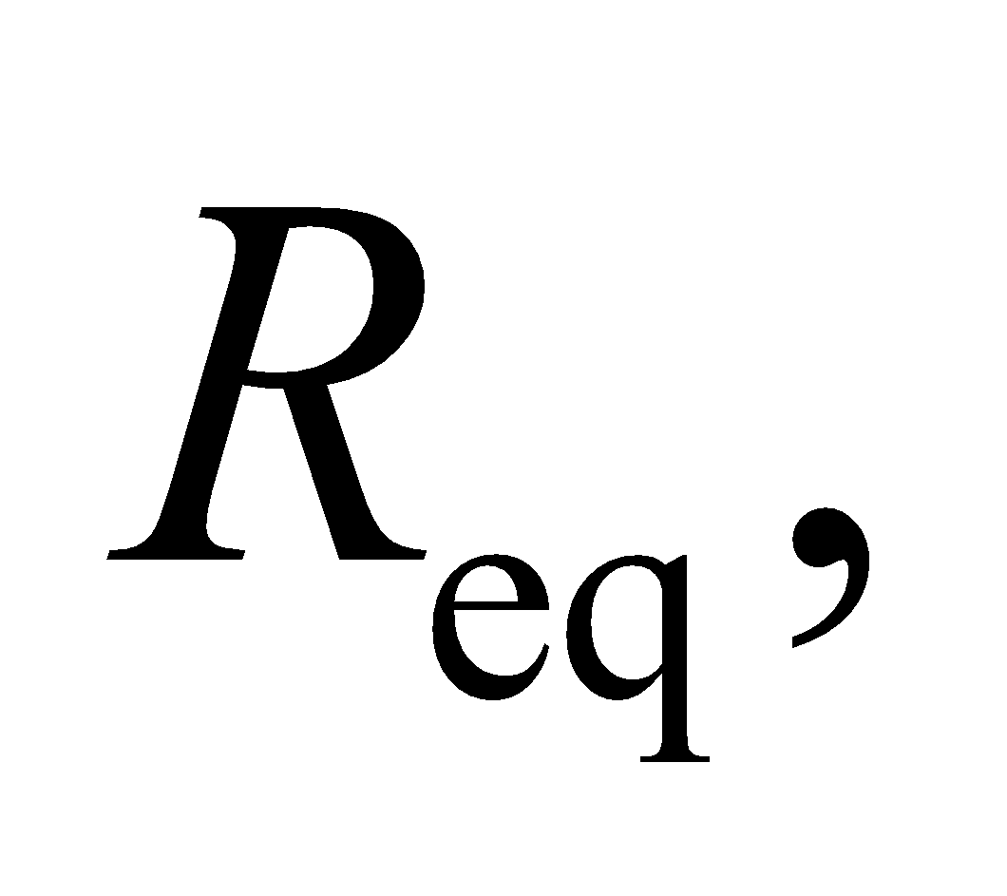 one finds 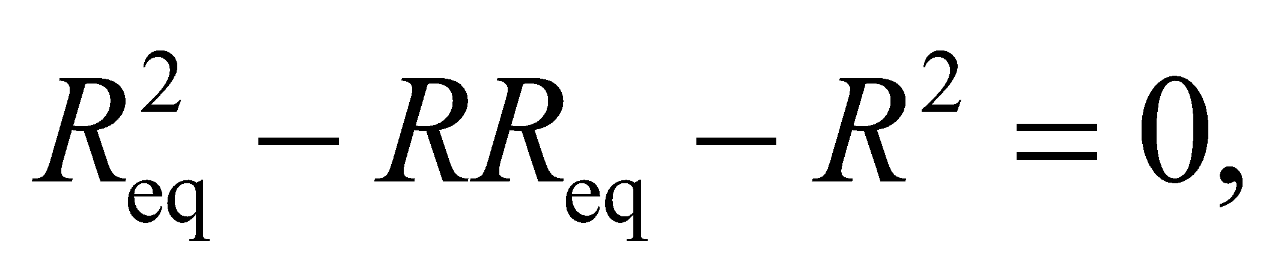 or

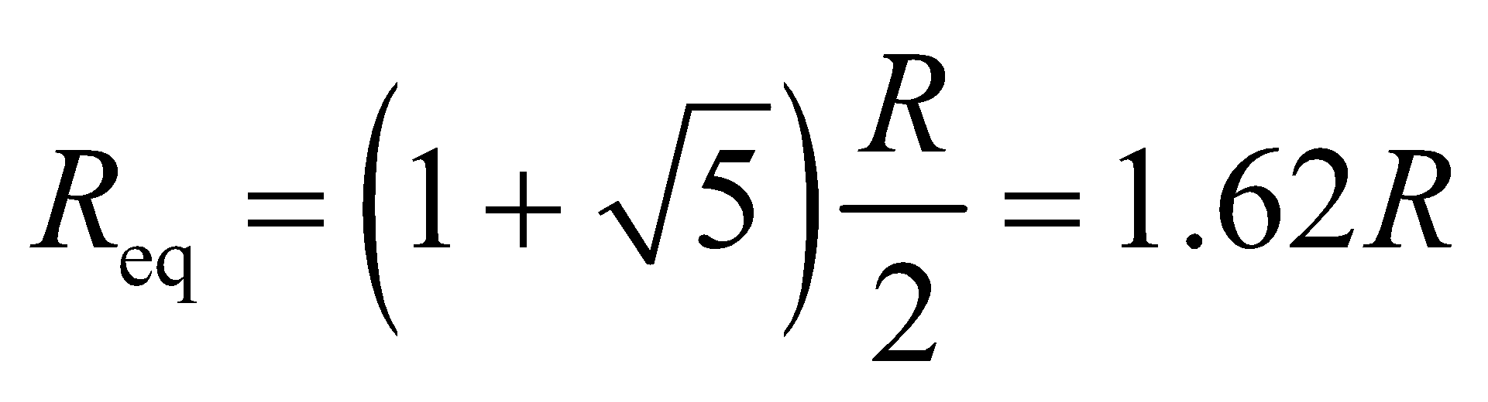

Note that only the positive root is physically meaningful for a resistance.

**Assess** Let’s see how this limiting value is reached. With only two resistors, the equivalent resistance is 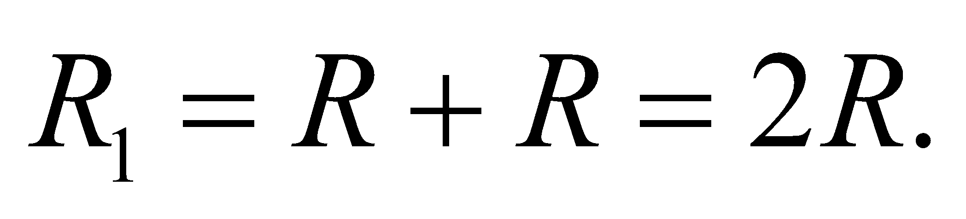 Next, consider four resistors (the four on the left of Fig. 25.41). The equivalent resistance is

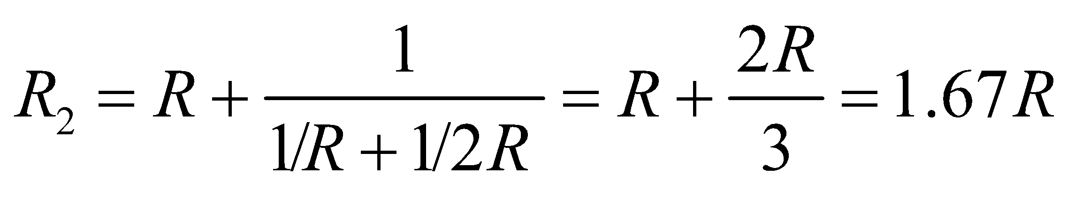

Continuing the same line of reasoning leads to the quadratic equation which we solved to obtain 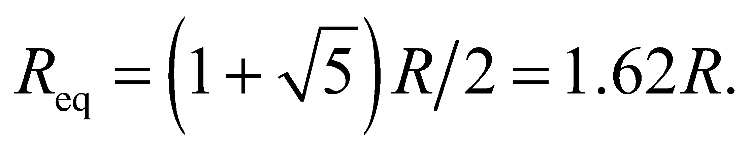

**71.** **Interpret** Using the plot provided of the capacitor voltage as a function of time, we are to find the battery voltage, time constant, and capacitance of an the *RC* circuit.

**Develop** From Equation 25.6, 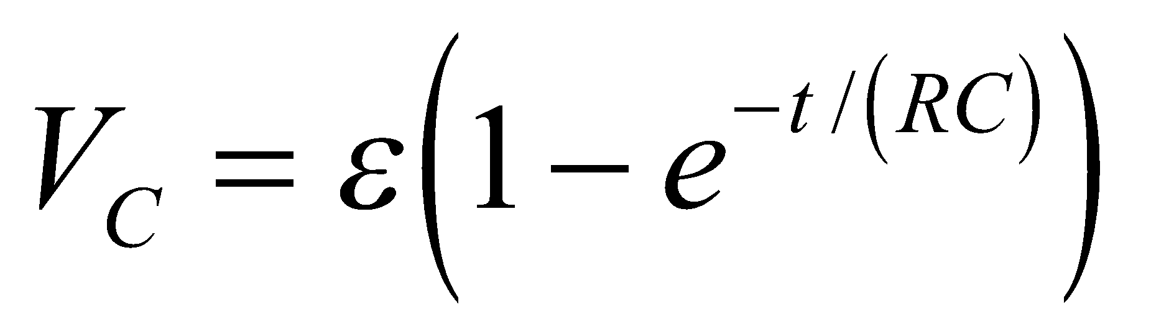, we see that the voltage *VC* across the capacitor asymptotically approaches the battery voltage *ε* as . Thus, we can read the battery voltage off the graph by finding the asymptotic limit of the capacitor voltage (see figure below). The time constant is the time it takes the capacitor voltage to reach 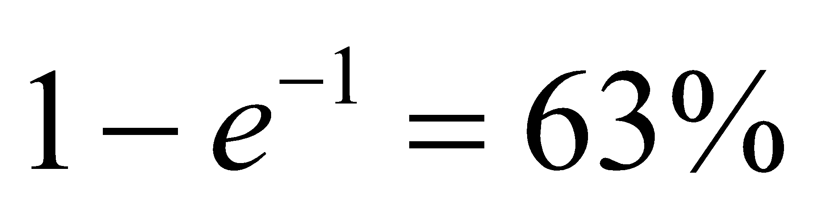 of its asymptotic value, as marked on the graph. From this estimate of the time constant *τ*, we can find the capacitance from using *τ* = *RC*.



**Evaluate** (a) From the asymptotic value of the capacitor voltage, we find that the battery voltage is 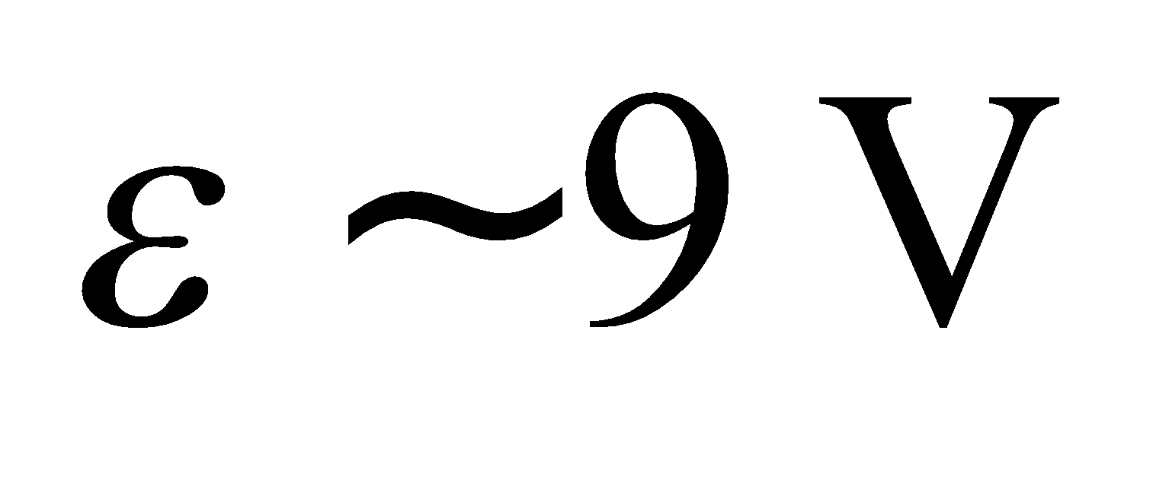.

(b) In one time constant t, the capacitor reaches 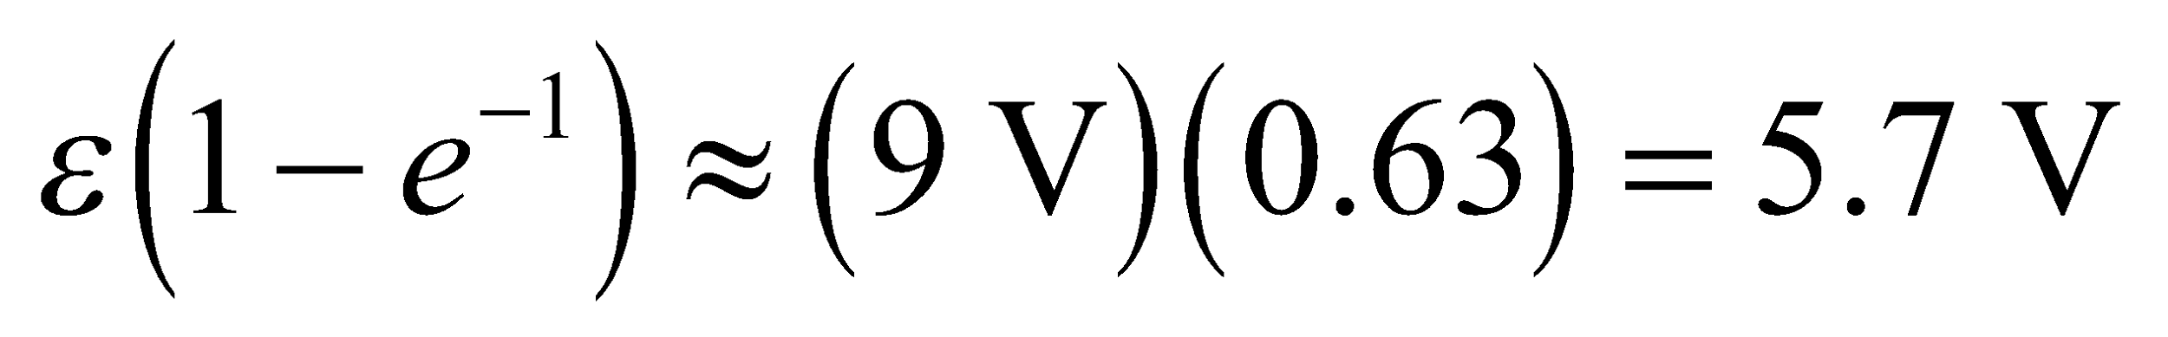. From the graph, this occurs at approximately .

(c) The time constant is *RC*, so .

**Assess** From the graph, we can also see that the rate of increase of the capacitor voltage within one time constant is approximately linear, with a rate of



**72. Interpret** This problem asks for the current through an emf source which is part of a more complex, multiloop circuit. The solution requires analyzing a circuit with series and parallel components.

**Develop** Consider the circuit diagram below, with the currents assumed as indicated. Applying Kirchhoff’s law to the right loop and the big loop gives



Solve for 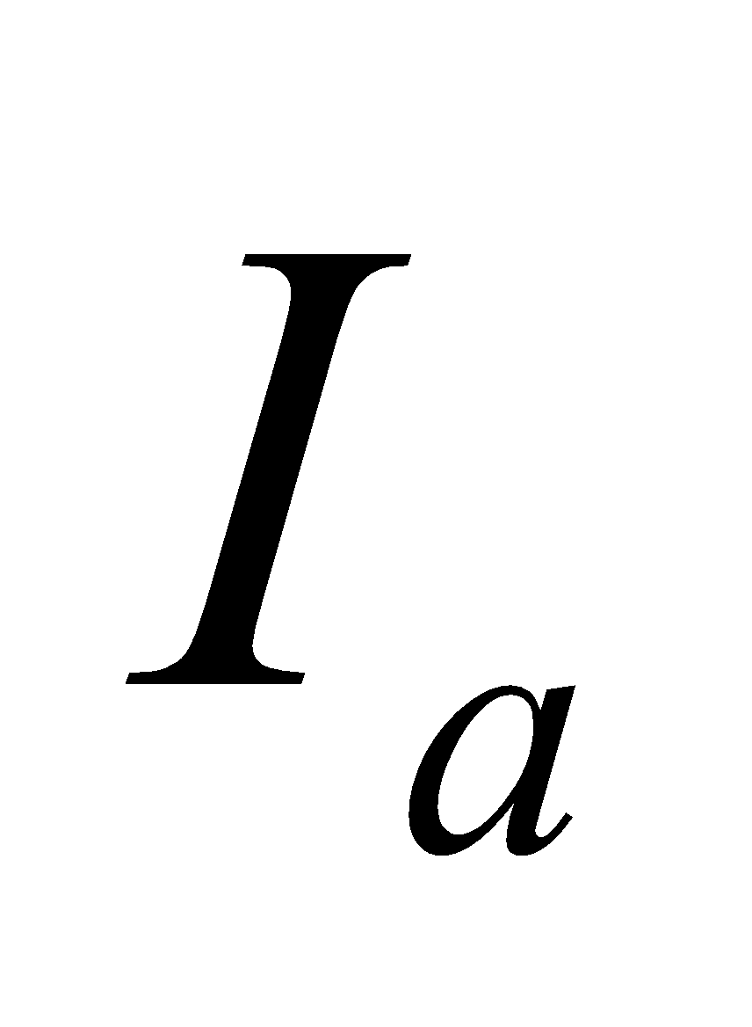 and 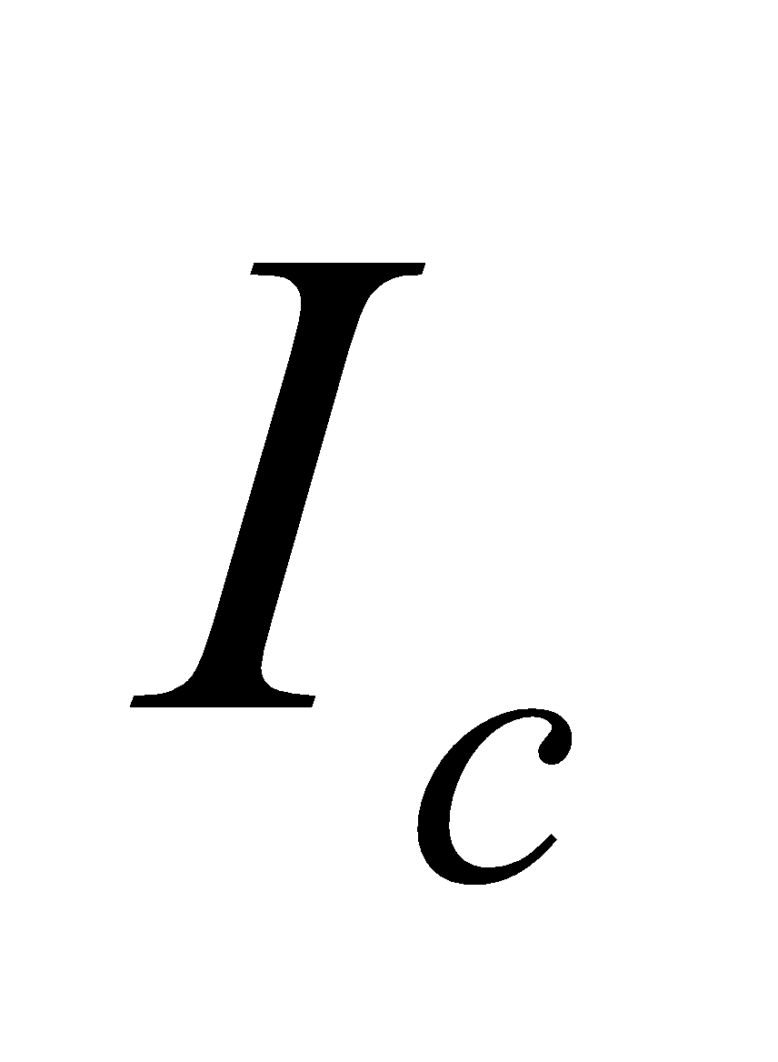 from the loop equations and substitute into the node equation:

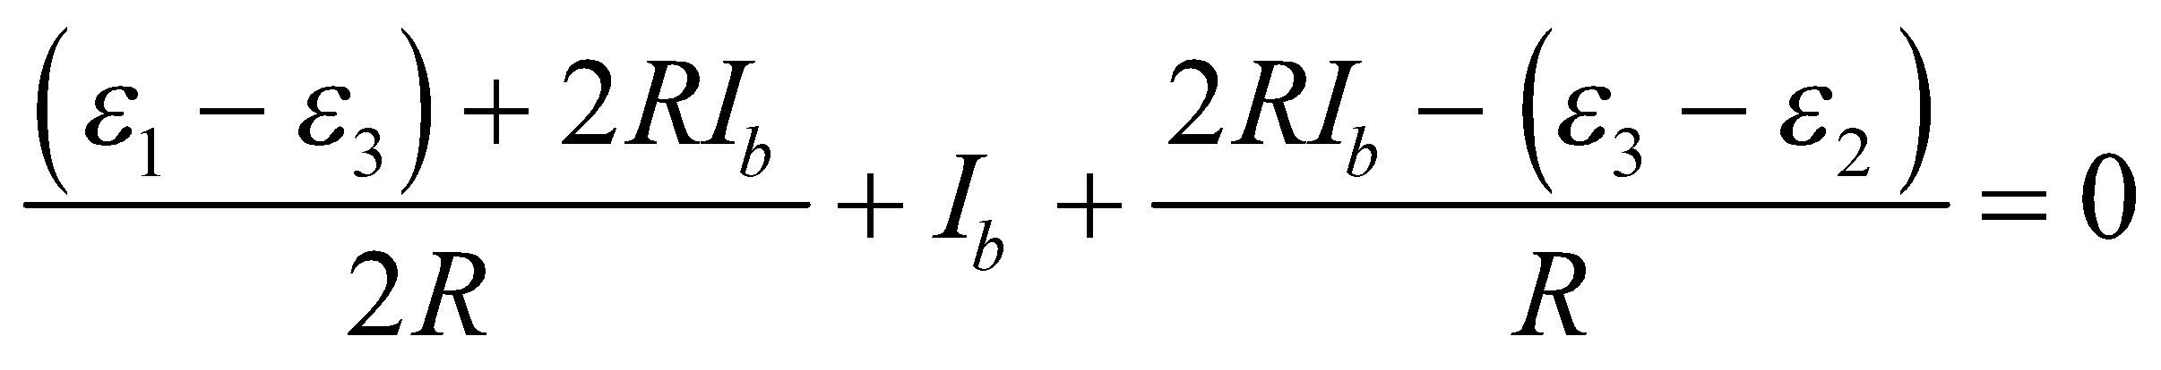

The current in 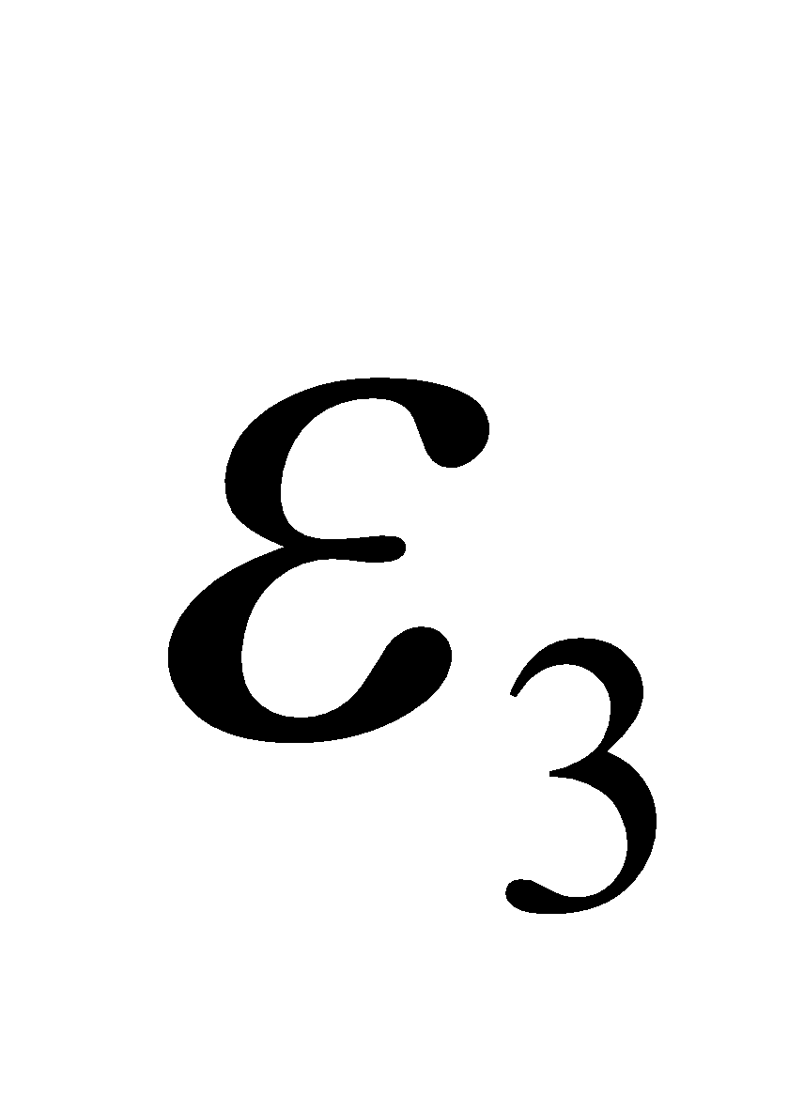 is 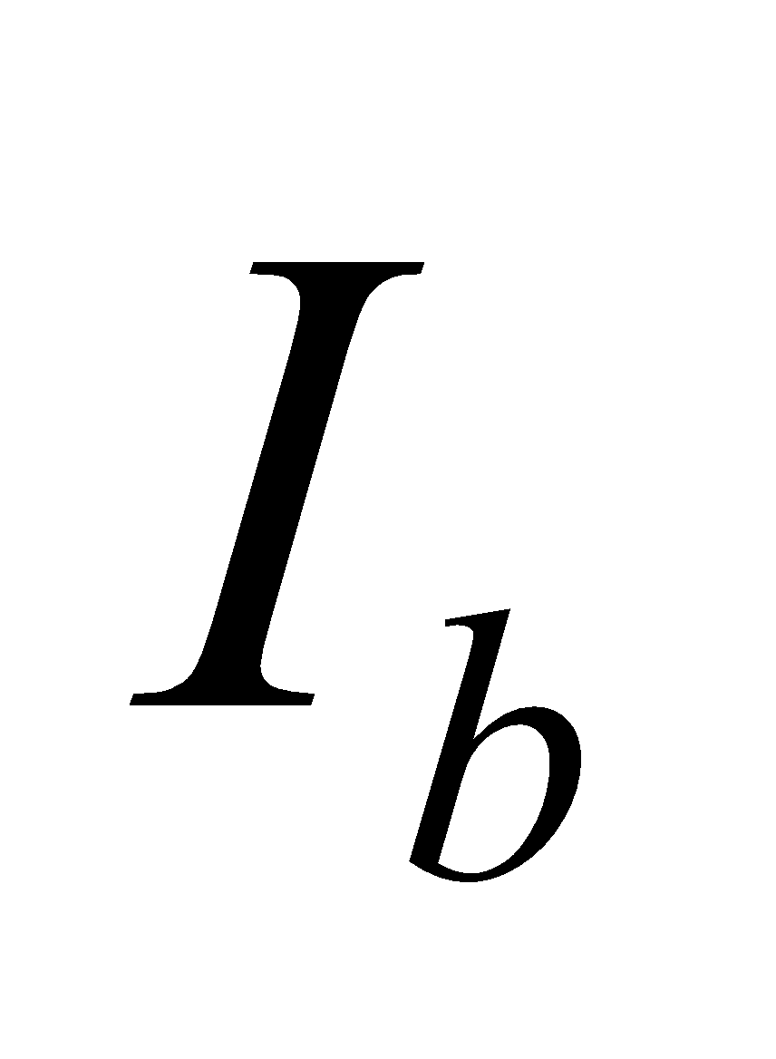



**Evaluate** Solving for 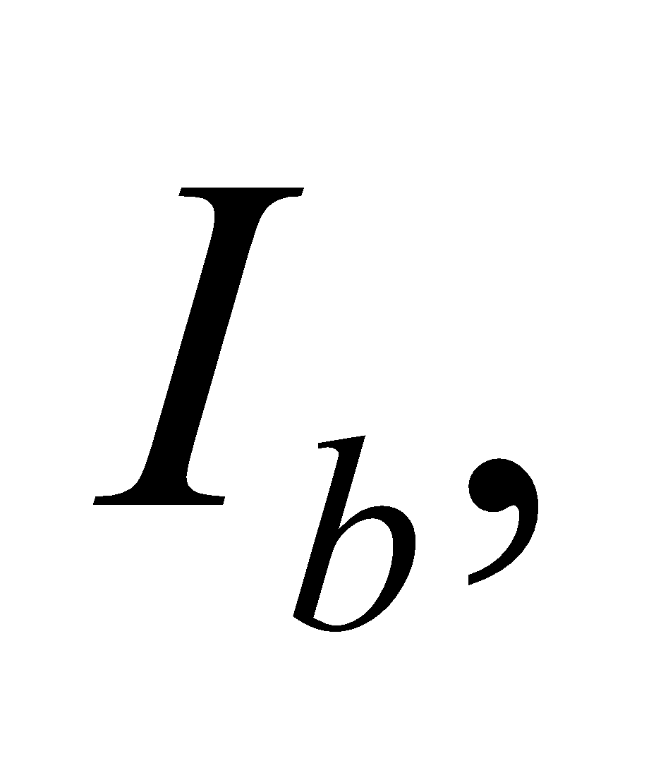 we find



The negative sign means that the direction of  is opposite of what was shown in the diagram.

**Assess** The negative sign in  can be easily understood by noting that  is smaller than 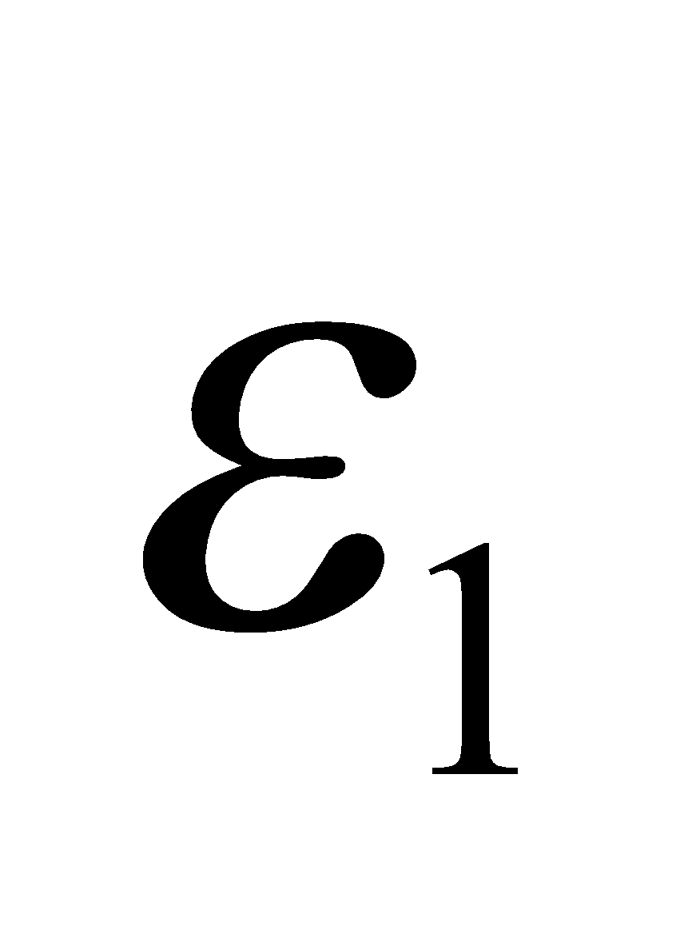 and 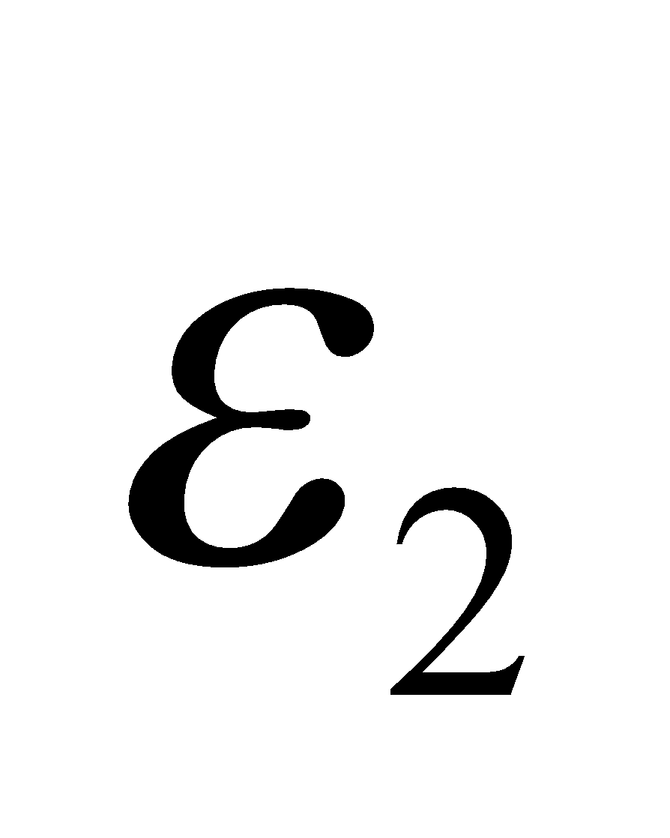.

**73.** **Interpret** This problem is an extension of the previous problem. The emf 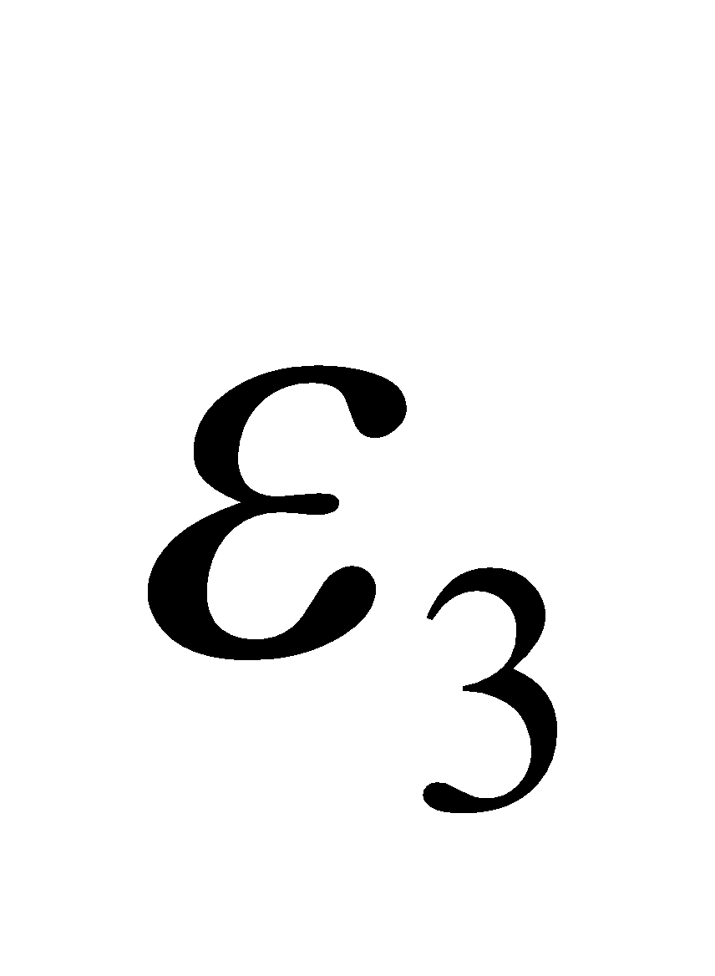 changes now so that it supplies the indicated current. The rest of the circuit elements remain the same and we are to find the new value of .

**Develop** The relation between  and the circuit emfs and resistances, given in the solution to Problem 72, can be solved for  in Fig. 25.40, resulting in 

**Evaluate** For  and with the rest of the circuit elements remaining the same,



**Assess** Thus,  changes by an order of magnitude from 20 mV (in Problem 25.72) to 220 mV here.

**74. Interpret** We are to represent a “leaky” capacitor with an equivalent circuit diagram, and determine the time constant for this circuit. In addition, we are also to show that the time constant does not depend on the geometry of the capacitor, but only on its material properties.

**Develop** For part **(a)**, see the figure below. The leaky dielectric is modeled as a resistor that connects the two capacitor faces. For part **(b)**, we will use the resistance of the insulation material,  where *d* is the thickness of the material and *A* is the area of the capacitor plates. We will also use Equation 23.4 for parallel-plate capacitance,  where  is the dielectric constant of glass. The time constant we are seeking is *τ* = *RC*.



**Evaluate (b) ** This is independent of the geometrical terms *d* and *A*, and depends only on the material properties:



**Assess** This is actually pretty good for a capacitor. Materials with high resistivity and high dielectric constant will make capacitors with longer leakage time constants.

**75. Interpret** We will use Kirchhoff’s laws to write a system of equations for the circuit shown in Figure 25.23a, and from the resulting equations we are to determine the time constant of the circuit.

**Develop** We first sketch our loops and nodes, as shown in the figure below. We have 3 unknowns, so we will need 3 equations. Nodes *A* and *B* give us duplicate information, so we will use only one of the two: our equations must then come from loops 1 and 2, and node *A*. Node *A* gives us



Loop 1 gives us



and loop 2 gives us



The voltage across the capacitor is given by 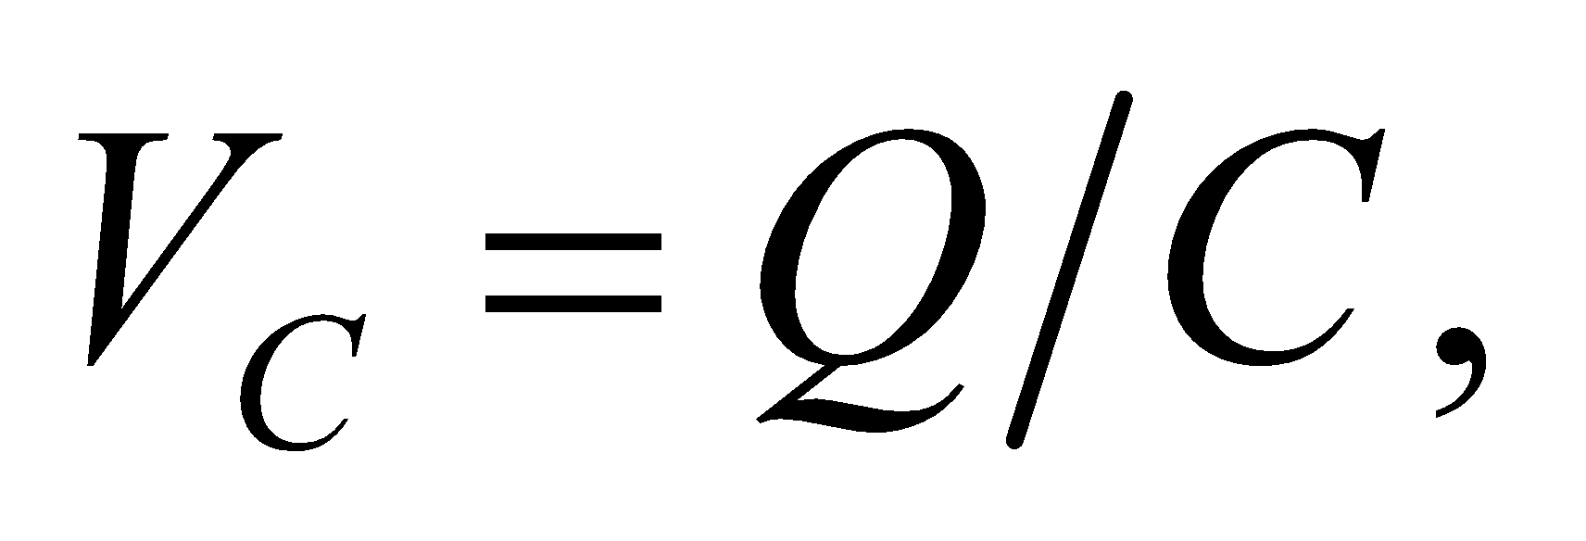 and  We will eliminate *I*1 and *I*2 in our system of equations, then rearrange the results into the form of Equation 25.4, from which we can easily identify the time constant.



**Evaluate** From node *A*,  Substitute this into the equation for loop 1:



Now we substitute into the equation for loop 2:

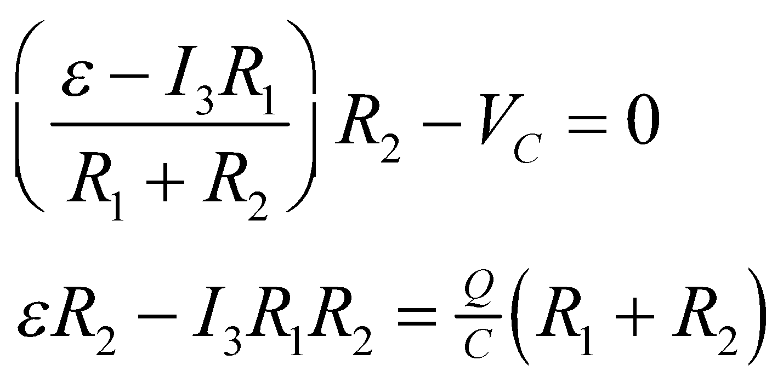

We take the time derivative of this last equation:



Rearrange this slightly to obtain



Now here’s a trick: rather than solve this equation, we note that it’s the *same* equation as 25.4, with a different cluster of constants in the denominator. In the solution to 25.4, we found that *τ* = *RC*, so here the time constant must be



**Assess** This trick of putting the equation in a previously solved form can save us a lot of effort. Note that we can *only* do it because all the terms in the square brackets are constants: if there was a term involving *I*3 in those brackets, then it would be a different equation and we couldn’t use the same solution.

**76. Interpret** We will use Kirchhoff’s laws to write a system of equations for the circuit shown in Figure 25.36, and from the resulting equations we will determine the current through resistor *R*2. We will need 4 equations.

**Develop** First we make a diagram of the circuit, as shown in the figure below. Nodes *A* and *B* give us duplicate information, so we will use only node *A*, along with the three loops.

Node *A*: 

Loop 1: 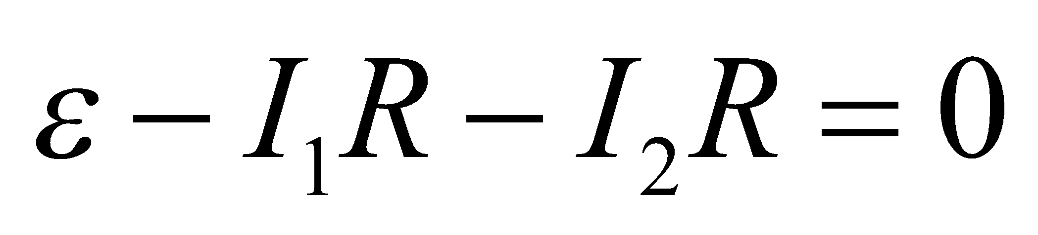

Loop 2: 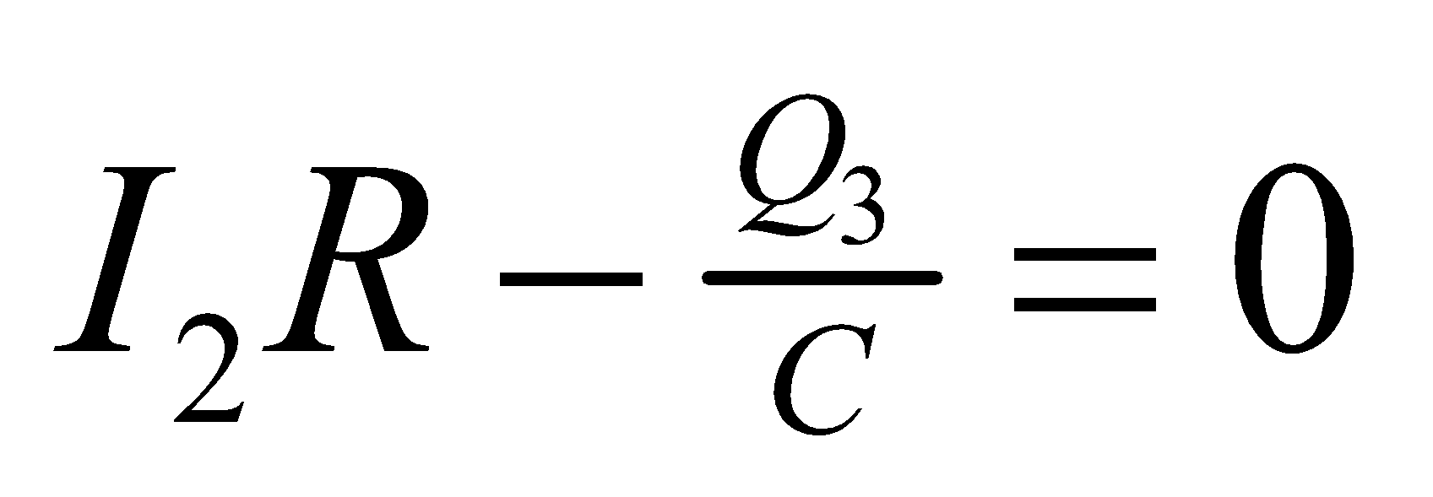

Loop 3: 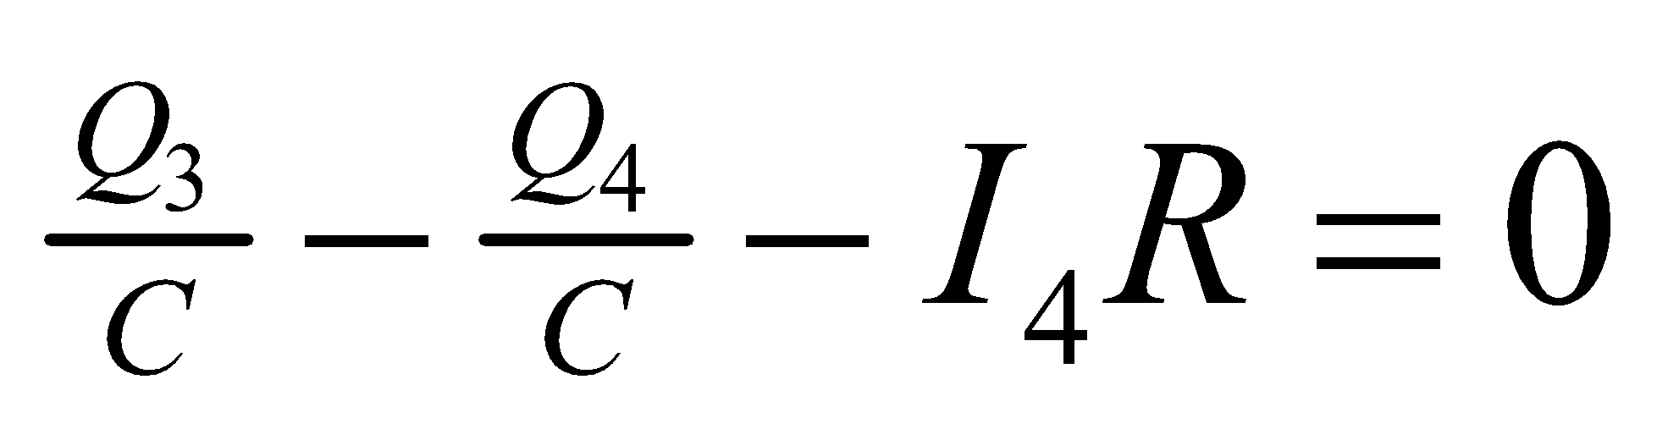



We will solve for *I*2 as a function of time.

**Evaluate**

Node *A*: 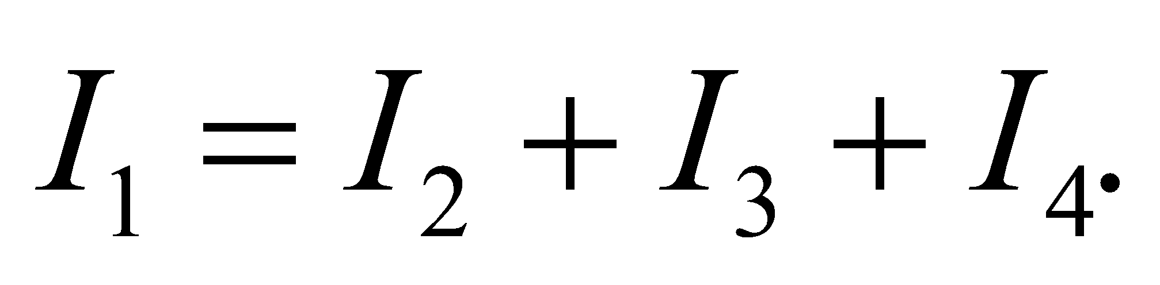

Loop 1:

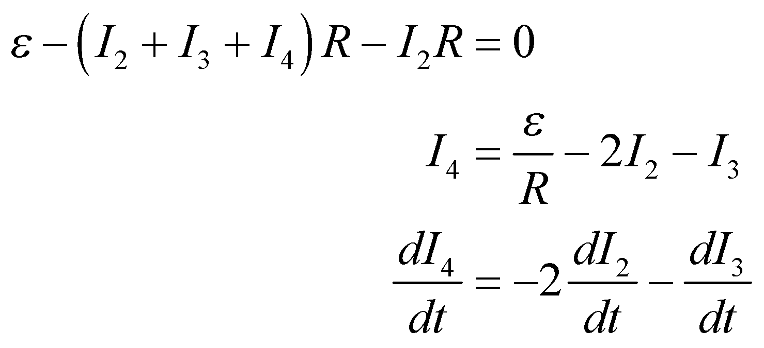

Loop 2:

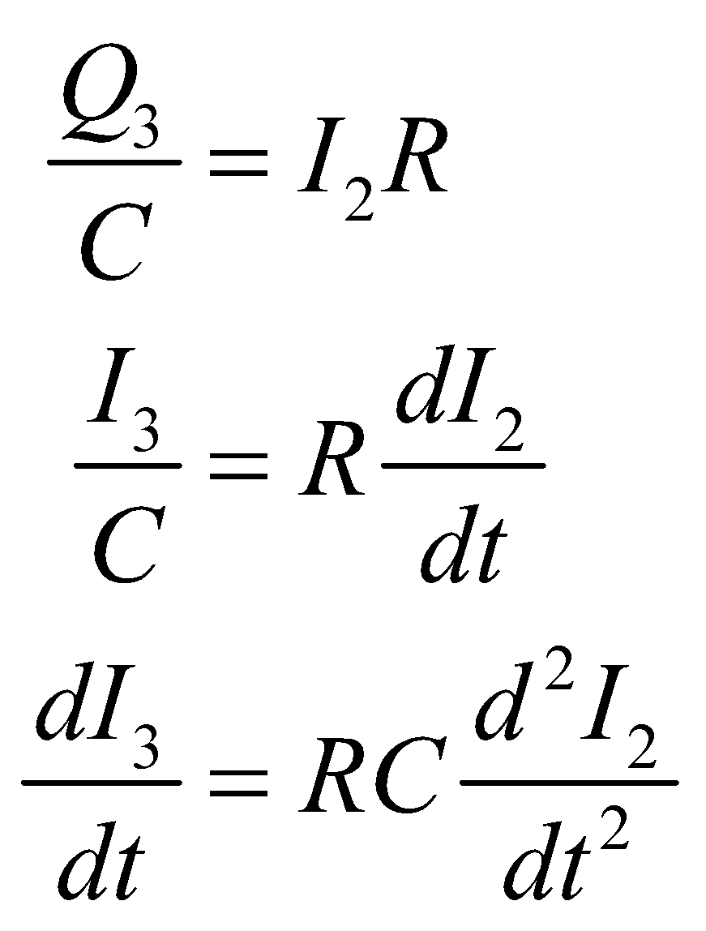

Loop 3:

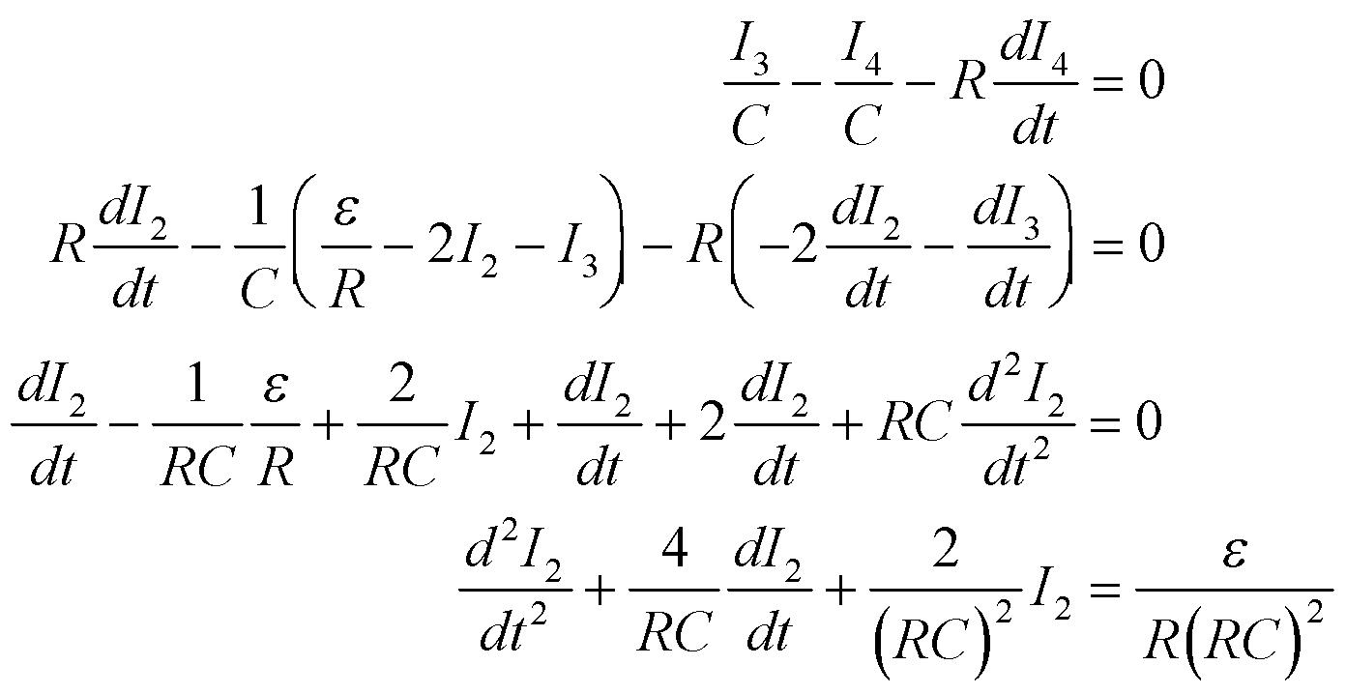

This is a second-order linear differential equation with constant coefficients. We can solve the homogenous equation using the characteristic equation:



So the solution to the homogenous equation is



and the solution to the inhomogenous equation is



Now we need the initial condition on *I*2 and *dI*2/*dt*. Since both capacitors are initially uncharged and essentially short circuits, 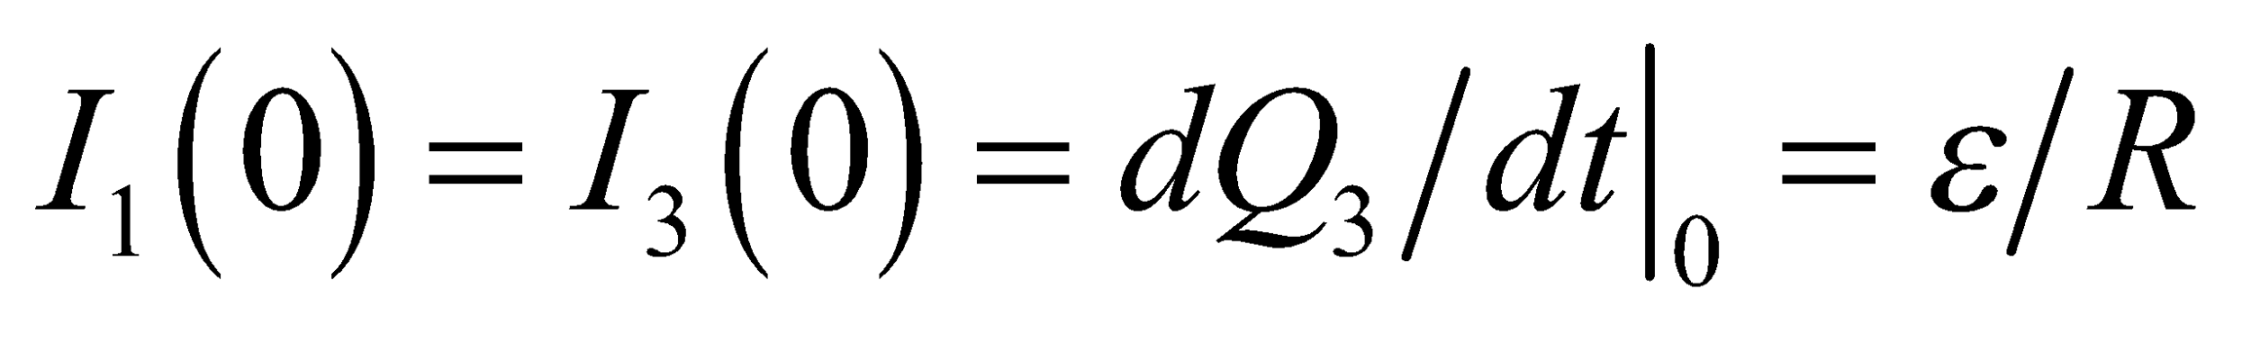 and the *initial* voltage across the central capacitor is given by  This voltage creates a current through *R*2 of



so

 and 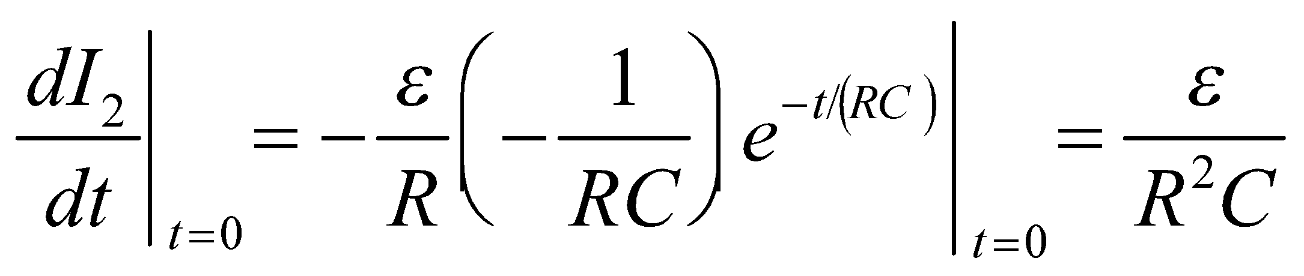

Applying the boundary condition  to the solution obtained previously gives us 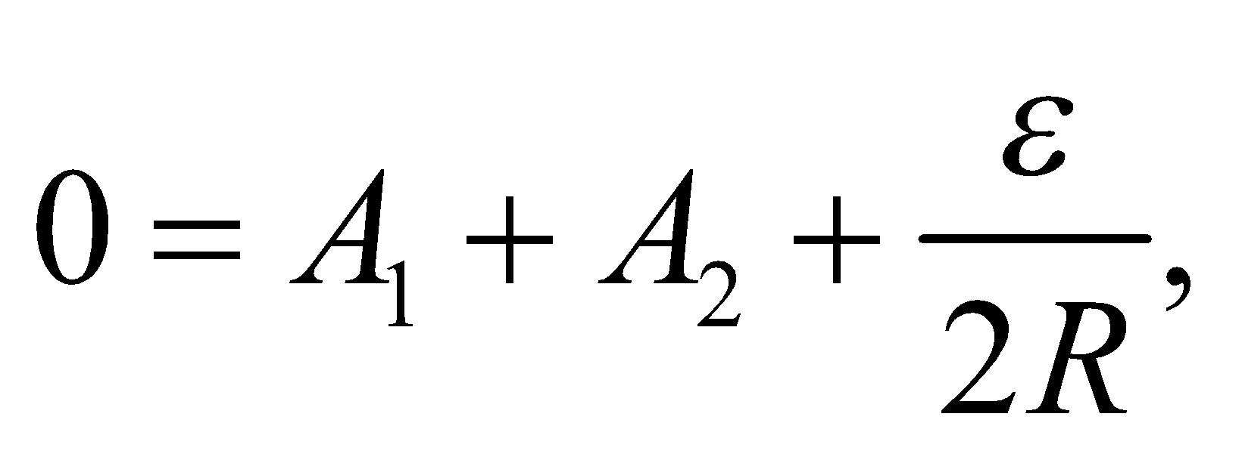 and applying

 gives us 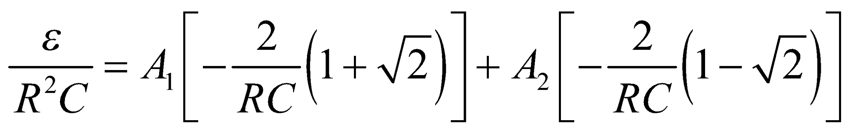

from which we can determine that 

So, our final solution is



**Assess** This was a difficult problem, but the technique used to set it up is the same as for an easier one: Kirchhoff’s laws.

**77. Interpret** We must convert a battery energy rating (in watt-hours) at a given voltage to a charge rating of ampere-hours.

**Develop** Apply Equation 24.7, *P* = *IV*. The battery is specified at 50 watt-hours, which means that it can supply *P* = 50 W for 1 hour. We will use *P* = *IV* to find *I*, knowing that the voltage is *V* = 6 V.

**Evaluate**  to a single significant figure.

**Assess** This is an 8-A·h battery, which is sufficient for our requirements.

**78.** **Interpret** We're asked to analyze a situation where stray voltage passes through a dairy cow.

**Develop** The cow in this case completes the circuit. Its resistance is in series with the intrinsic resistance of the stray voltage.

**Evaluate** The equivalent resistance is the sum of the cow and intrinsic resistances. The current can be found by Ohm's law:



The answer is (b).

**Assess** We can't say for sure what a cow feels, but this is above the threshold for sensation in humans (see Table 24.3).

**79.** **Interpret** We're asked to analyze a situation where stray voltage passes through a dairy cow.

**Develop** The voltage across the cow can be found with Ohm's law.

**Evaluate** Given the current from the previous problem, the voltage between the cow's tongue and hoof is

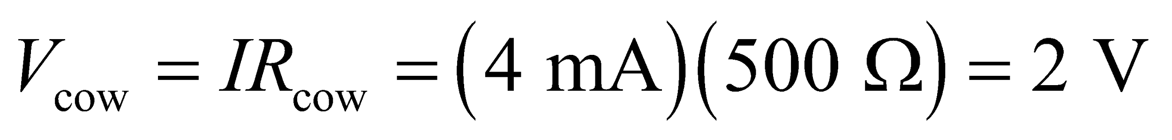

The answer is (a).

**Assess** This is not a lot of voltage; it's just a little more than a D battery.

**80.** **Interpret** We're asked to analyze a situation where stray voltage passes through a dairy cow.

**Develop** An ideal voltmeter is one with infinite resistance.

**Evaluate** If an ideal voltmeter is attached from the water bowl to the ground, it will measure directly the emf, which in this case is 6 V.

The answer is (c).

**Assess** The intrinsic resistance has no effect, since no current flows through the circuit with an ideal voltmeter. If we chose a more realistic case, say, a voltmeter with 10-MΩ of resistance, then a tiny current will trickle through the circuit (0.5 μA), and the voltage reading will be 4.9995 V (if indeed the voltmeter’s precision is this high).

**81.** **Interpret** We're asked to analyze a situation where stray voltage passes through a dairy cow.

**Develop** An ideal ammeter is one with zero resistance.

**Evaluate** If an ideal ammeter is attached from the water bowl to the ground, it will close the circuit and read the current as:



The answer is (b).

**Assess** This gives an idea of the what the maximum current might be from the stray voltage. It also exemplifies the best way to eliminate the problem: by connecting the water bowl directly to ground. This would provide a zero resistance pathway for current to flow, so that the cow no longer gets a shock every time it goes for a drink.